The Indian Tribe Camps by a Cliff
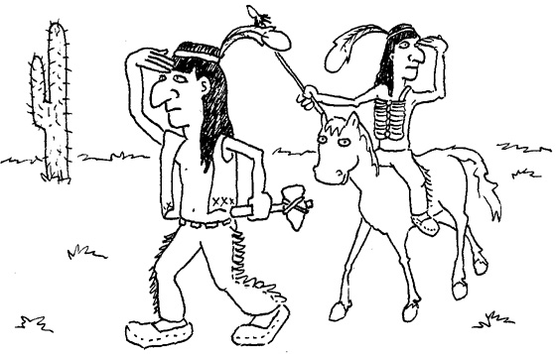  This is an Indian and this is his friend.  They ride and hike many miles.  They can’t find their tribe. | 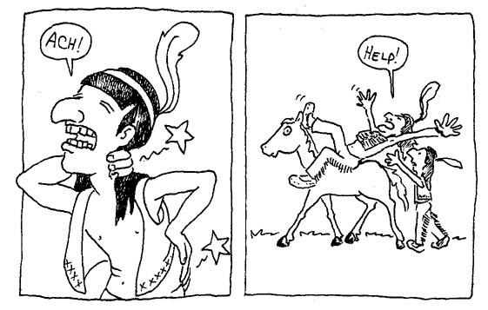  The Indian’s back is stiff. His neck is stiff.  His friend is tired. He falls.  The Indian helps him.
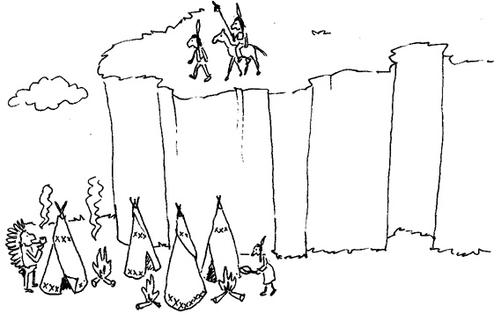  The Indian tribe camps by a cliff.  The camp has many tents and campfires. | 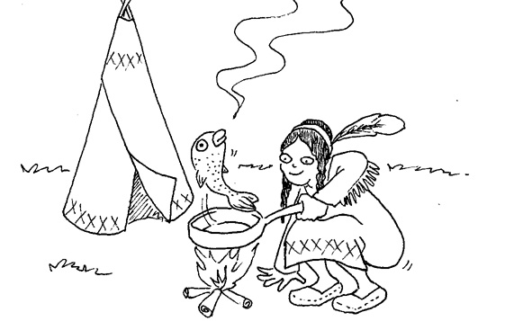  They like fish.  They fry fish in pans.  The fish smells fantastic!
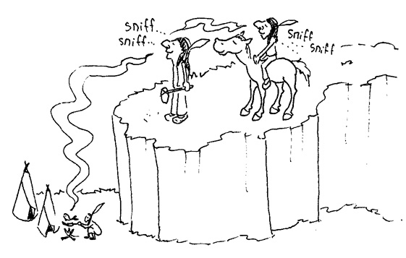  The Indian sniffs. He smells a campfire.  He smells fish. | 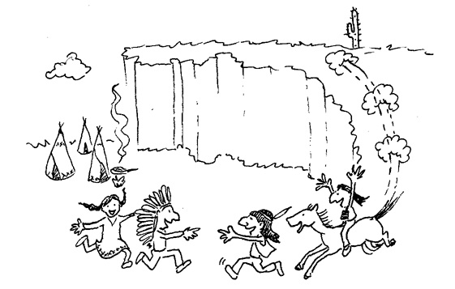  The Indian and his friend find the tribe!  All the family is happy by the campfire.

Word List
1 | 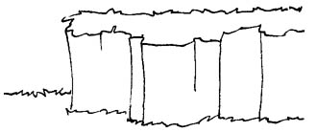 | cliff
2 | 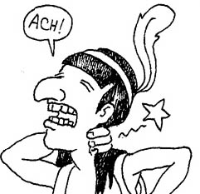 | stiff
3 |  | sniff
4 | 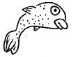 | fish
5 | 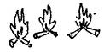 | campfires
6 |  | tired
7 | 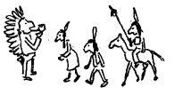 | tribe
8 | 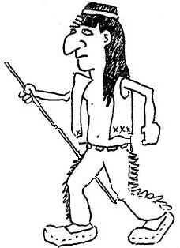 | hike
9 |  | fall
10 | 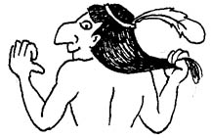 | back
11 | 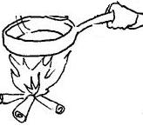 | fry
12 | 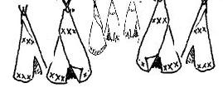 | many tents
Game: Mix-and-match sentences. Cut apart. Compose as many correct sentences as possible – subject, verb, rest of sentence. (Match verb to subject.) Sentences should make sense!
If you feel the number of options is overwhelming, choose a subset of the sentence elements to give to the student; make sure they include some logical and correct sentences.
The Indian |  |  |  |  |  |  | is |  | tired and stiff.
The family |  |  |  |  |  |  | are |  | his baby
The Indian’s friend |  |  |  |  |  |  | fry |  | by a campfire.
The baby Indian |  |  |  |  |  |  | finds |  | fish in a pan.
His back |  |  |  |  |  |  | like |  | in the tent.
The Indian and his friend |  |  |  |  |  |  | likes |  | by the cliff.
His back and neck |  |  |  | hike and ride |  |  |  |  |  | campfires.
The Indian’s tribe |  |  |  |  | find |  |  |  | many miles.
He | rides and hikes |  |  |  |  |  |  |  | his friend.
A tent |  | fall |  |  |  |  |  |  | his family.
Tents |  |  | fed |  |  |  |  |  | the tribe.
The fish |  |  | helps |  |  |  |  |  | fish.
A campfire |  |  | help |  |  |  |  |  | him.
The tents and campfires |  |  |  |  |  | sniffs |  |  | by the tent.
They |  |  | smells |  |  |  |  |  | fantastic!
I |  |  | smell |  |  |  |  | by the campfires.

Point out that, to make sentences, first match between verbs and subjects:
  - If the subject is one of the “סנובים” – the “snobs” he, she, or it, for which we have the “s” spelling rule (to add “s” to the end of the verb in present simple tense), you need a verb that ends in “s”
  - In this game, those verbs are: smells, sniffs, is, helps, likes, rides and hikes, and finds.
  - As a first step, sort the verbs and subjects into groups: those subjects that need an “s” at the end of the verb (he/she/it), and those that do not. (“The family” and “The Indian’s tribe” are both “it”- they need “s” verbs.) (Subjects that end in “s” are plural nouns– the other “s” spelling rule.)
  - There is a verb in the game that is a past simple irregular verb: fed. Any subject (I/you/we/they/he/she/it) can be paired with any verb in past simple.

- The sentence has to make sense. The verb has to logically suit the subject, and the purple “continuation of the sentence” has to suit the subject and verb.
- Some possible sentences (there are others) are:
  - The Indian is tired and stiff.
  - His back is tired and stiff.
  - The Indian and his friend fry fish in a pan.
  - I fry fish in a pan.
  - The fish smells fantastic!
  - The Indian’s tribe is by the cliff.
  - The tents and campfires are by the cliff.
  - Tents are by the campfires.
  - Tents are by the cliff.
  - The family finds the tribe.
  - The Indian finds the tribe.
  - I find the tribe.
  - They find the tribe.
  - He rides and hikes many miles. etc.

