The Illusionist
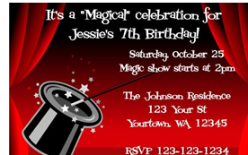  It was my birthday and it was a special occasion. I had written invitations to my friends to join me at a magical illusion show. | The illusionist arrived on the stage. He was known to be a character and was wearing a silver cloak and a chiffon scarf. He performed several illusions involving disappearing cards  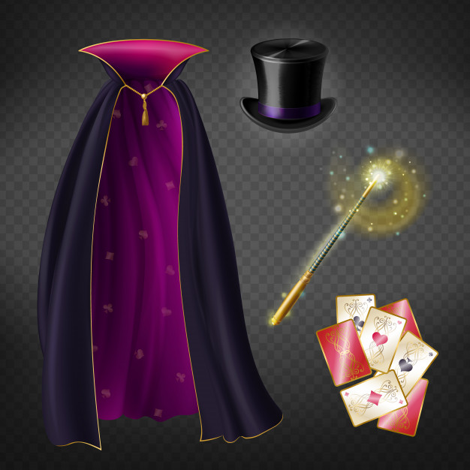
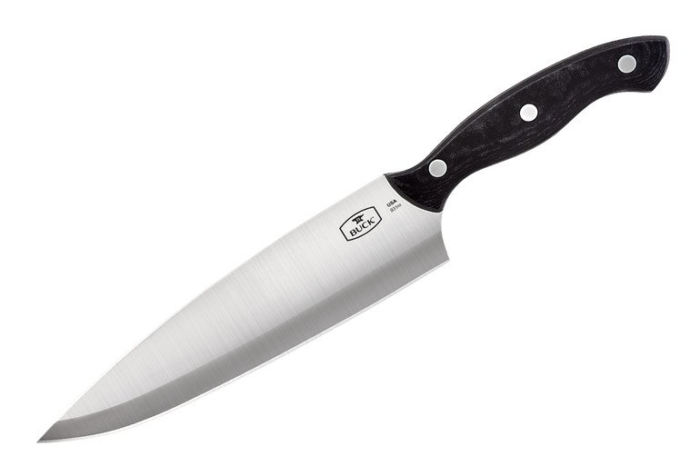  Suddenly there was an intrusion by a masked man carrying a knife.  What did he want? We tried to guess what was happening. | Without warning, there was an explosion which sounded like a bomb going off. Smoke filled the stage and it was as if our vision was blurred.    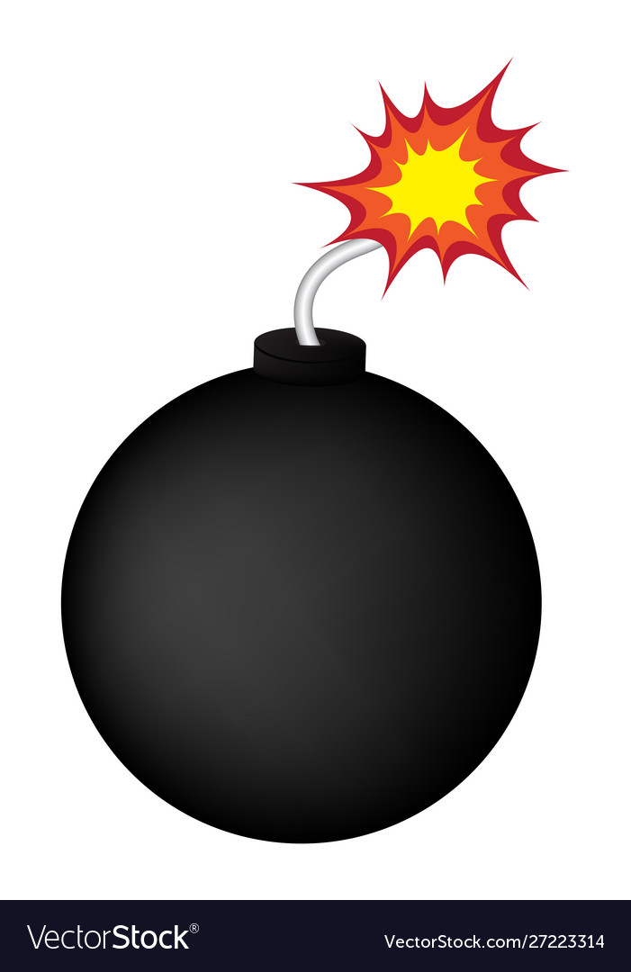
The theatre filled with tension. What was happening on the stage?!   | 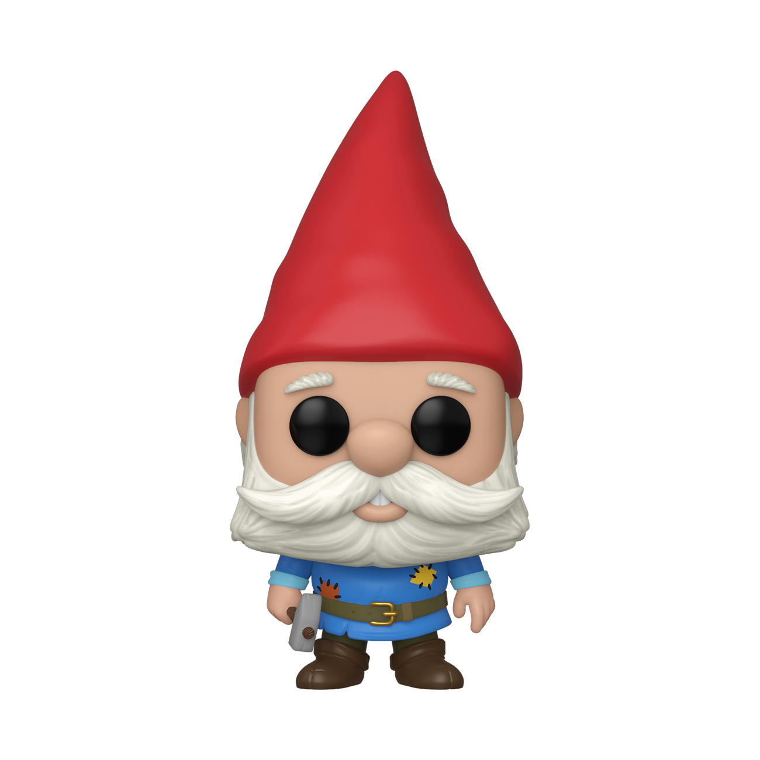  As the smoke cleared, we could see the illusionist standing there looking at a gnome in the place of the masked man.

Word List
1 |  | guess
2 | 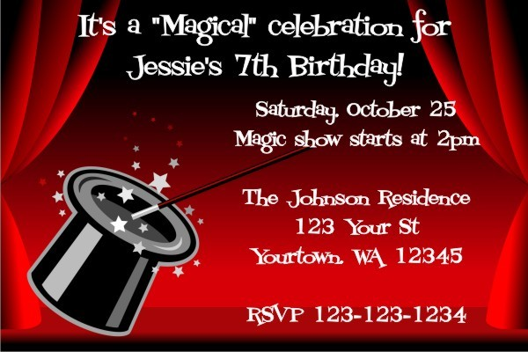 | invitation
3 |  | illusion
4 |  | knife
5 |  | explosion
6 |  | bomb
7 | 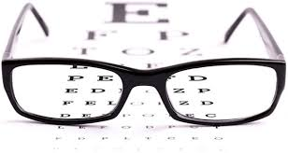 | vision
8 | 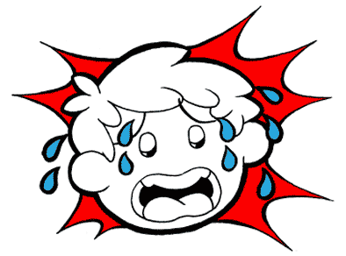 | tension
9 |  | gnome
10 |  | theatre
11 |  | television
12 |  | illusionist

Word search:

Find the following words hidden in the grid below. They could be written in either horizontal direction, up or down and along the diagonal.

GUESS INVITATION ILLUSIon KNIFe EXPLOSIOn BOMB VISION TENSIOn GNOME THEATRE TELEVISION ILLUSIONIST

J | W | Y | M | N | Y | G | N | O | M | E | M | A | A | P
T | D | K | O | O | G | B | Q | N | X | C | O | D | A | G
S | C | W | I | I | K | U | M | K | K | M | B | O | M | B
U | U | K | N | S | H | B | E | M | W | I | L | A | V | C
W | H | T | V | O | N | O | I | S | I | V | E | L | E | T
K | X | Q | I | L | H | U | M | T | S | K | Q | G | D | I
C | Z | M | T | P | I | U | E | E | A | H | N | P | G | J
L | I | N | A | X | Z | N | Z | E | U | U | J | I | K | K
E | Q | Z | T | E | S | W | M | N | N | X | H | V | F | T
X | L | J | I | I | U | P | M | Q | O | K | A | I | Z | E
L | H | X | O | V | V | N | J | W | T | I | E | E | C | Y
P | N | N | N | T | H | E | A | T | R | E | S | D | I | Y
J | L | U | N | T | O | L | L | R | W | U | F | I | V | I
S | N | O | I | S | U | L | L | I | S | W | X | P | V | A
W | T | S | I | N | O | I | S | U | L | L | I | Z | R | C

Answer Key

GUESS
INVITATION
ILLUSION
KNIFE
EXPLOSION
BOMB
VISION
TENSION
GNOME
THEATRE
TELEVISION
ILLUSIONIST

J | W | Y | M | N | Y | G | N | O | M | E | M | A | A | P
T | D | K | O | O | G | B | Q | N | X | C | O | D | A | G
S | C | W | I | I | K | U | M | K | K | M | B | O | M | B
U | U | K | N | S | H | B | E | M | W | I | L | A | V | C
W | H | T | V | O | N | O | I | S | I | V | E | L | E | T
K | X | Q | I | L | H | U | M | T | S | K | Q | G | D | I
C | Z | M | T | P | I | U | E | E | A | H | N | P | G | J
L | I | N | A | X | Z | N | Z | E | U | U | J | I | K | K
E | Q | Z | T | E | S | W | M | N | N | X | H | V | F | T
X | L | J | I | I | U | P | M | Q | O | K | A | I | Z | E
L | H | X | O | V | V | N | J | W | T | I | E | E | C | Y
P | N | N | N | T | H | E | A | T | R | E | S | D | I | Y
J | L | U | N | T | O | L | L | R | W | U | F | I | V | I
S | N | O | I | S | U | L | L | I | S | W | X | P | V | A
W | T | S | I | N | O | I | S | U | L | L | I | Z | R | C

