Ann's iPad and Dan's Hat
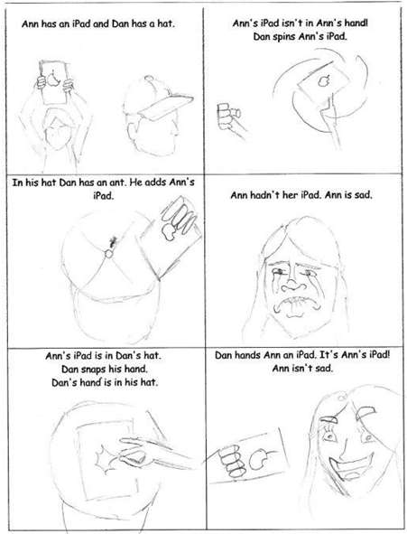
Word List
1 | 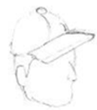 | Dan
2 | 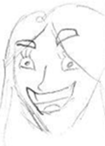 | Ann
3 | 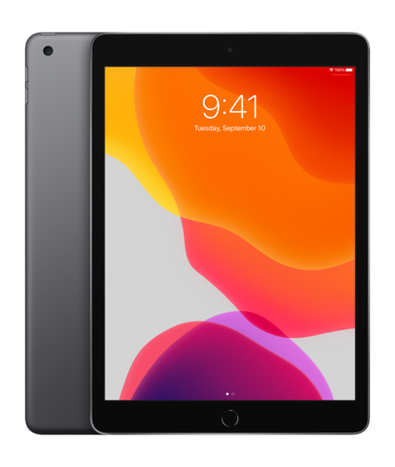 | iPad
4 |  | hat
5 |  | ant
6 |  | hand
7 | 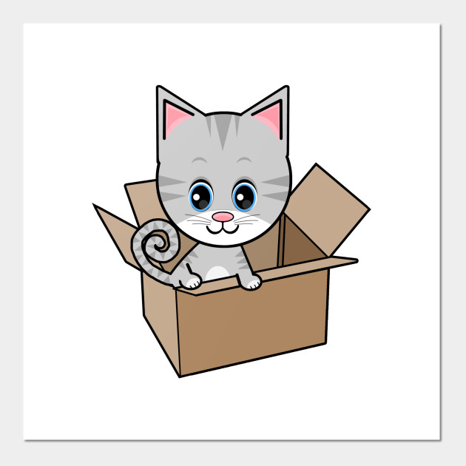 | in
8 |  | isn’t sad
9 |  | sad
10 | 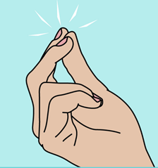 | snap
11 | יש לו | has
12 | אין לו | hasn't
Game instructions
Preparation: Make cards with the following English words on one side, and a different (not matching) Hebrew word on the back with a star.

Play: The students shuffle the cards and then place the cards with the Hebrew words and stars face up. The first card is the smiley with the start. The student reads the English word from the back of the card they chose, and the student that finds the answer in Hebrew keeps that card and turns it over to read the next word. Play carries on until the last card is turned over. The students with the most cards is the winner.

start  התחלה | שלו | ישב | אצל, ב...
אבא | רזה | בתוך | עשה
הוא | עצוב, עצובה | יד | אייפד
ה' הידיעה - סוף | כובע | זה | נמלה

thin | this | his | did
in | he | hand | ant
hat | dad | sat | and
iPad | sad | at | The end  סוף

What the fronts of the cards should look like:
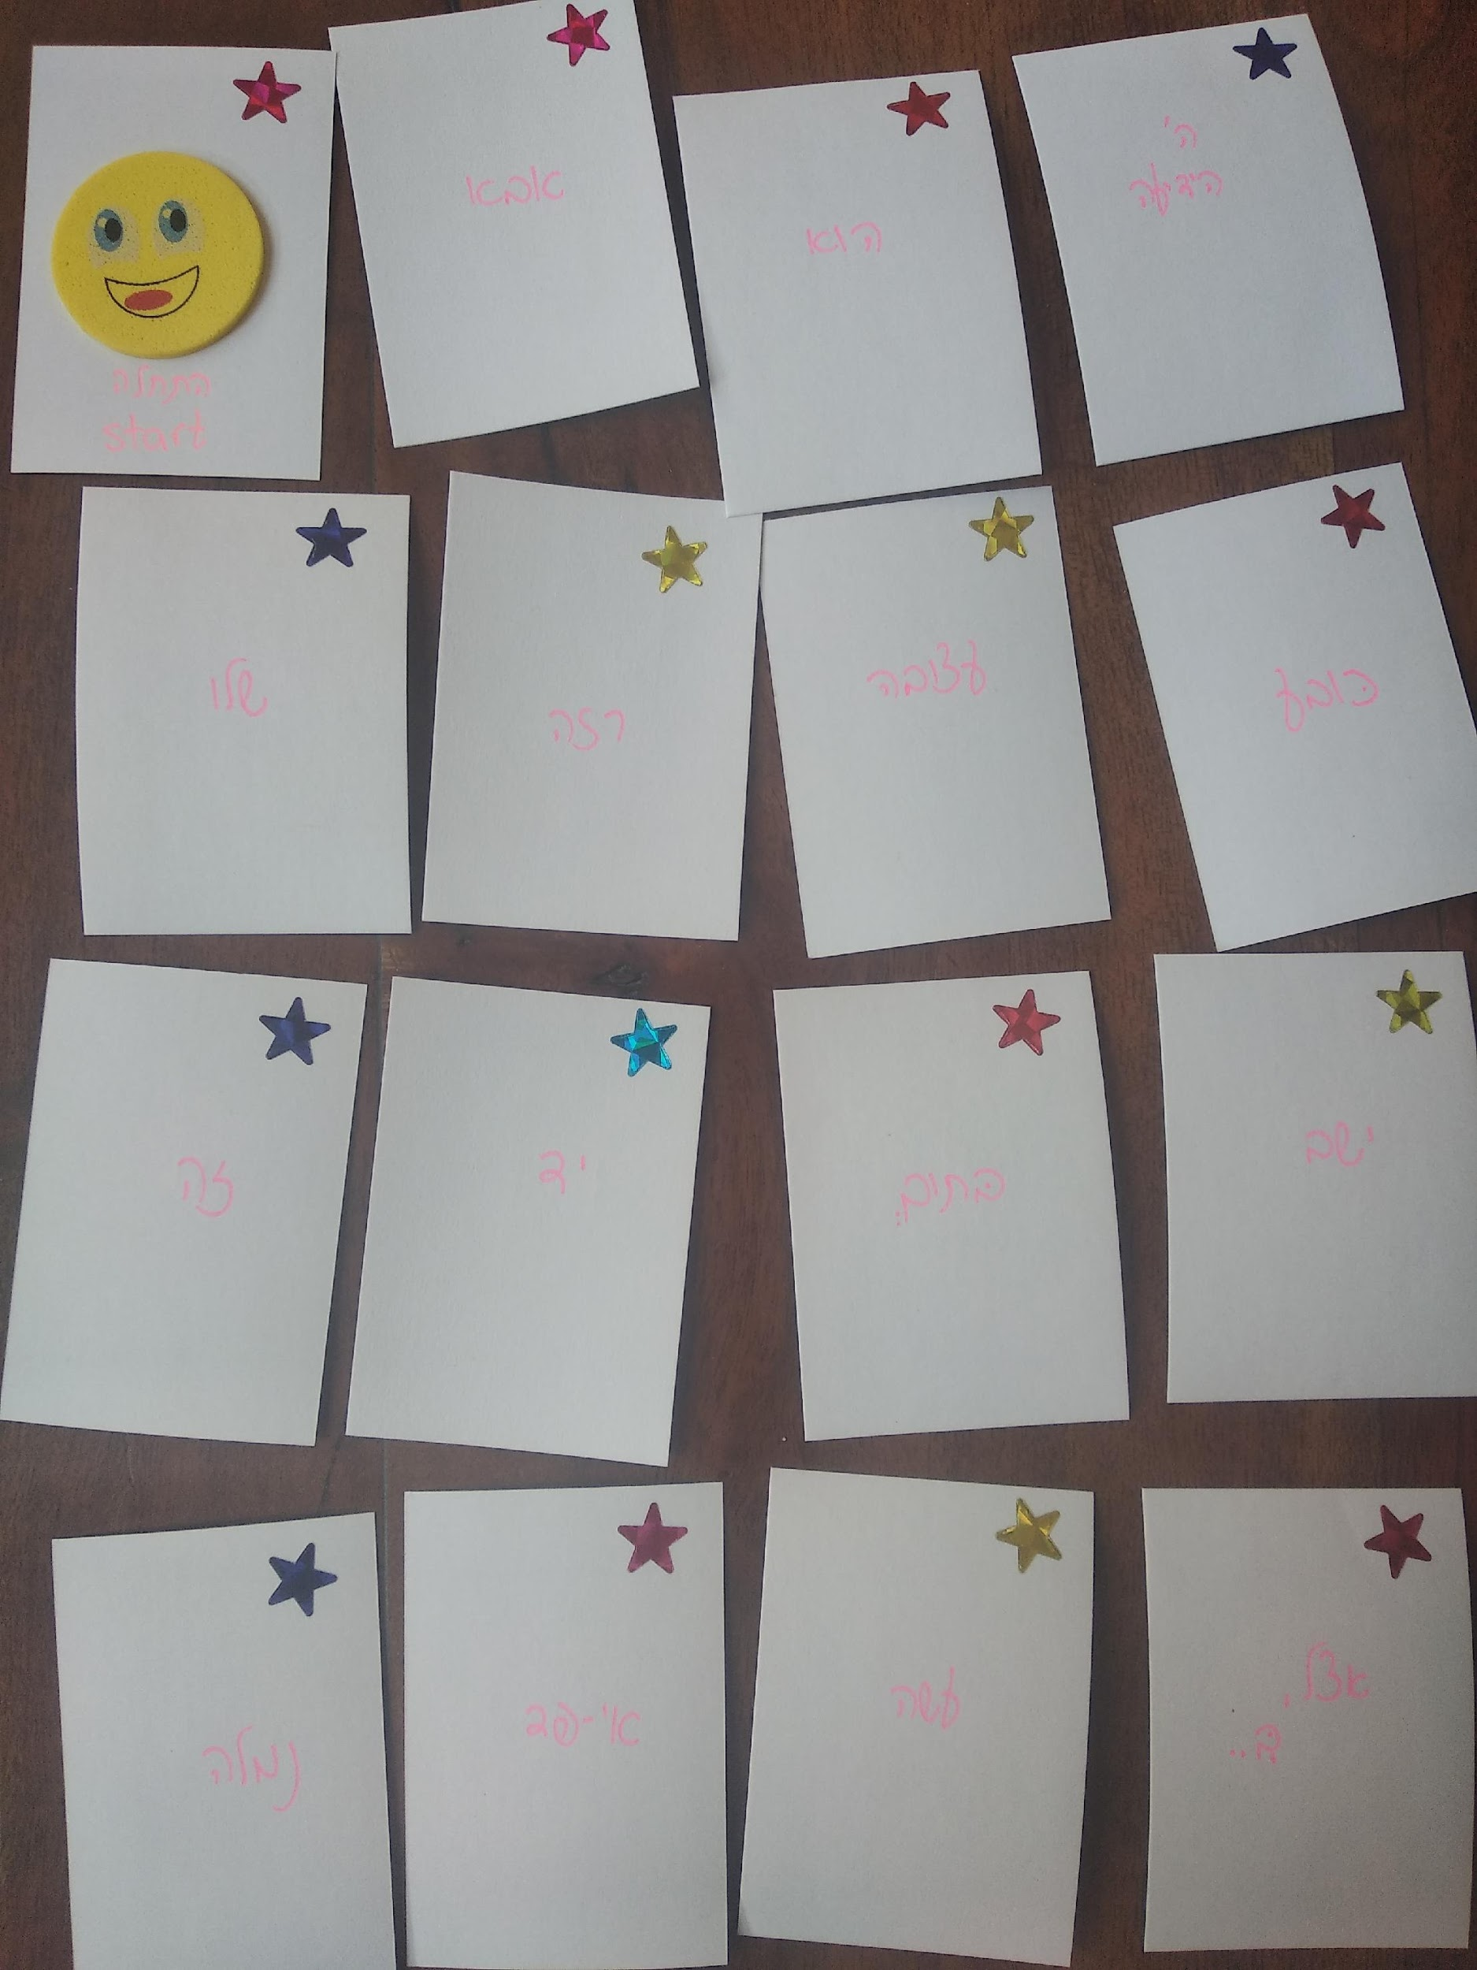

What the backs of the cards should look like:
