Fill in the missing letters:
li_ _

sa _ _

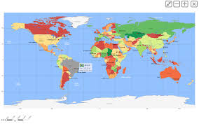 at_ _s
a_im_ _s

p_ _ nts

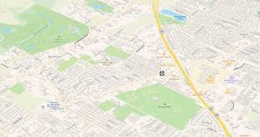m _ _

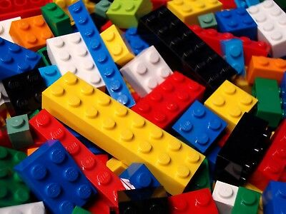_ _go

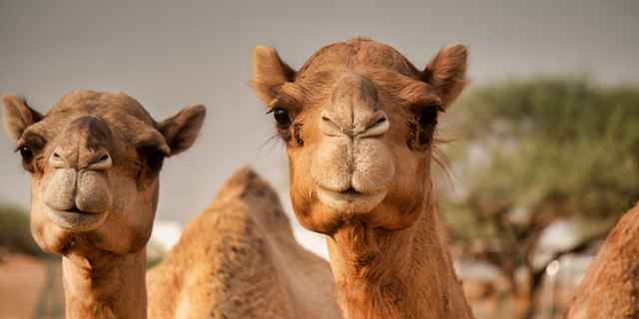c_ m_ _s

b_ _c_

Answers (from top to bottom)
like
salt
atlas
animals
plants
map
Lego
camels
black

Circle the Word
Tutor: read words aloud and ask your students to circle the word they hear. Some words appear more than once. If you want to, you can time how long it takes, then repeat and try to improve the time.
 |  | lemons
plants | planet
 |  | plan
black | plants
 |  | salt
lemons | black
 | salt | planet
camel |  | plants
 | lemons | black
salad | camels
 |  | planet
 | salt
lamp
 | plan | blast
planet
 | blast | planet
salt
 |  | salad
salad | plants
plants |  | lemons
 | salad
 |  | salad
black
 | salad | lamp
salad
 |  | black
black | plants

