Fifi the Cat and Alfred the Fish
Alfred is Mike's fish. He is in a pan.  The sly, fat cat Fifi bit Alfred the fish. She and Alfred sat in a red hat.  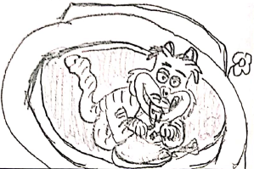 | Mike came back and set the fan:  -spin, spin, spin-  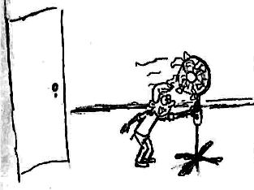
The fan flips the red hat! Then the red hat fell and the sly cat Fifi ran.  Mike is mad at Fifi. She bit his fish!  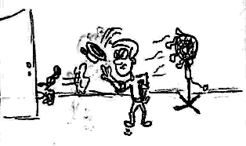 | Alfred the fish flips, then rests.  He is dry.  Mike said, "My fish! Back in the pan!" Alfred isn't dry. Fantastic!  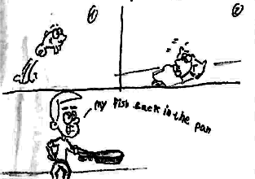
That sly cat Fifi left. She ran fast. Mike is mad at Fifi! She bit his fish.  Can he kick Fifi?  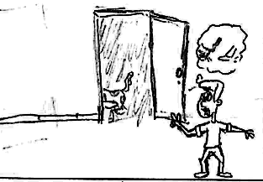 | Mike didn't kick Fifi.  The happy cat ran and ran.  She hadn't any fish.  She said, "mmm, it's me, myself and I!"  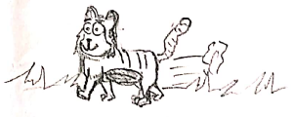

Word List
1 |  | Fifi
2 |  | fat
3 |  | fish
4 |  | Alfred
5 |  | fan
6 |  | fell
7 |  | Mike
8 |  | left
9 |  | fast
10 |  | kick
11 |  | fantastic
12 |  | myself

Memory Game
Here are two versions of the "concentration" game, for weaker and stronger pupils.
Some alternative games are:
- Counting Words - How many times do particular words appear in the story? A contest.
- Who can find the word [ask about one of the f words]? How many times?
Weaker pupils: : The students need to match the words to their pairs. They need to turn over a card, read it correctly and then find it's pair.
Print two copies of this set of cards, laminate or glue to heavy paper, and cut out.

fast | fan | Fifi
kick | fell | fat
fantastic | Mike | fish
myself | left | Alfred

Stronger pupils: The students need to match the words to their translation in Hebrew. They need to turn over a card, read it correctly and then translate it.

Print one copy of the above set of word cards, and one copy of the following cards that contain the translations of the above words:
מהיר | מאוורר | פיפי
בועט | נפל | שמן
פנטסטי | מייק | דג
אני, עצמי | עזב | אלפרד

