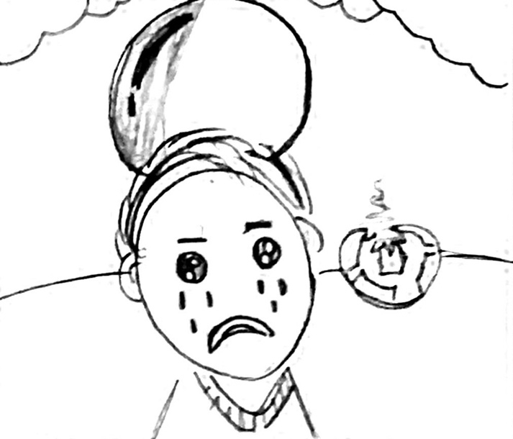
Tom’s Football
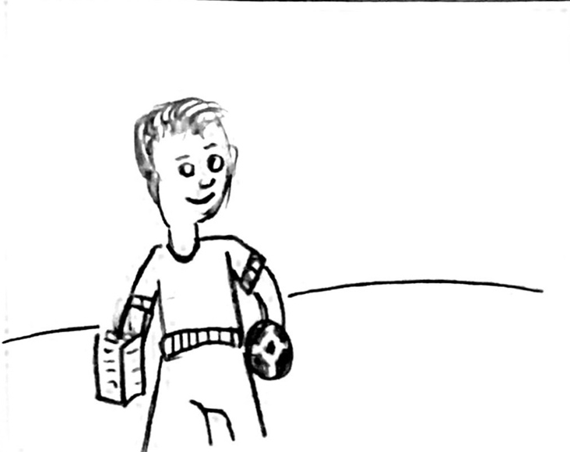  Tom is good-looking and tall. He loves football and cooking. | Tom isn’t happy. His football is torn. He can’t kick it into the net.
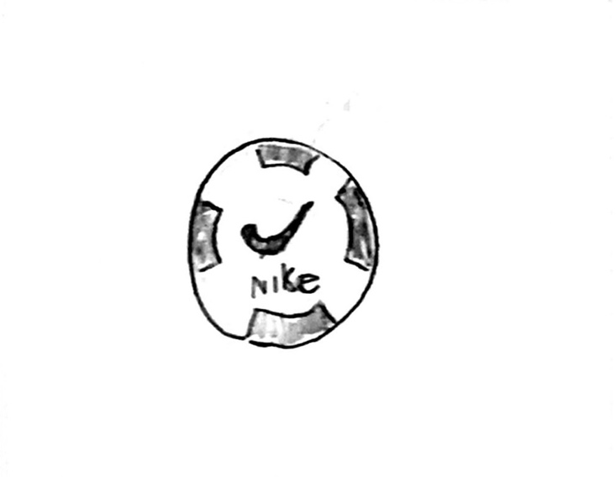  Tom’s mum* gave him a Nike football to make him happy. | 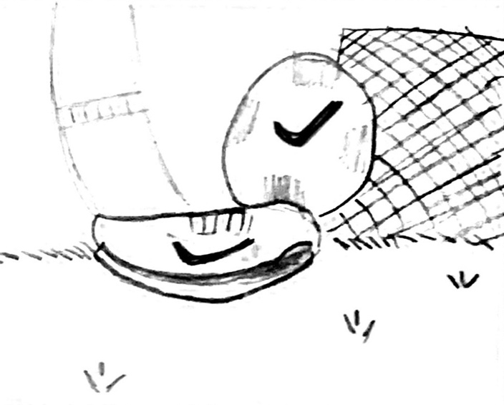  Tom quickly took his football to the garden. He runs and kicks it into the net and has a good time.
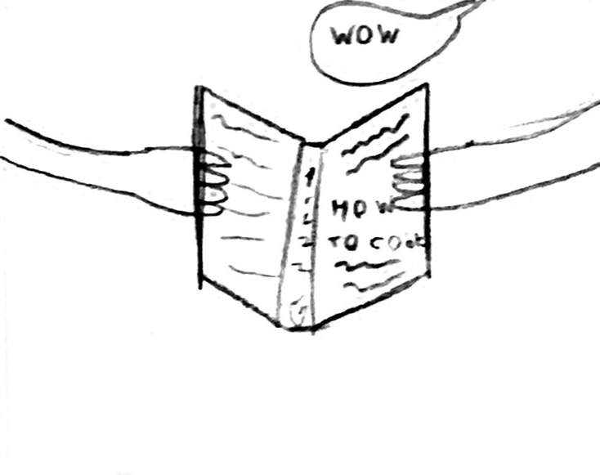  Tom comes inside and looks in his cooking notebook. He cooks a snack for his family. | 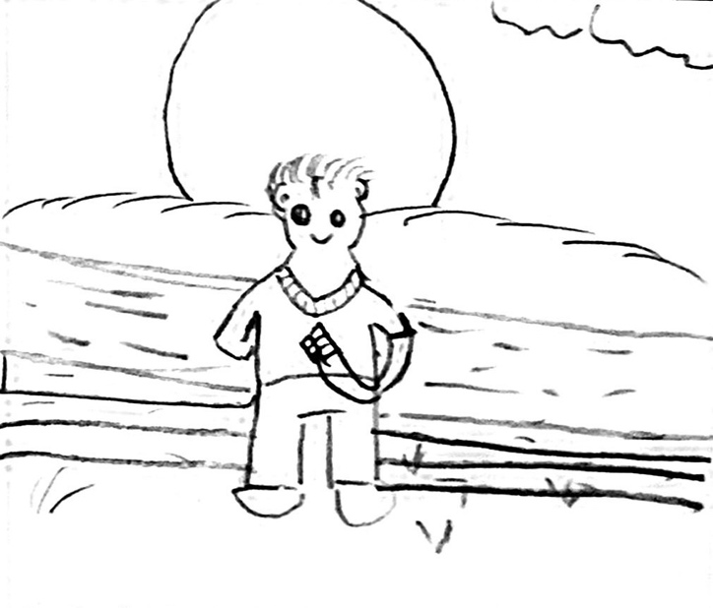  Tom then sat on the wooden steps and ate his snack. He felt good.
*“Mum” is the British version of the American “Mom”

Word List
1 | 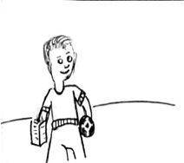 | good-looking
2 | 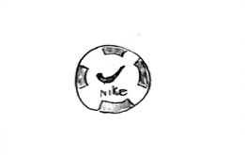 | football
3 | 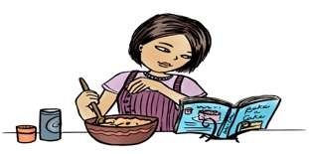  This Photo by Unknown Author is licensed under CC BY-NC-ND | cooking
4 | TOOK | took
5 |  | good
6 | This Photo by Unknown Author is licensed under CC BY | looks
7 | 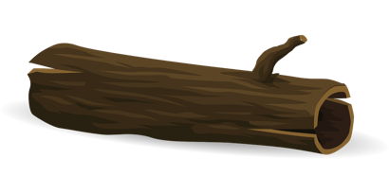 | wooden
8 | 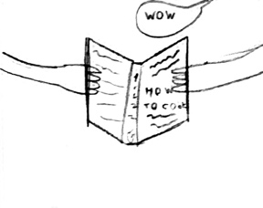 | notebook
9 | This Photo by Unknown Author is licensed under CC BY-SA | happy
10 | 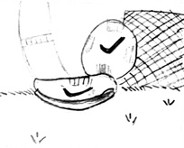 | kick
11 | 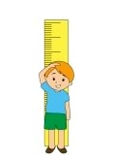  This Photo by Unknown Author is licensed under CC BY | tall
12 |  | loves

Game to print and play on paper:

Missing word sentences.
See page below for word bank.

- Tom is ____________ - ____________ and tall.

- Tom loves football and _______________.

- Tom isn’t ____________.

- Tom’s mum gave him a Nike ______________ to make him happy.

- Tom quickly ______________ his football to the garden.

- Tom comes inside and ___________ in his _________ notebook.

- Tom then sat on the ______________ steps and ate his snacks. He felt _____________.

Cut out the words below to put into the sentences above.

Sentence 1 | looks | goods | looking | good
Sentence 2 | cook | cooking | football
Sentence 3 | tall | happy | good
Sentence 4 | notebook | football | snack
Sentence 5 | took | looks | kick
Sentence 6 | cooking | looks | look | cook
Sentence 7 | garden | good-time | good | wooden

Online game – missing word - Hickey lesson – 36a – short oo

Please click link below to go directly into the online game for lesson 36a – short oo vowel sound.

https://wordwall.net/resource/28618140

You can also go to the site www.wordwall.net and use the magnifying glass/search function at the top of the screen to search for the game under the title, Hickey lesson – 36a – short oo. Navigate to the option with the subtext “Missing word
by Shaneenikolaou”

