My Friends' Journey
Honey?  I wanted to ask you…  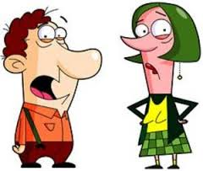 |       Where is Lindsey?  Where is Joey?  Where is Whitney?  Where is Britney?
Where is everybody?   | I need their apartment key!  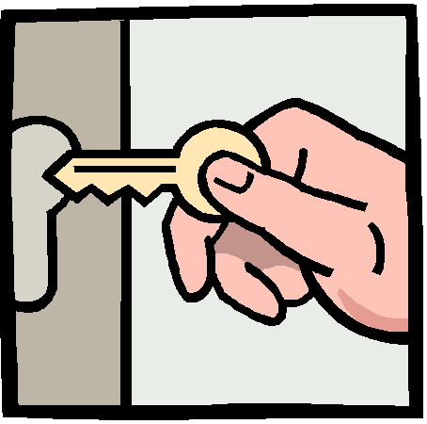
  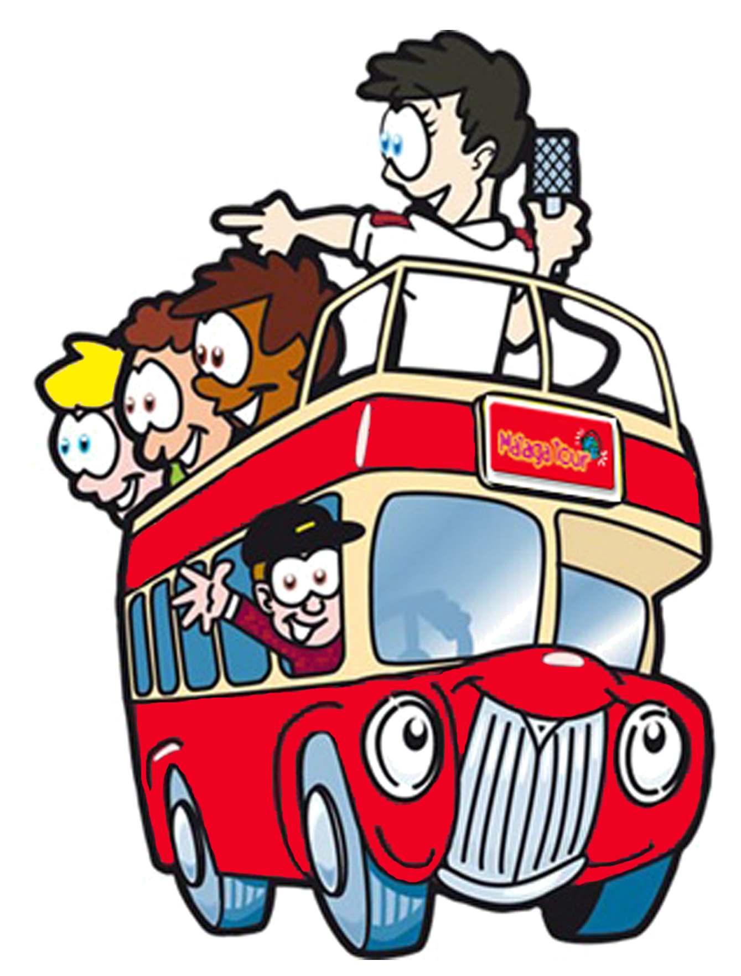  Haven't you heard?  They are on a short journey in a valley near the border in Turkey. | Wow! It probably cost them a-lot of money…  
I hope they'll send us pictures of some of the beautiful sites out there.     | Yeah! And some of the unique donkeys, monkeys and turkeys that live there.    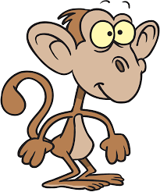  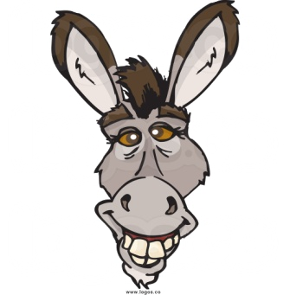  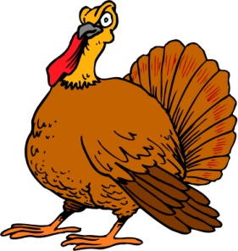

Word List
1 | 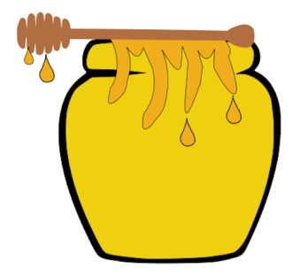 | honey
2 |  | Lindsey
3 |  | Joey
4 |  | Whitney and Britney
5 |  | money
6 |  | key
7 |  | journey
8 |  | valley
9 | 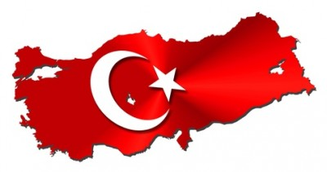 | Turkey
10 |  | donkey
11 |  | monkey
12 |  | turkey

Game 1: Concentration (cut out cards, shuffle, match word to picture)
 | turkeys
 | honey
 | monkey
 | Lindsey
 | Joey
 | Whitney & Britney
 | money
 | key
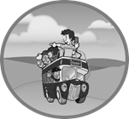 | journey
 | valley
 | Turkey
 | donkey

Game 2: Word Sort
Laminate and cut up the word cards (words ending in the –ey and other long e spellings), and the two boards. Put the words in a bag and give each player a board.
Have the learner pick the words out of the bag and read them aloud. Find the picture to match the word on the board. The player who fills her board first is the winner.

-ey words

honey | Turkey | turkey | journey
monkey | donkey | money | key
valley

Other long e endings
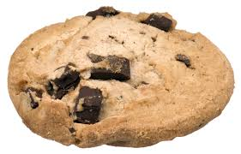 |  | 
 | 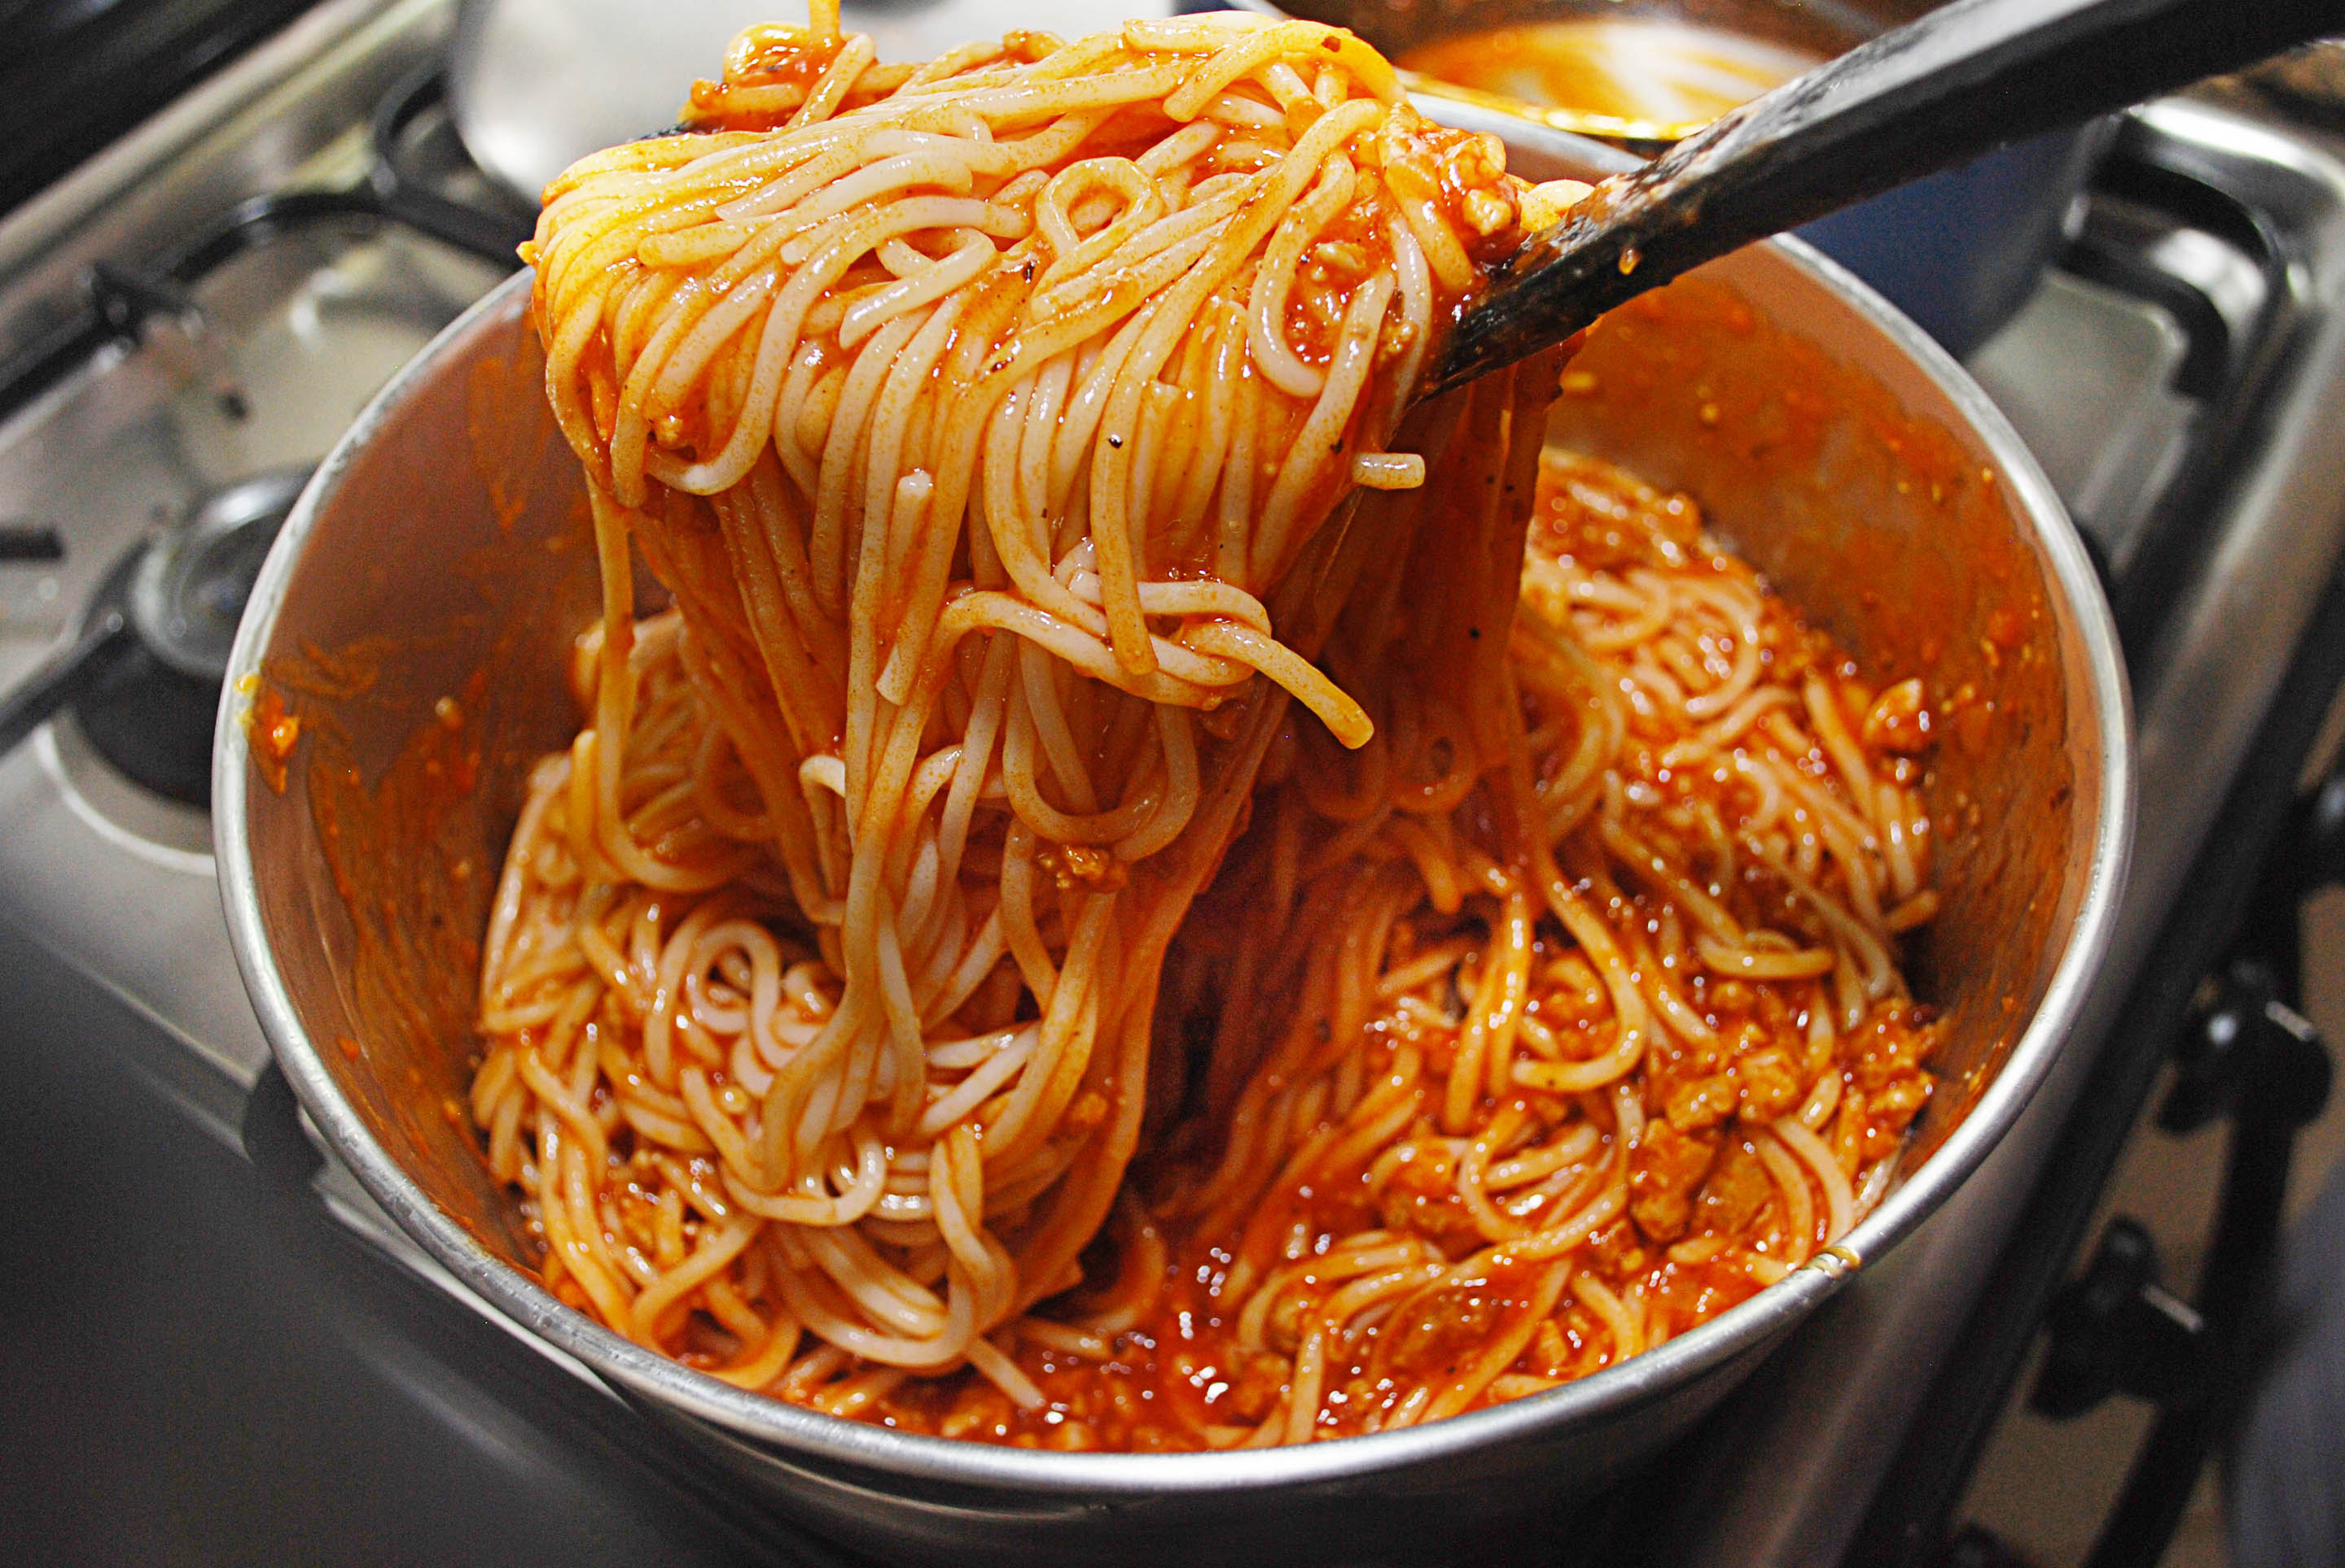 | 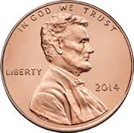
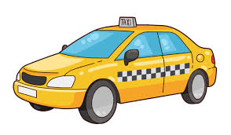 |  | 

cookie | coffee | candy | funny
penny | taxi | spaghetti | lady
see

