The Boat in the Clean Sea
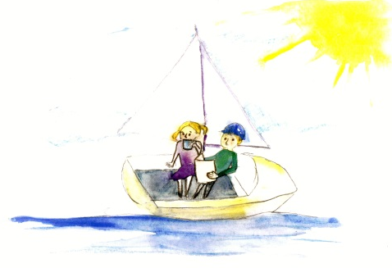  It is a nice day. The sun shines.  Gail and Dean sail on a boat in the open sea. Dean reads a book and Gail sips hot tea. | 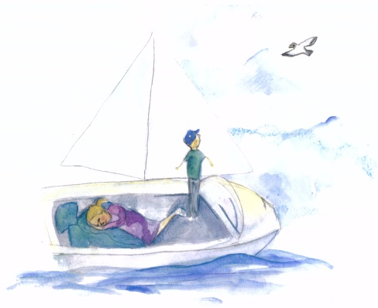  Gail lays her coat on the floor of the boat and lies on it. Dean looks at a seagull soaring in the sky!
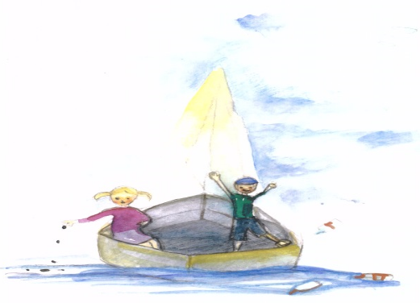  Gail eats seeds and tosses the shells from the boat, and Dean kicks bottles off the end of the boat. They fall into the sea. Goal! | 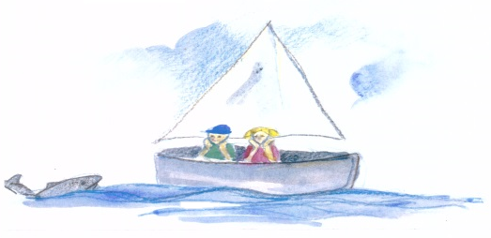  Just then a big tail splashes beside the boat. Gail's coat gets wet. Afraid, Dean screams. A giant shark pops up beside the boat and wails a mean roar!
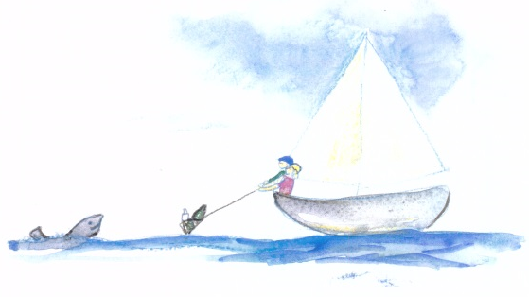  "This is my home, you are visitors!  I am not mean, but my goal is to keep my  home clean. Please take an oath to keep the sea clean, and clean the sea near the boat as a team.” | 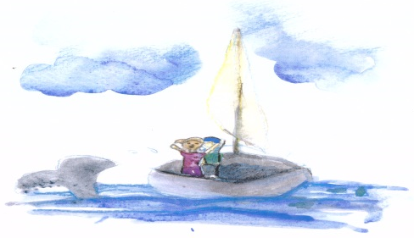  Dean and Gail toss a net in the water and clean up all the trash they tossed from their boat. The shark smiles and says, "Thank you! Your boat may stay!" Then he flips his tail and dives back into the sea beneath the boat.

Word List
1 | 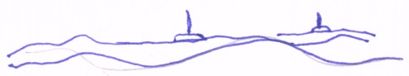 | sea
2 | 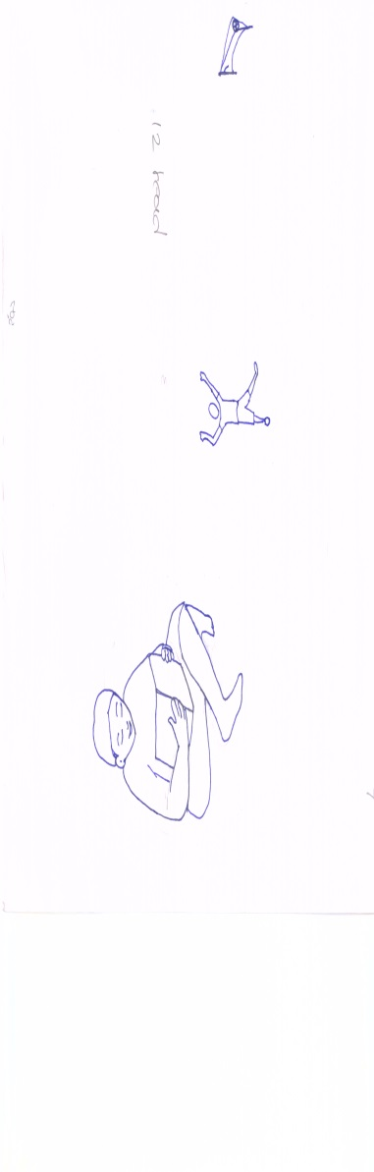 | read
3 | 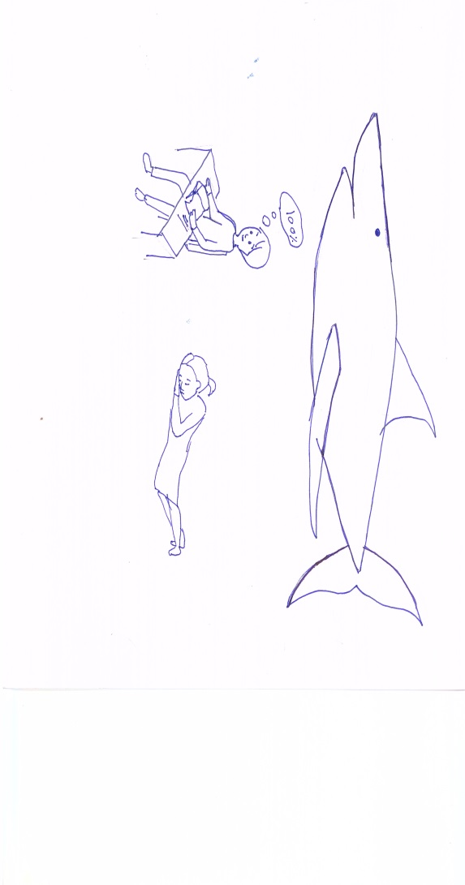 | lie
4 | 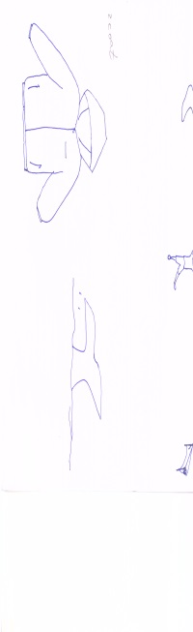 | coat
5 | 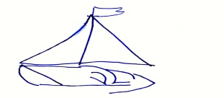 | boat
6 | 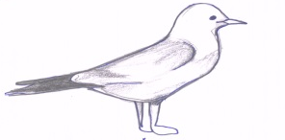 | seagull
7 | 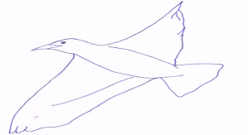 | soar
8 | 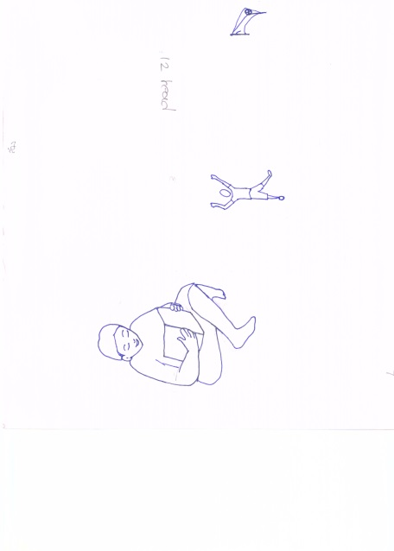 | goal
9 | 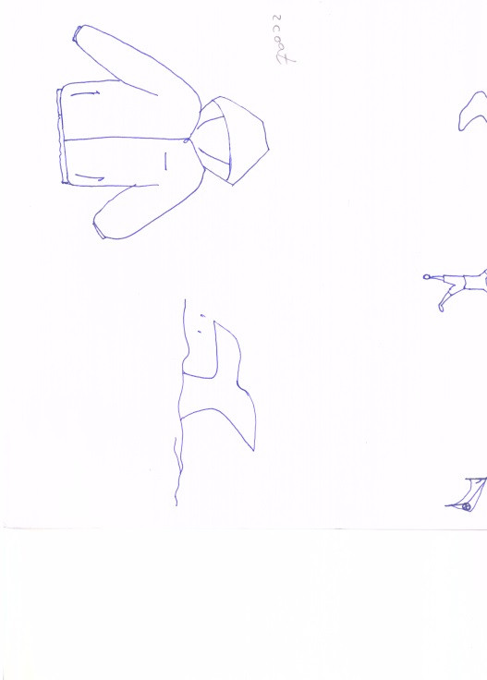 | tail
10 | 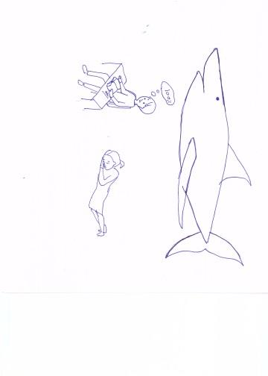 | shark
11 |  | goal
12 | 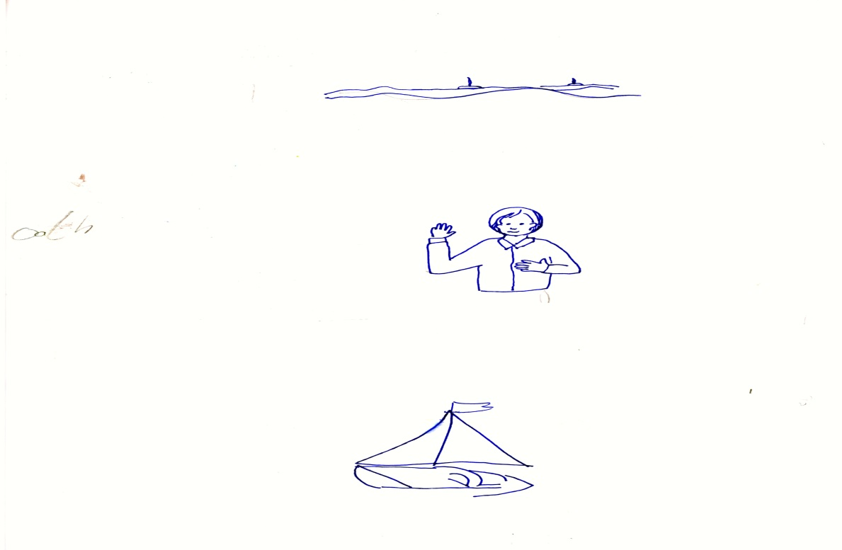 | oath

Game: Sequencing Sentences

Preparation: Laminate or glue onto stiff backing. Cut the following sentences into strips, one strip per sentence.

How to play: The student has a pile of strips with a sentence from the story on each one. Their job is to put the sentences in order according to the sequence in the story.

Play the game only after they have studied the story and learned the new words.

Here are the sentences in the correct order (the answer key):

The Boat in the Clean Sea

Dean reads a book.

Dean kicks a bottle off the end of the boat. "Goal!"

A giant shark pops up beside the boat.

"My goal is to keep my home clean."

Dean cleans up all the trash he tossed from the boat.

"Your boat may stay."

