Word List
 | Rhonda | 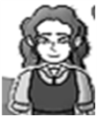 | 1
 | rhino | 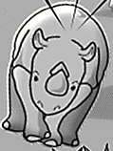 | 2
 | Rhett |  | 3
 | fond |  | 4
 | rhinestones | 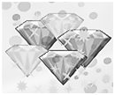 | 5
 | rhombus | 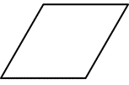 | 6
 | rhodium | 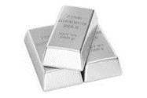 | 7
 | charm | 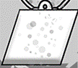 | 8
 | rhyme | meet  neat  Pete  sweet | 9
 | rhythm | 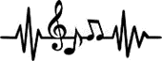  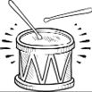 | 10
 | rhubarb | 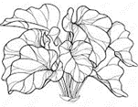 | 11

RHONDA THE RHINO KEEPER — Word Bingo (4x4 Grid)
Teacher’s Instructions:
Objective:
Word Bingo is designed to reinforce vocabulary by boosting word recognition and spelling through a familiar, fun, and interactive game.
Materials:
- Four Printed and Laminated Bingo Boards (4x4 grid)
- Dry-erase markers or chips for students
- Word list for calling out
Preparation:
- Print Bingo boards. Glue to stiff paper. Laminate if desired.
- Prepare the following word list to call out during the game:

Word List:

- charm
- fond
- licked
- Rhett
- rhinestones
- rhino
- rhodium
- rhombus
- Rhonda
- rhubarb
- rhyme
- rhythm
- shouted
- sniffed
- toxic
- treat

How to Play:
- Distribute laminated Bingo boards and dry-erase markers/chips to students.
- Call out words from your list (one at a time).
- Students mark the word on their board if they have it.
- The first student to complete a full row, column, or diagonal shouts “Bingo!”
- Verify the Bingo board and play another round!

Tip:
Use dry-erase markers on laminated boards so the boards can be reused.
Use chips such as coins or cut-out paper squares for non-laminated boards.

RH BINGO BOARD 1
rhodium | meet  neat  Pete  sweet  treat | shouted | rhythm
charm | licked | rhubarb | 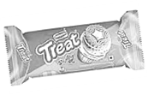
 | Rhett | toxic | rhinestones
sniffed | fond |  | Rhonda

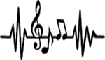 | rhombus | 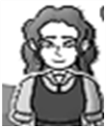
 | sniffed |  | treat
shouted |  | Rhett
 | licked |  | rhyme
RH BINGO BOARD 2

RH BINGO BOARD 3
 | rhombus | shouted | rhyme
rhodium |  | rhythm | treat
rhinestones | sniffed | Rhonda
 | licked |  | toxic

 | Rhonda | rhyme | charm
meet  neat  Pete  Sweet  treat | rhino |  | rhubarb
sniffed | Rhett | Treat
rhythm | fond |  | shouted
RH BINGO BOARD 4

