Gail and Craig Visit the Farm
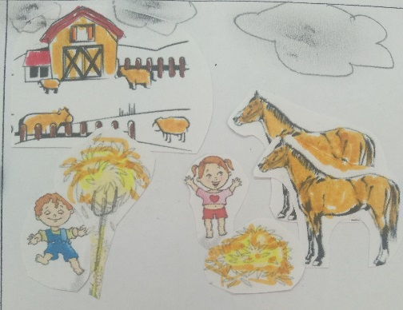  The horses are waiting to be fed. Gail feeds the horses and Craig cleans the barn. | 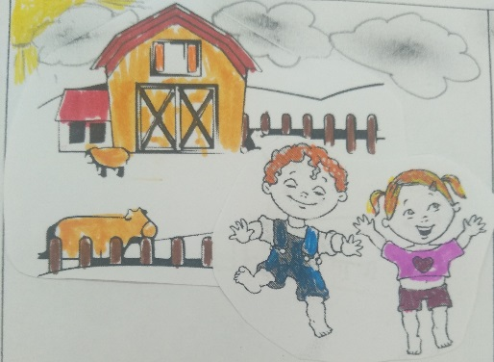  Gail is Craig's sister. Today it may soon rain, but they visit a farm. They help the people in the farm.
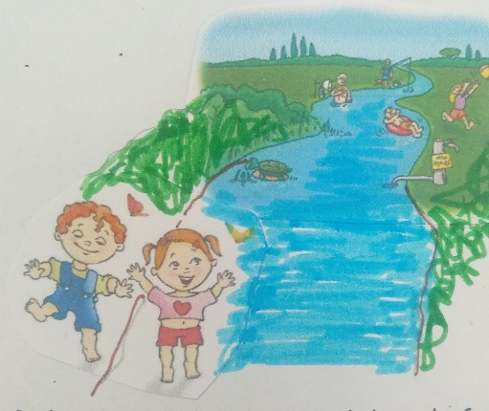  Gail and Craig are done. Gail doesn't feel faint. They go to swim in the river together. | 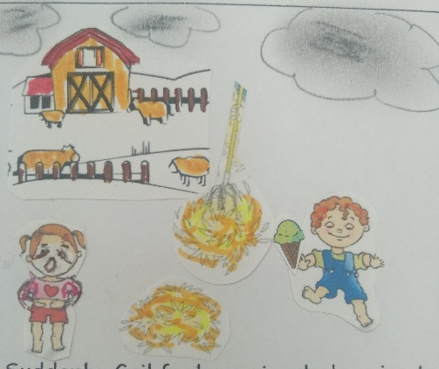  Suddenly, Gail feels a pain, she's going to faint… Craig gives Gail an ice cream and soon Gail feels better, she's not afraid.
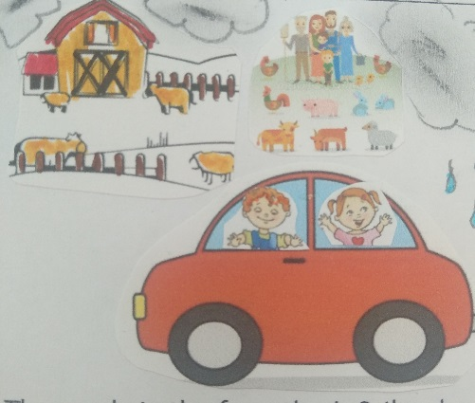  The people in the farm thank Gail and Craig. They said: "Wait! Stay! But if you must go, please come to visit again!" | 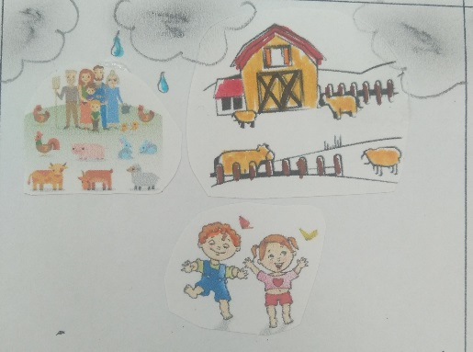  The people in the huge farm love Gail and Craig but it's time to go home before it rains.

Word List
1 | 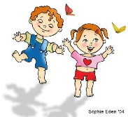 | Gail
2 |  | Craig
3 | 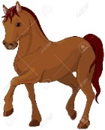 | horse
4 | 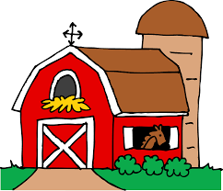 | barn
5 | 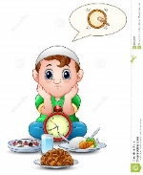 | wait
6 | 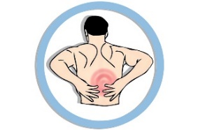 | pain
7 |  | faint
8 |  | ice cream
9 |  | afraid
10 |  | huge
11 |  | rain
12 |  | again
Memory game:
Match the word to the picture that describes it.
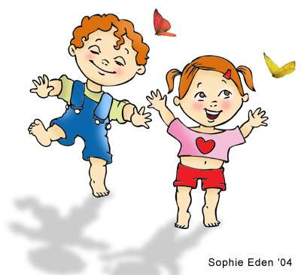 | Gail
 | Craig
 | horse
 | barn
 | wait
 | pain
 | faint
 | ice cream
 | afraid
 | huge
 | rain
 | again

