Yams at the Camp
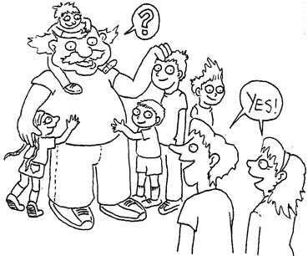  ”Can the kids and I camp?” asks Sam.  ”Yes!” said Nan and Ken. | 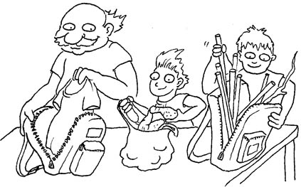  Sam and the kids pack their backpacks.  They pack yams in a sack.  They pack sticks.
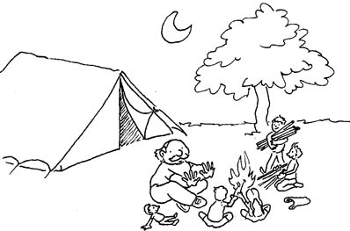  They camp in their tent. | 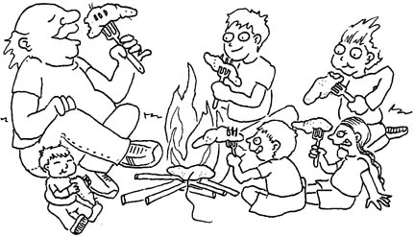  They had the yams at the camp.  Yams are the best camp snack!
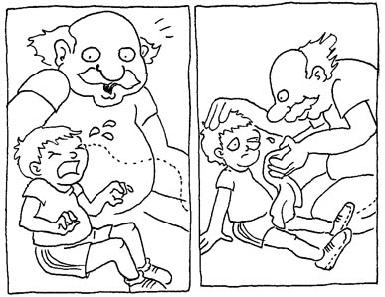  An ash is in Ben’s eye.  Ben’s eye is red. Sam is there. | 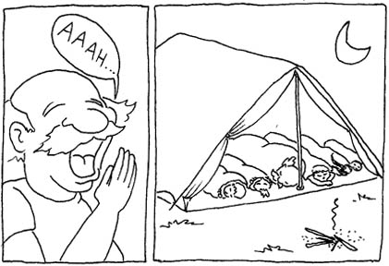  “Can I rest yet?” Sam asks.  “Yes,” the kids said.  They rest in the tent.

1 | 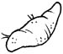 | yam
2 | 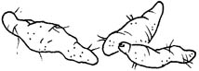 | yams
3 | 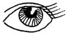 | eye
4 | 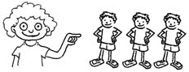 | they
5 | 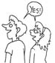 | yes
6 | 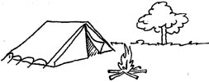 | camp
7 | 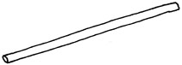 | stick
8 | 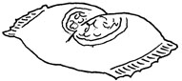 | snack
9 | 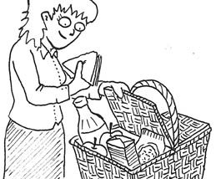 | pack
10 | 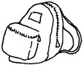 | backpack
11 | 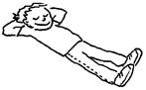 | rest
12 | 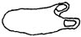 | sack

Crossword Puzzle
Use the picture clues to fill in the words across and down:

 |  |  | 1. |  |  |  | 3. |  |  |  | 14.
 |  |  |  |  |  |  | 6. |  | 7.
 | 13.
 |  |  | 2. | 4. |  |  |  |  | 12.
 |  |  |  | 5. |  |  | 8. |  |  | 15.
 |  |  |  |  |  |  | 9.
 |  |  |  |  |  |  | 11.

Picture Clues:
Down: | Across:
1. | 1.
3. | 2.
4. | 5.  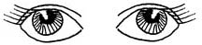
7.  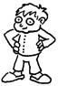 | 6.  
8. | 9.  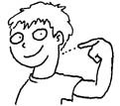
13.  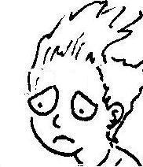 | 11.
14.  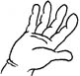 | 12.  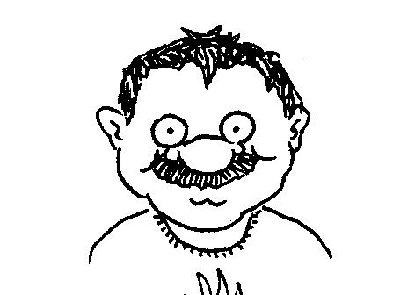
15.  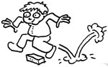 | 13.  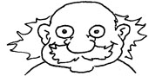

Crossword Puzzle Solution:
Check your finished puzzle against this solution:

 |  |  | 1.  y | e | s |  | 3.  s |  |  |  | 14.  h
 |  |  | a |  |  |  | 6.  a | s | 7.  k |  | a
 | 13.  S | 2.  a | m |  |  |  | c |  | i |  | n
 | a |  | 2.  s | 4.  t | i | c | k |  | 12.  d | a | d
 | d |  |  | h
 |  |  |  | 5.  e | y | e | 8.  s |  |  | 15.  s
 |  |  |  | y |  |  | 9.  n | e | 10.  c | k
 |  |  |  |  |  |  | a |  |  | i
 |  |  |  |  |  |  | 11.  c | a | m | p
 |  |  |  |  |  |  | k

