Kate’s Cake
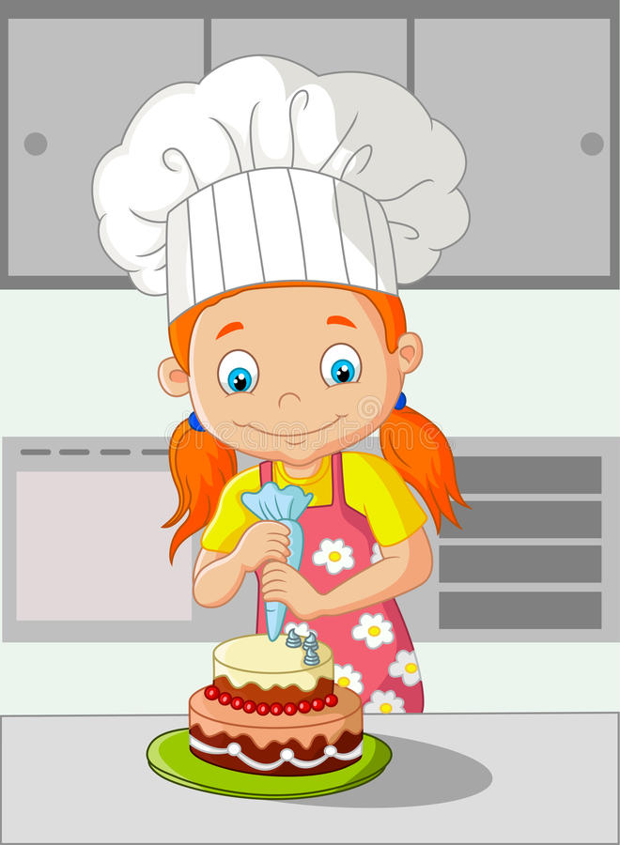  My name is Kate. I bake fantastic cakes. | 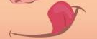  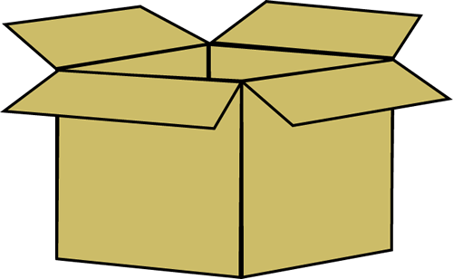  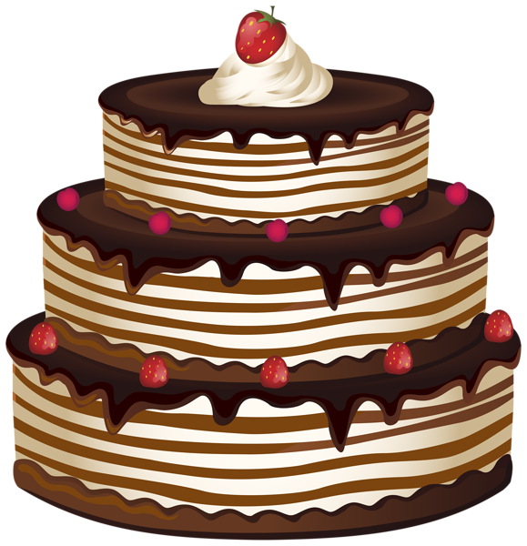  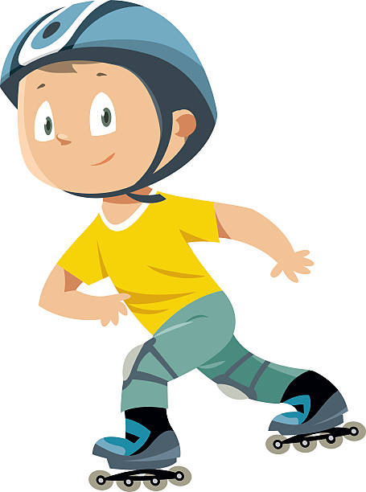  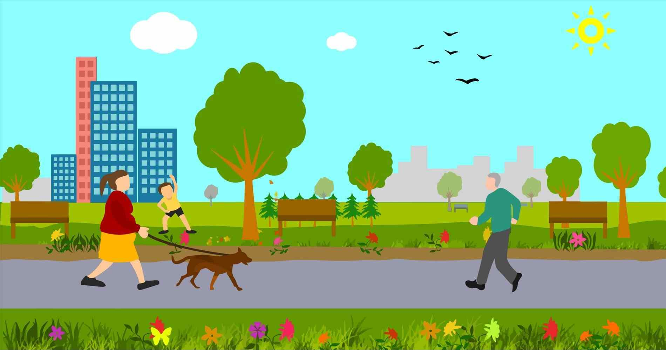  Nate likes cakes. He takes my cake and escapes in skates!
  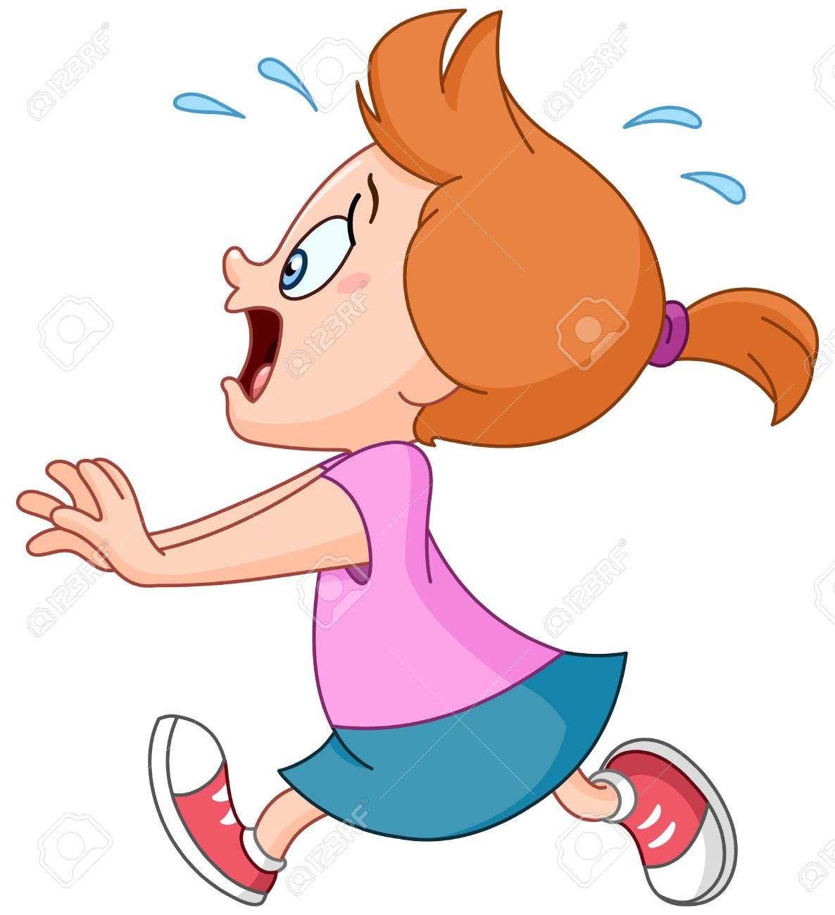  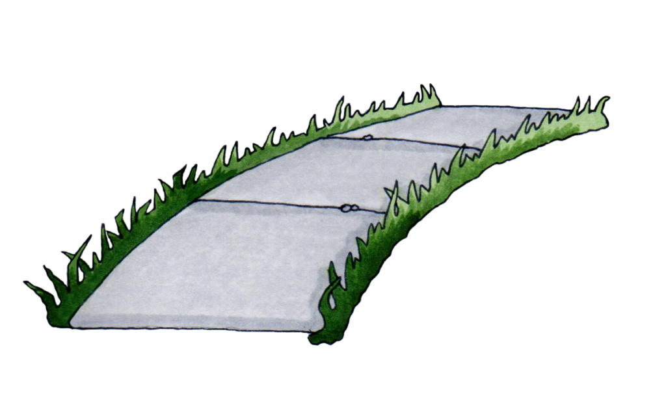  Nate skates happily by the park. He has my cake! I am helpless. I can’t skate. | 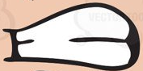  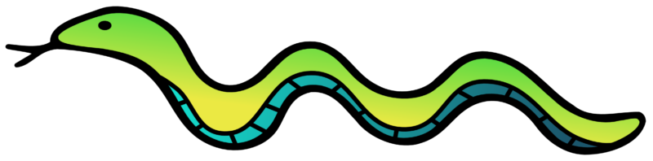  A snake passes Nate’s path.  Nate hates snakes.
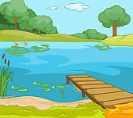  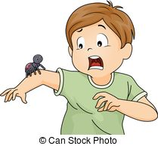  ssss…  The snake hisses. Nate panics and falls in a lake by the park. | 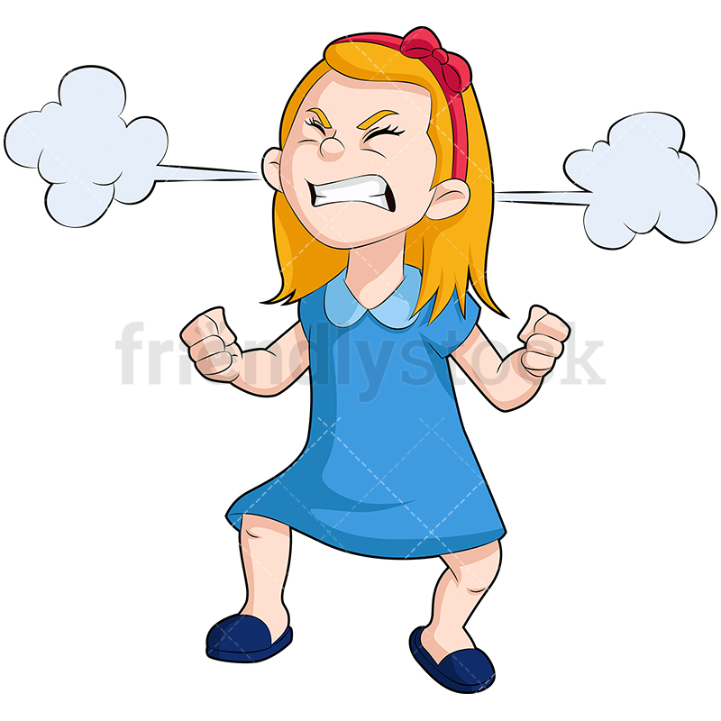  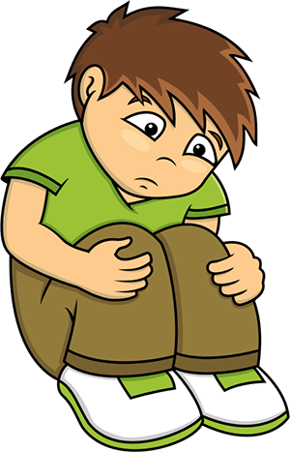  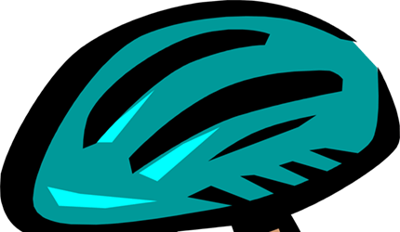  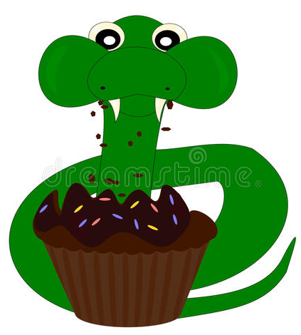  I came late. The snake ate my cake. I am mad. Nate is sad. He made a mistake.

Word List
1 |  | Kate
2 |  | cake
3 |  | Nate
4 | 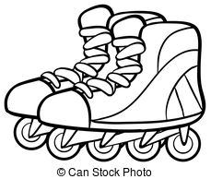 | skates
5 |  | escape
6 |  | snake
7 |  | path
8 | 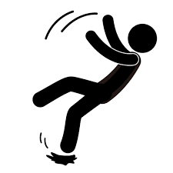 | fall
9 | 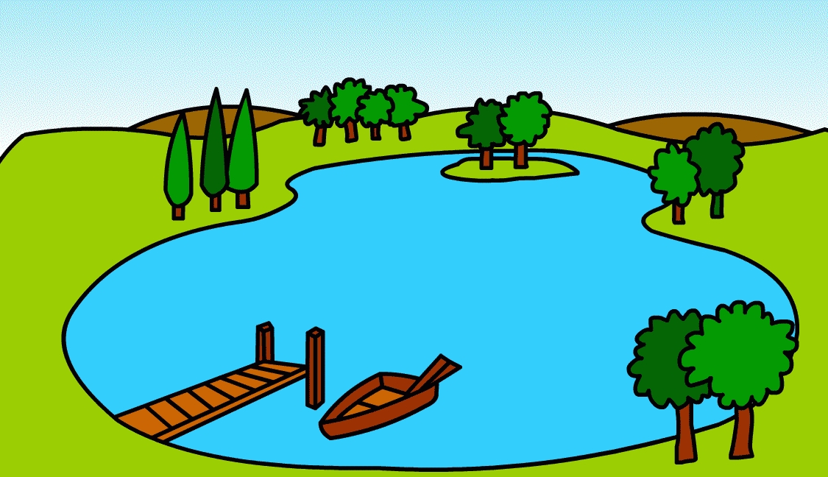 | lake
10 |  | park
11 | 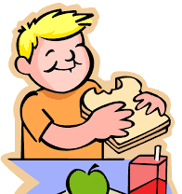 | ate
12 |  | late

Game: Two-Piece Puzzle
How to play: Match halves!
Kate | cake
Nate | skates
escape | snake
path | late
  mistake | ate
sad | mad

