A Furry Surprise
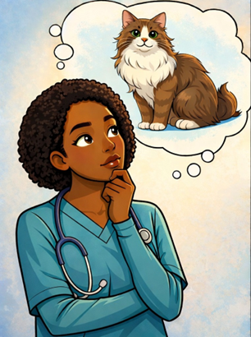  Ella’s friends know that she wants a purple purse – and a very furry cat. | 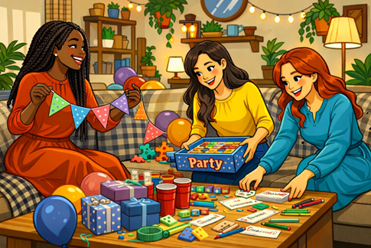  Ella is a nurse. She returns home after five every Thursday and Saturday. Her friends will have a surprise party for her next Thursday.
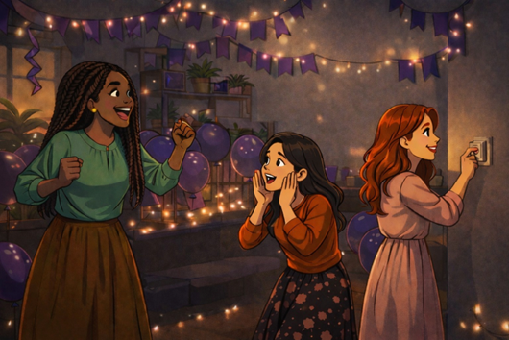  It is almost time for the party. Tamar says, “Ella will return home soon.” Mazal and Sara shout, “Hurry! Turn off the lights!” | 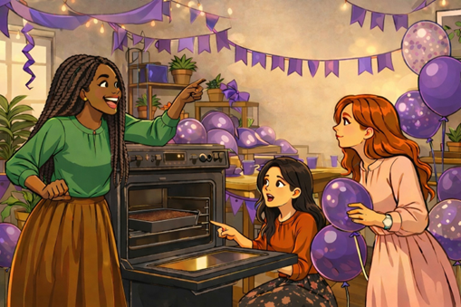  It’s Thursday! Tamar and Sara are  frying burgers together.  Mazal shouts, "Don’t burn the burgers!”
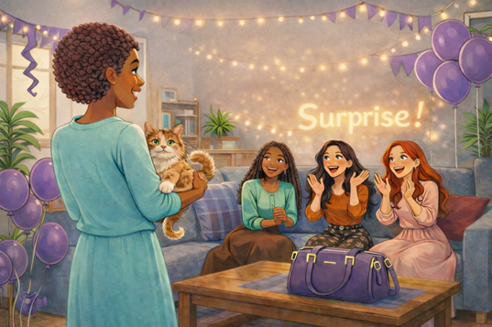  Ella says, “I love my purple purse, and  my new furry cat. Thank you very much!  I will name her, “Shaggy.” | 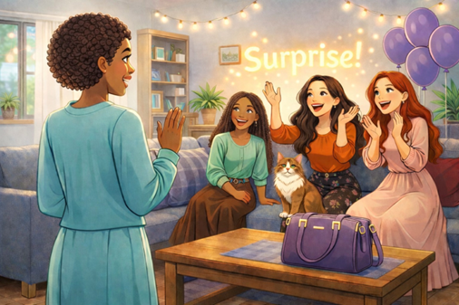  Ella opens the door. Ella’s friends shout, “Surprise!” and turn on the lights.
Word List
1 |  | surprise
2 | 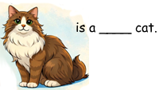 | furry
3 | 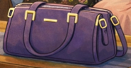 | purse
4 |  | cake
5 | 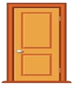 | door
6 | 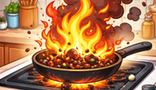 | burn
7 |  | purple
8 |  | burger
9 |  | nurse
10 | 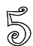 | five
11 |  | light
12 |  | party
Matching Game Puzzle

The puzzle is on the next page.
Preparation:
Cut out the squares on the dotted lines only (do not cut out the triangles).
Options:
You can enlarge the puzzle, glue your puzzle onto colored paper or cardboard and laminate. You can make giant squares on stiff board or Bristol.
To play:
Match the rhyming words by placing them together with the edges of their squares touching. Assemble the puzzle into a 3X3 square so that every word only touches a rhyming word. (There are lots of “right ways” to assemble the puzzle, since the words at the top and bottom of each column and both ends of each row also rhyme.)
The game that accompanies a longer version of the story used in this lesson uses a similar, but more advanced, set of words. However, the pieces CANNOT be used together. Anyone using both games should mark the back of each game piece with either “1” or “2,” or something else easily visible so that the sets can be quickly sorted if the pieces are mixed. Printing the sets on different colors of paper or cardboard (Bristol) is another option.

Matching rhymes game on Wordwall:

https://wordwall.net/resource/107846268/%D7%90%D7%A0%D7%92%D7%9C%D7%99%D7%AA/matching-rhymes-hickey

show  day try  door | curry  were say  are | moon  my her  grew
or  worry purse  burn | car  tree furry  love | new  nurse she  frying
turn  more right  know | of  too for  hurry | trying  light you  soon

