Chandler, Chad and Chelsea on a Day Off School

Chandler, Chad and Chelsea are classmates. They have a day off school and they are deciding what to do.  "What are we going to do today? "Let’s do something fun for a change," said Chelsea.    “Let’s go to the beach after lunch,” Chad suggested.  "Sounds good!" Chelsea said.  "I have some chestnuts, peaches and bananas. They’d go well with chocolate ice cream!”  "I don’t like sweets. I prefer chicken and chips," said Chad. | "I have to check on something first,” Chandler said.    “We can go to the cinema instead if you want,” Chelsea suggested. “I know a theater that allows in dogs. Champ can tag along.”  “I need to go home’,” Chandler said. “I have to prepare my speech for tomorrow’s diplomacy debate lesson. I need to read Chapter 2 in the book and add some charts”.  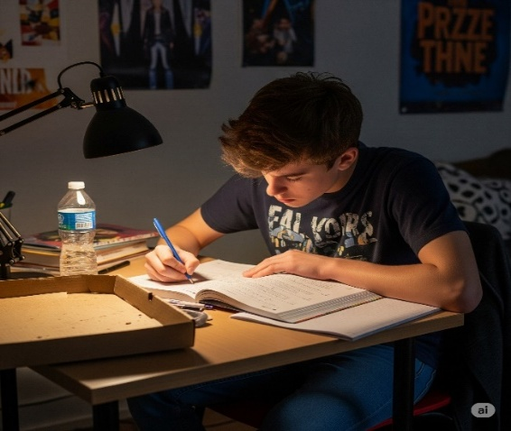

"Chill out, my friend,” said Chad.  “First, let’s take a pic. Say cheese!”  “I’m not up to that,” said Chandler.    “Maybe we can play some chess,” Chelsea suggested.  “No time,” Chandler said, “I need to get my butt on a chair and do my homework.” | “My mom also expects me to do all the house chores.  I asked her nicely to choose only one task for me – taking out the bin, for example. She just chuckled and started preaching to me saying, ‘If you want to reach your goals in life - you must face the challenges.’“  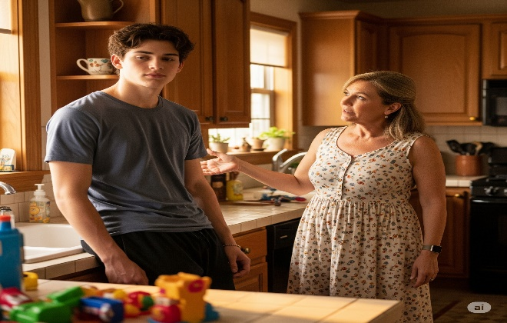

"Cheer up, friend”, said Chad, seeing his chance.  “I will take Chelsea to the beach,” he offered. “We will have a chat, sit on a bench, eat a sandwich and dance the cha-cha on the warm sand.”   | “Do you want me to punch you?” Chandler said angrily. “There is no chance in the world that she is into you. You are no Prince Charming!” he shouted.    “Chill, man! forget it! We are friends!" Chad told him.  “Adios, ciao, I’m off. See you when I see you”! Chandler replied angrily.  “Come on, don’t be a child!" called Chad as Chandler left for home.  “Oh, well, tomorrow is another day…” Chad mumbled to himself.

Word List
1 |  | change
2 | 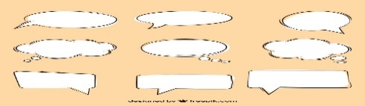 | chat
3 |  | beach
4 |  | chart
5 |  | peaches
6 |  | preach
7 |  | bench
8 | 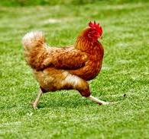 | chicken
9 |  | choose
10 |  | speech
11 |  | cheer
12 | 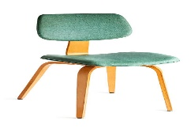 | chair

Word Search
Search for the word in the field. The hidden word can be positioned in all directions, written from left to right, from right to left,
horizontally, vertically and diagonally, but is always on one straight line.
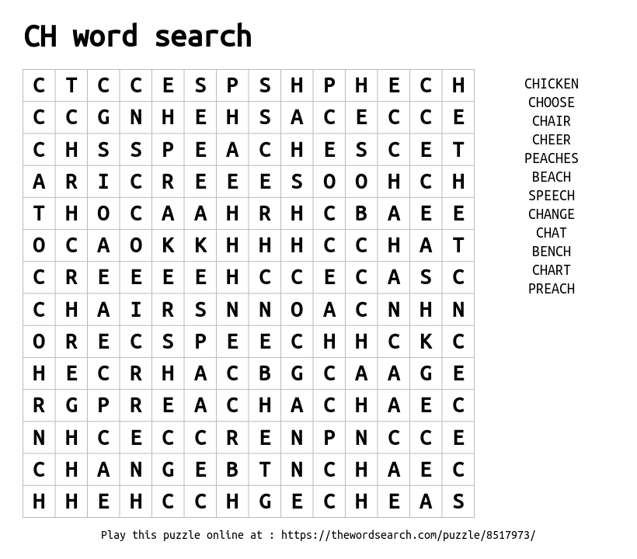
Online Games
'Whack-a- mole"
https://wordwall.net/resource/6082114/digraph-ch
Hit the moles that are digraph "ch"

Online Word Search https://thewordsearch.com/puzzle/8517973/ch-word-search/

