Brooke Cooks Food for School
Brooke looks at the room.  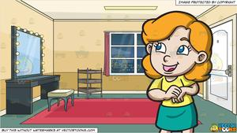 | Brooke looks at the moon in the room.
Brooke cooks food.  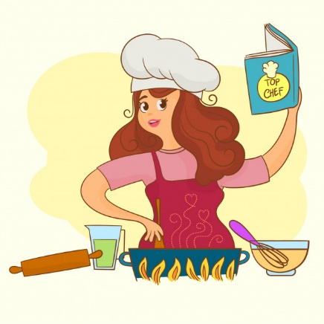 | Brooke cooks food for school.  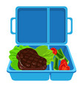
Poor Brooke! She lets the food fall.  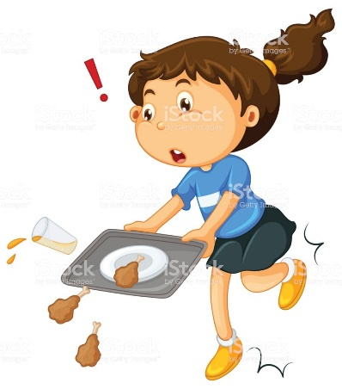 | Poor Brooke! The food is on the floor.  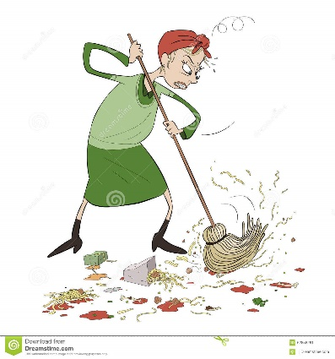

Word List
1 | 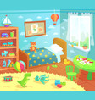 | room
2 |  | look
3 |  | moon
4 |  | cook
5 |  | school
6 | 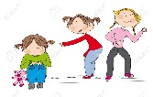 | poor
7 |  | floor
8 |  | door
9 |  | cool
10 |  | soon
11 |  | hood
12 |  | wood

Bingo
One board uses written words (decoding practice), the other pictures (comprehension practice). The teacher reads the word and the student has to find the correct word or picture.

cool | school | wood
cook | poor | hood
look | moon | floor

Phonemic Awareness Exercise
Make various cards, one for /ʊ/ ("short oo" as in pull, book) and one for /u/ ("long oo" as in food, flute). You can cut up the bingo boards, above, to make cards with either pictures or words.

cook
school

Teacher says the words and the student(s) has to pick the correct card from the group. With each correct answer, the student gets a point. For groups, the students can be divided into two teams, which each one sets up a lineup, similar to baseball. Each student takes turns in trying to put the correct card in the proper category stack (/ʊ/ and /u/).

