The Dog, the Cat and the Bone
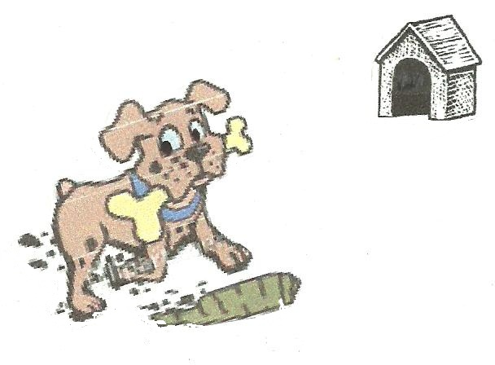  Rose’s pet dog, Spot, hid his bone  in a big hole, far from his home. | 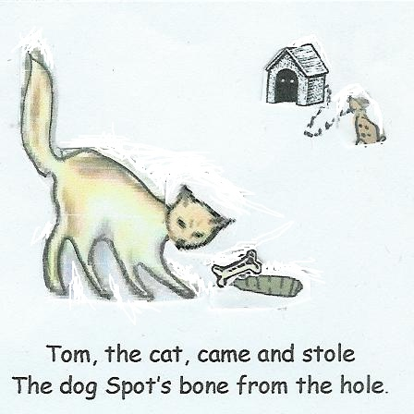
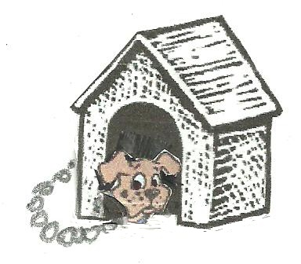  Spot was mad at the cat, so  he began to try to go.  But he didn’t get far alone.  A rope held him to his home. | 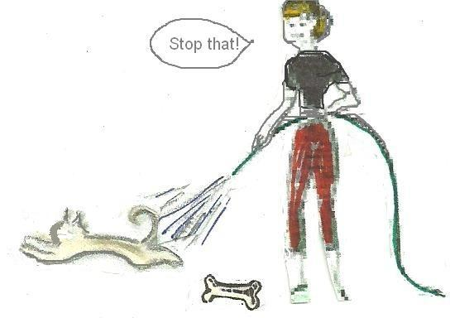  Rose came to help. She said, "Stop that!"  She had to help Spot get his bone back!  She had a hose to scare off the cat.  Tom ran fast to escape the attack.
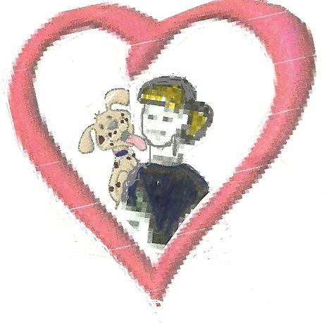  Spot is so glad that he licks Rose,  a big kiss on her lips and nose. | 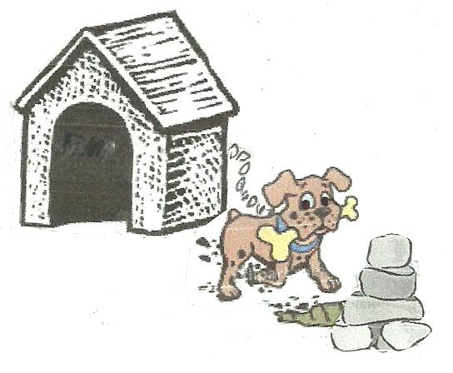  Then, Spot hid his bone by a big stone  This time the hole is close to his home.

Word List
1 | 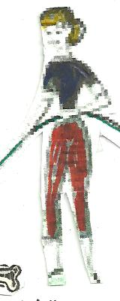 | Rose
2 |  | bone
3 | 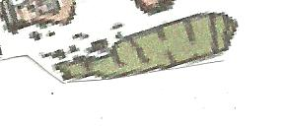 | hole
4 |  | home
5 |  | hose
6 |  | rope
7 |  | nose
8 |  | stone
9 |  | lips
10 | 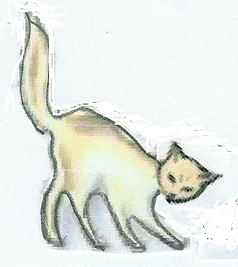 | cat
11 | 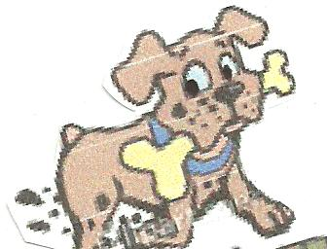 | dog
12 | 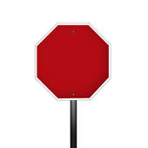 | stop

Ruler Matching Game:
- Empty the “sargel m’shulav” numbers out of the clear tray and place the tray over the words.
- Find the picture to match each word, and place its number over the word in the tray.
- Check yourself: slide in the ruler cover, turn over, and compare to the diagram.
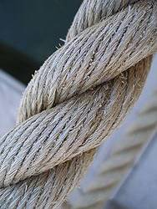 | 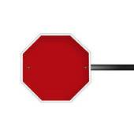 |  | stone | home
 | 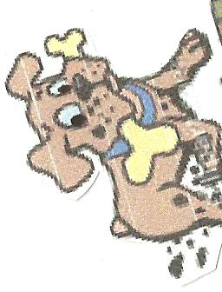 |  | Rose | stop
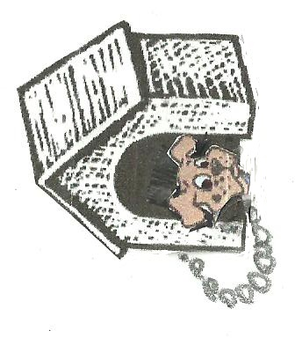 | 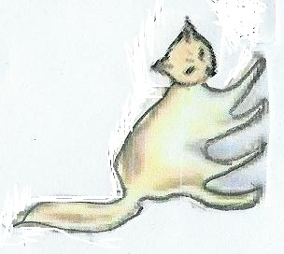 |  | lips | dog
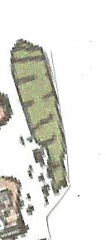 | 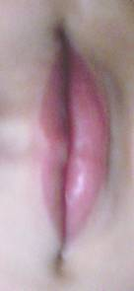 |  | hole | hose
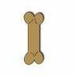   | 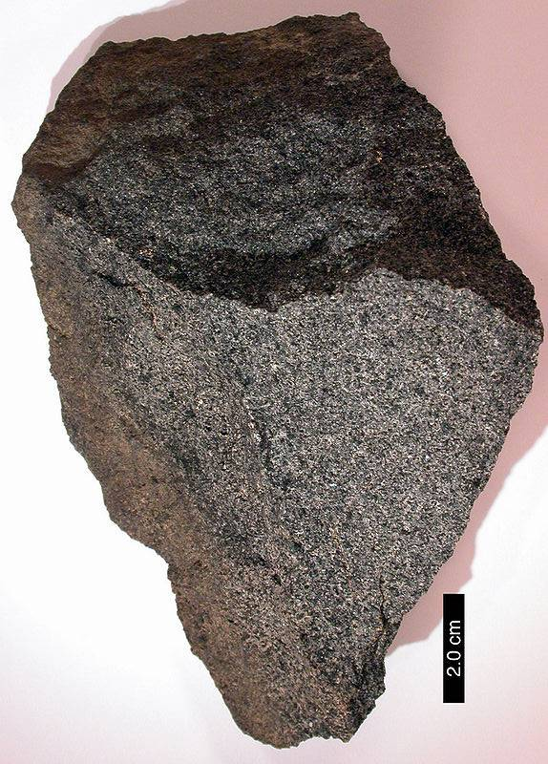   |  | cat | rope
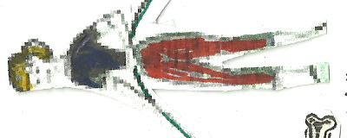 | 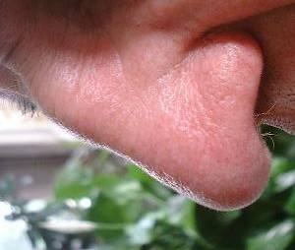 |  | bone | nose

