Tom has a Problem in the Garden
  This is Tom! | 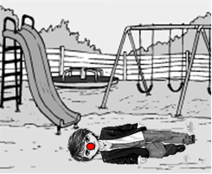  Tom fell in the garden  and broke his nose!
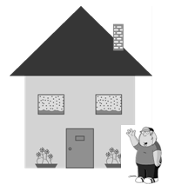  Daddy is close. He is at home. | 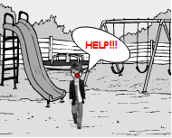  Tom has a problem.  He calls for some help!
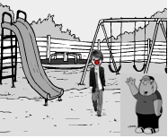  Daddy opens the front gate and comes close to Tom.  Daddy hopes Tom’s nose is O.K. | 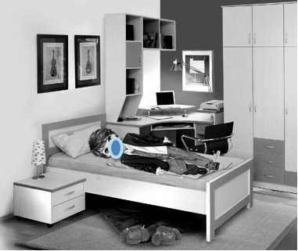  Tom gets a cold compress.  Tom’s nose is O.K.!

Word List
1 |  | Tom
2 | 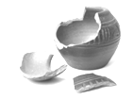 | broke
3 | 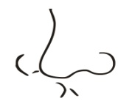 | nose
4 |  | close
5 | 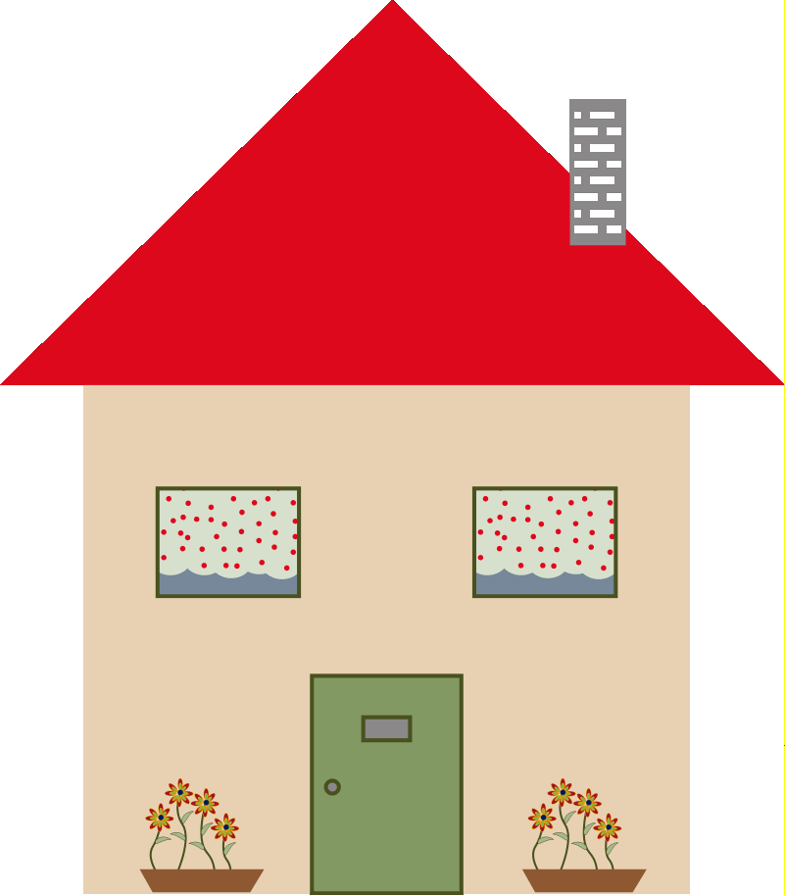 | home
6 |  | problem
7 | 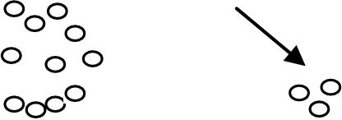 | some
8 | 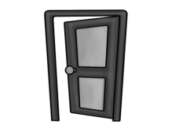 | open
9 |  | front
10 | 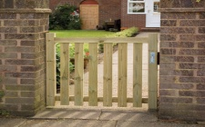 | gate
11 | 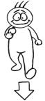 | come
12 |  | hope

Game
For this game you need:
1 dice and 2 playing soldiers.
All players start from number 1. Each at his turn throws the dice and moves forward. But, when one falls on a colored square – something needs to be done!
Blue: Pick up a word card and translate the word. If you knew it – go 2 steps forward. If you didn't know it – go one step backwards.
Green: Go 3 steps forward!
Yellow: Go back to number 1…

Let's play a game!
64 | 63 | 62 | 61 | 60 | 59 | 58 | 57
49 | 50 | 51 | 52 | 53 | 54 | 55 | 56
48 | 47 | 46 | 45 | 44 | 43 | 42 | 41
33 | 34 | 35 | 36 | 37 | 38 | 39 | 40
32 | 31 | 30 | 29 | 28 | 27 | 26 | 25
17 | 18 | 19 | 20 | 21 | 22 | 23 | 24
16 | 15 | 14 | 13 | 12 | 11 | 10 | 9
1 | 2 | 3 | 4 | 5 | 6 | 7 | 8

Cards for the game – glue onto stiff paper or laminate and cut out

nose | broke
home | close
some | problem
front | open
come | gate
garden | hope

