A Furry Surprise
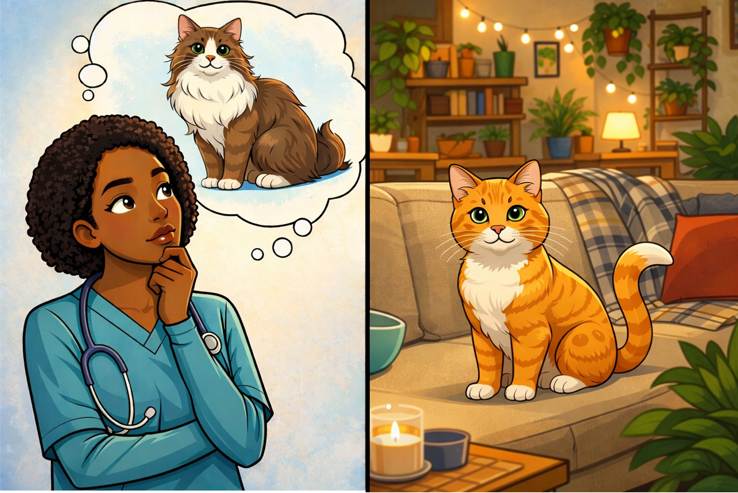  Ella’s friends know that she wants a purple purse – and a furry cat. Her cat, Ginger, has very short fur. Ella’s friends will give her a very furry cat. | 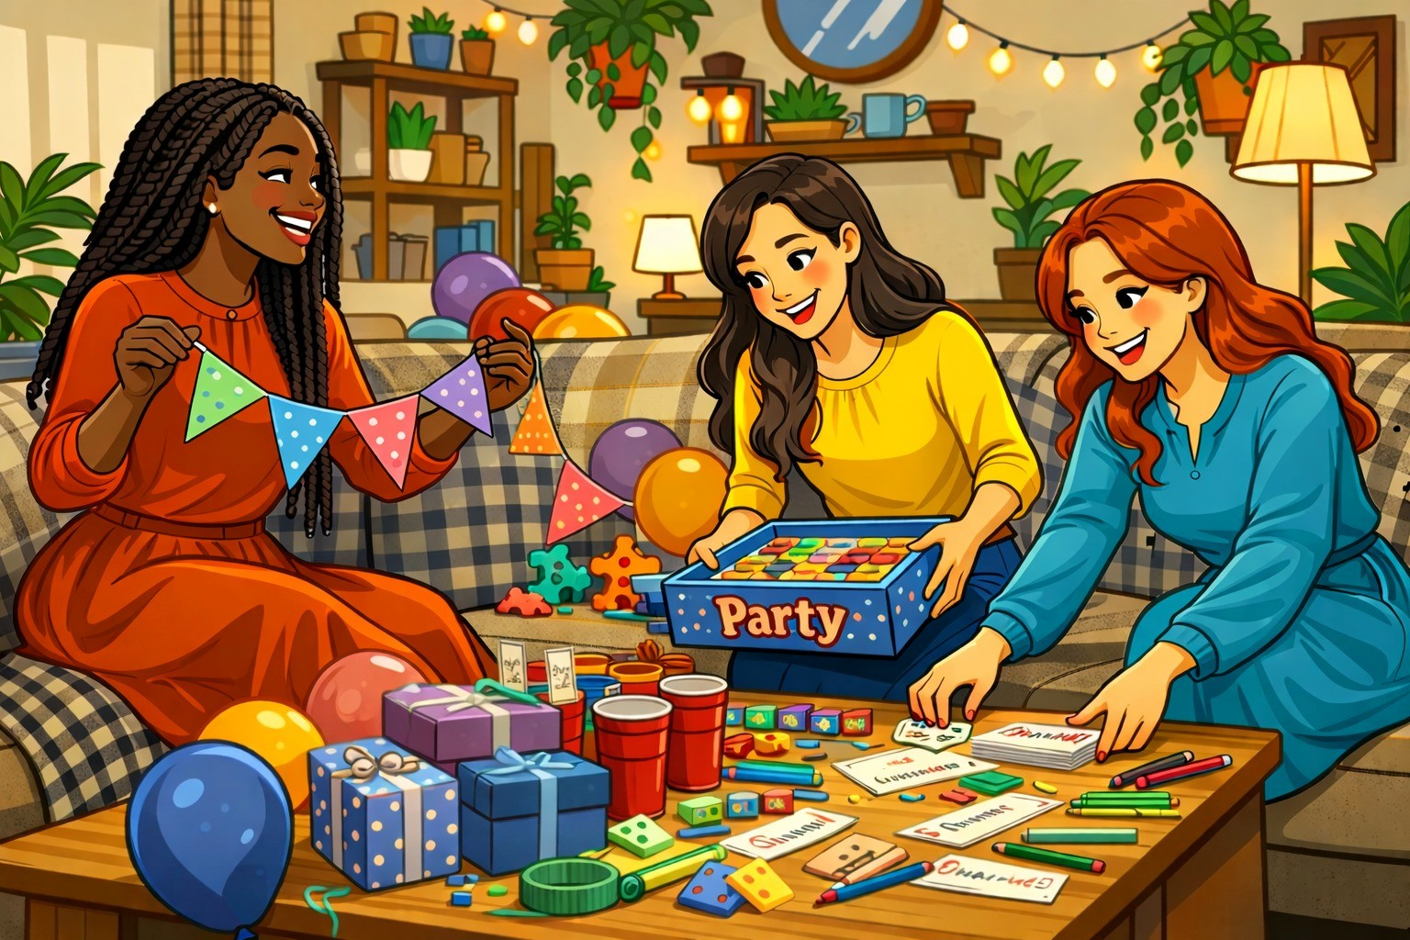  Ella is a nurse. She helps people if they are hurt. She returns home after five every Thursday and Saturday. Her friends will have a surprise party  for her next Thursday.
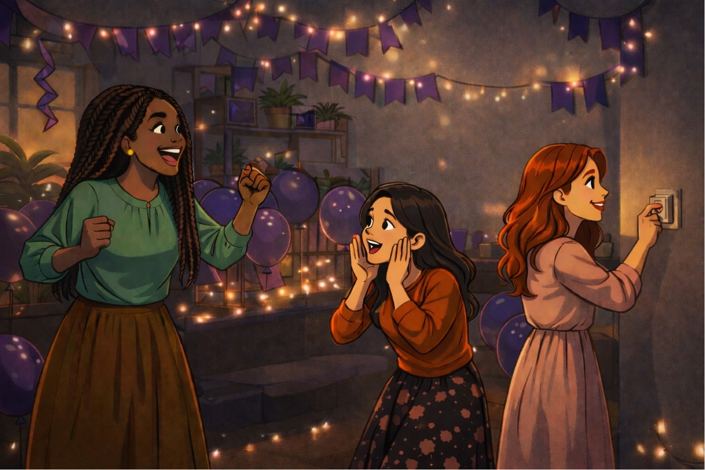  It is almost time for the party.  Tamar says, “Ella will return home soon.” Mazal shouts, “You are right. Hurry!”  Sara shouts, “Turn off the lights!” | 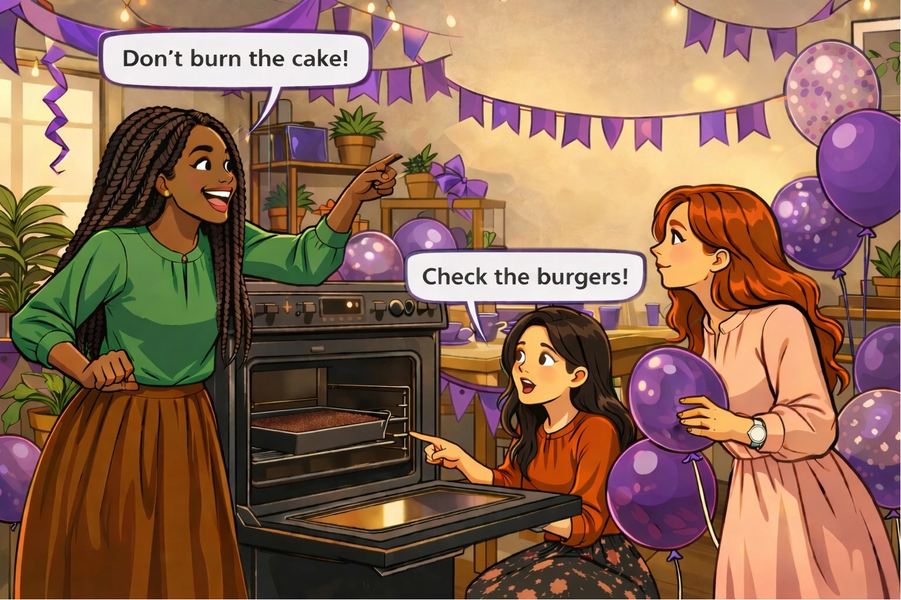  It’s Thursday! Tamar and Sara are frying burgers together. Mazal is baking a cake. Tamar shouts, "Don’t burn the cake!” Mazal shouts, “Check the burgers!”
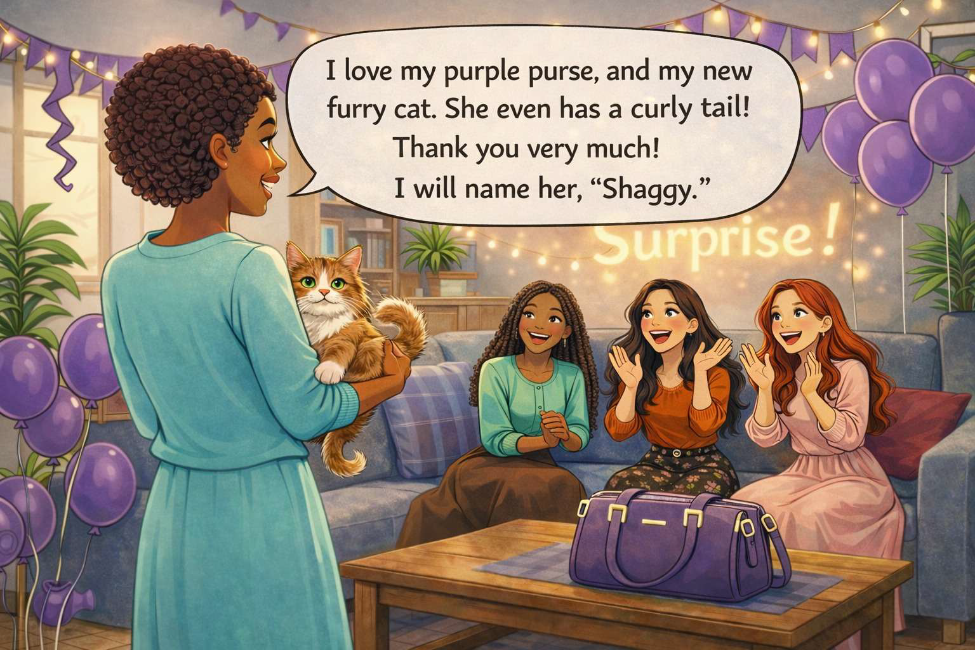  Ella says, “I love my purple purse, and my new furry cat. She even has a curly tail! Thank you very much! I will name her, “Shaggy.” | 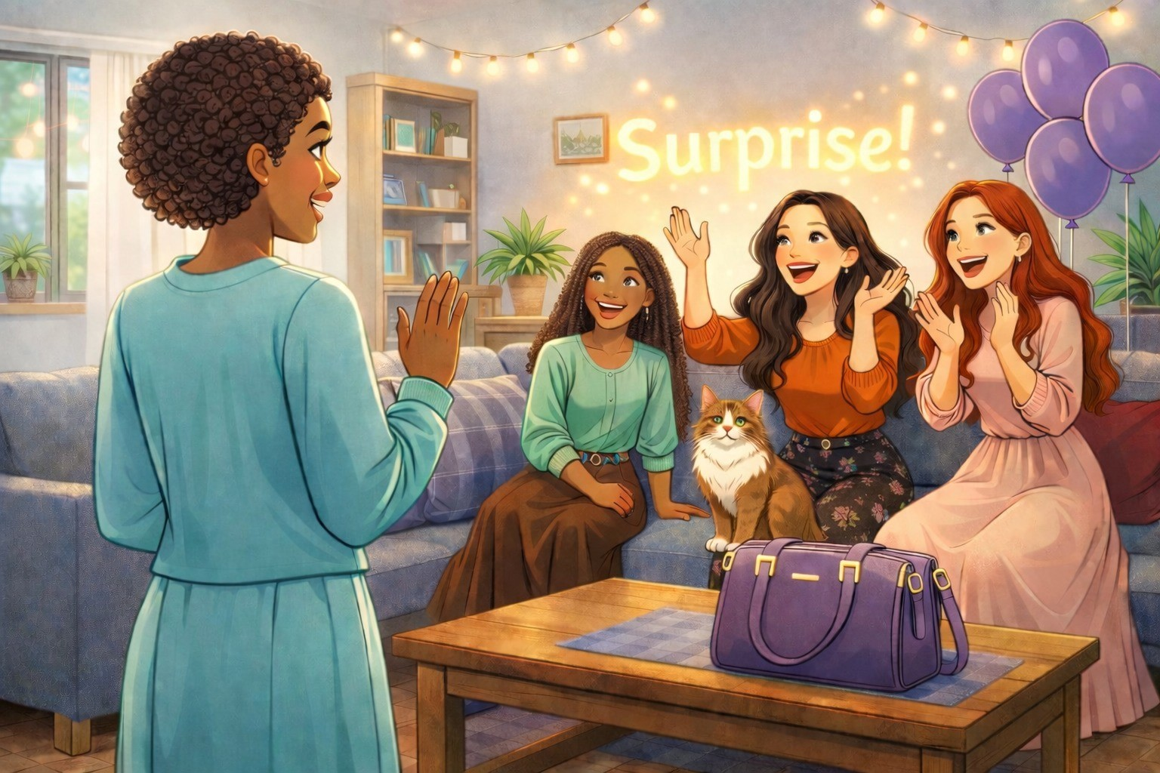  Ella opens the door. Ella’s friends shout, “Surprise!” and turn on the lights.  This is a wonderful party.
Word List
1 |  | surprise
2 | 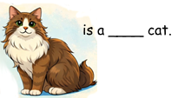 | furry
3 | 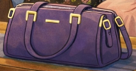 | purse
4 |  | cake
5 | 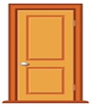 | door
6 |  | burn
7 |  | purple
8 |  | burger
9 |  | nurse
10 | 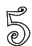 | five
11 |  | light
12 |  | party

Matching Game Puzzle

The puzzle is on the next page.
Preparation:
Cut out the squares on the dotted lines only (do not cut out the triangles).
Options:
You can enlarge the puzzle, glue your puzzle onto colored paper or cardboard and laminate. You can make giant squares on stiff board or Bristol.
To play:
Match the rhyming words by placing them together with the edges of their squares touching. Assemble the puzzle into a 3X3 square so that every word only touches a rhyming word. (There are lots of “right ways” to assemble the puzzle, since the words at the top and bottom of each column and both ends of each row also rhyme.)
The game that accompanies a shorter version of the story used in this lesson uses a similar, but easier, set of words. However, the pieces CANNOT be used together. Anyone using both games should mark the back of each game piece with either “1” or “2,” or something else easily visible so that the sets can be quickly sorted if the pieces are mixed. Printing the sets on different colors of paper or cardboard (Bristol) is another option.

Matching rhymes game on Wordwall:

https://wordwall.net/resource/107846268/%D7%90%D7%A0%D7%92%D7%9C%D7%99%D7%AA/matching-rhymes-hickey

buying  blue they  hurry | purse  of new  her | June  play love  you
worry  girl door  laughter | were  know curl  tree | too  more go  yesterday
after  turn bite  frying | she  car burn  verse | Saturday  light are  soon

