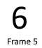 |  | 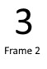
This book belongs to  Lesson X, (target letters) |  | 1. Story Title
 |  | 
  Frame 1 |  |   Frame 6
Instructions for making a Little Book from a 6-frame Hickey story (or any 6-page story):
Create a 2-page file that you can print two-sided, then fold and cut into a little book.
There is an invisible table in this document.
To see the outlines of the print area of each page of the little book, in the Word menu, click Table Layout>View Gridlines.
- Do “save as” of this document and give your new file a title, (Example: Little Book of Lesson 1, It is I!)
- View the file as multiple pages so you can see both pages at one time.
- Select the text above, 1. Story Title and replace it by typing the title of your story, (example: It is I!)
On the back cover type the lesson number (replace the X) and the target letter(s) (replace (target letters)). Example: Lesson 1, i,t,p,n,s
- Open the file containing the story in comics format.
- From your comics-format file, use the “Snipping Tool” app to copy the picture and text of frame 1 as a graphic file to paste into the Little Book in the proper numbered spot. (This copies them together as one graphic.)
- Select above, 2 Frame 1 and paste the picture and text of frame 1 into it.
Select above, 7 Frame 6 and paste the picture and text of frame 6 into it.
- For our example it will now look like this:
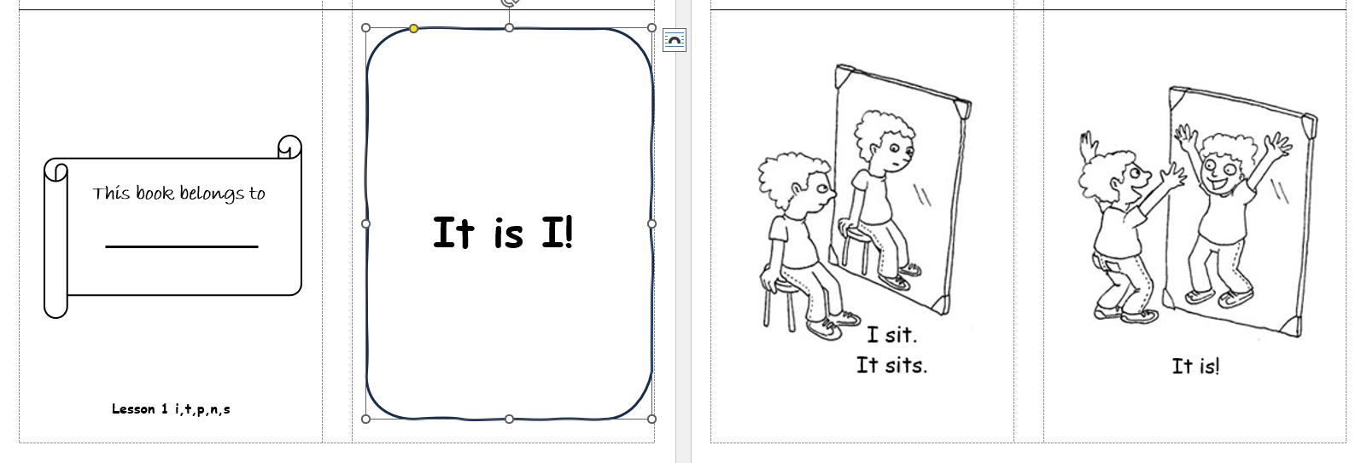
- Now repeat for each frame, selecting from the comics-format file the picture and text, copying it, and pasting it into the numbered spot in the Little Book file.
- Save the file.
- Print the first two pages of the file (not this page of instructions) on the two-sided setting.
- Cut on the solid line. You’ll have two halves of the paper.
- Stack the two halves of the paper so the front and back covers are at the top of the stack and fold along the spine of the book. (Check that the inside pages are in the right order, and you didn’t turn that half-sheet over.)
- Staple the spine along the fold line (you need a long stapler for this, to reach the spine from the edge of the paper). Refold the book.
- Let your student write their name onto the back cover.
- Read and enjoy!

