The Team's Meal
Once a year my team and I go to eat by the sea.  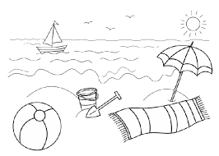 | Every one of us brings something to eat
and we have a big meal.  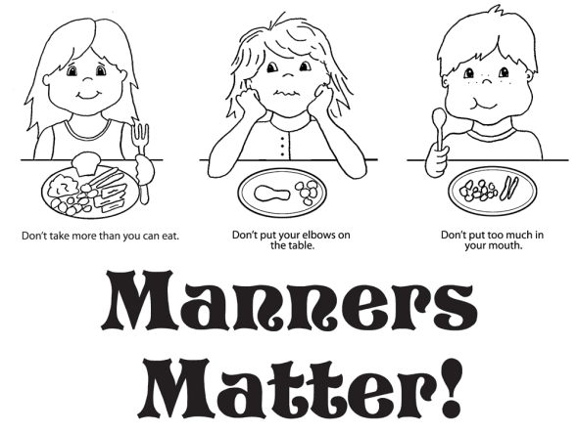 | When we finish eating we clean up the trash  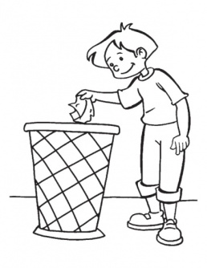
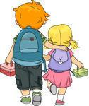  and then we leave.  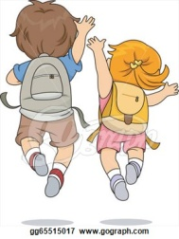 | Dan is so mean.  When I ask him to please help he starts to  scream.
Suddenly I feel a leaf on my nose | 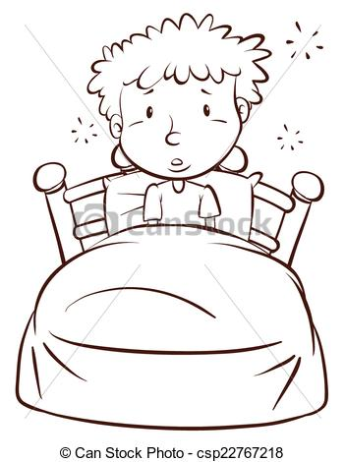  and realize it is only a dream.

Word list:
1 |  | year
2 |  | team
3 |  | eat
4 |  | sea
5 |  | meal
6 |  | clean
7 | 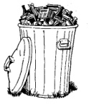 | trash
8 |  | leave
9 |  | mean
10 |  | scream
11 |  | leaf
12 | 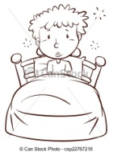 | dream
Game:
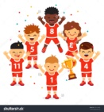
Cut the words and place them in the right place in the story
Once a _____
my _____
and I go to ______ by the _____.
Every one of us brings something to eat, and we have a big _____.
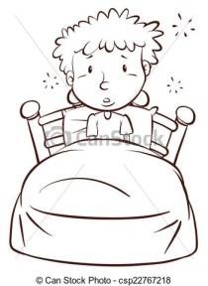
When we finish eating, we _____ up the _____
and then we_____.
Dan is so _____.
When I ask him to please help he starts to _____.
Suddenly I feel a ____ on my nose, and
realize it is only a ______.

Cut
year | team | eat
sea | meal | clean
 | leave | mean
scream | leaf | dream

