The Angry Dog
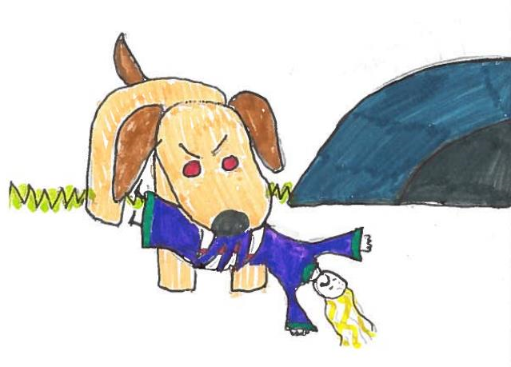  The angry dog takes her to his den in his long fangs. |   “Spare me,” she begs “if I sing.”  She sings from morning to evening.
  He can’t kill her - the song is so fine. “I’ll not bite,” he barks. |   She is so happy she kisses him.
  Bang!!!  The spell is broken - he is a man! |   He brings a ring for her finger.  They marry in the spring.
Word List
1 |  | angry
2 |  | long
3 |  | fangs
4 |  | sing
5 | 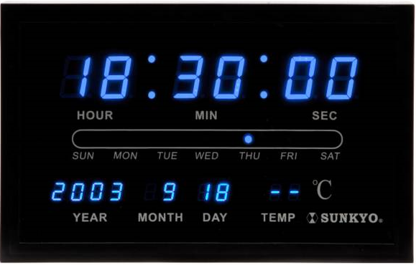 | evening
6 | 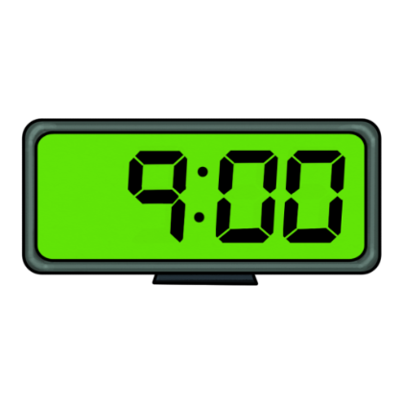 | morning
7 |  | ring
8 |  | finger
9 |  | spring
10 |  | happy
11 | 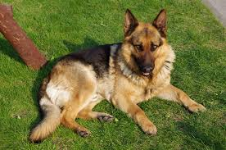 | dog
12 |  | spell

Instructions for the Game Four in a Row

You will need:
- The board on the next page, printed and stuck to a piece of cardboard.
(You can laminate it if you want.)
- Two sets of 30 coloured counters, each set in a different colour.
- The word cards, cut out and stuck to cardboard. There a two groups of cards and the words in each group should be stuck to different coloured cards. The first group contains words from the story so hopefully the learner should be familiar with them. The second group are the “challenge” cards containing “new” words.

To Play
- Place the cards face down in two separate piles – one for each of the colours.
- Divide the counters between the players so that each player has a different colour.
- Each player in turn takes a card from the first group and reads the word written on it. If he/she reads the word correctly he/she can place a counter on the board. The idea is to try to get a line of four counters next to one another either horizontally, vertically or diagonally. Each player has to try to create his own lines whilst blocking the other player’s attempts. At any stage a player can take a card from the second group. These are the “challenge” cards and if a player manages to read one of these words he can place two counters. The teacher can use this “trick” to control the game.
- When all the squares on the board have been filled, the winner is the player with the most lines of four counters. If you lack time, you can play a shorter version in which the winner is the first player to make a complete line of four counters.
- If you run out of word cards, just shuffle them and reuse them.

Four in a Row

Words from the story: (glue this page onto coloured paper and cut into cards)
angry | evening | kiss
dog | morning | spell
takes | spring | broken
den | finger | bang
long | bring | bite
fangs | ring | bark
sing | marry | man
song | happy | begs
“Challenge” cards (ng words not in the story; glue onto a second colour, cut cards)
fling | string | thing
strong | ping-pong | king
hang | sting | gong
singing | sang | pang
bedding | mongrel | mango
spinning | spitting | standing
skipping | running | belong

