The Ten Falafel Balls
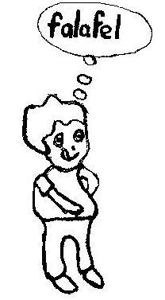  Mike likes falafel. He has it all the time.  He is fat. | 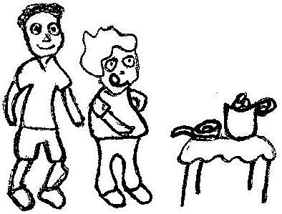  He and his tall friend Fred fry many falafel balls in a pan. They fill a tin.  In the tin are ten falafel balls.
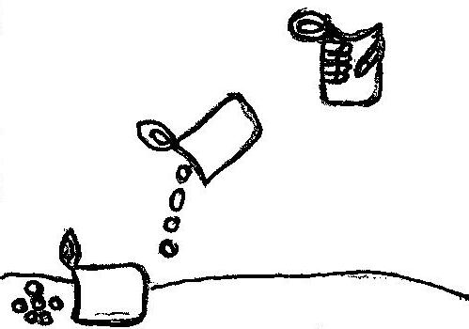  Fred held the tin in his hand.  Then the tin slips!  The falafel balls fall in the sand. | 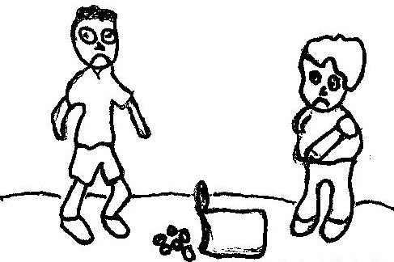  Mike and Fred felt sad.  Their falafel fell in the sand!  There isn’t any falafel left!
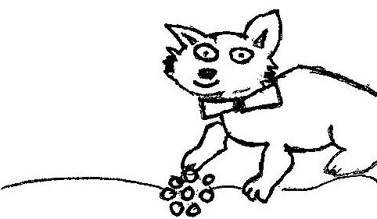  Mike’s pretty black cat is happy.  She likes falafel!  She has the falafel that fell in the sand. | 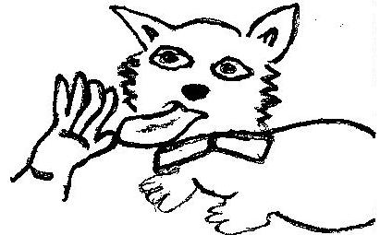  The pretty cat licks Fred’s hand.  Fred likes cats that lick him.  At last, he is happy and he smiles.

Word List
1 | 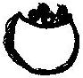 | falafel
2 | 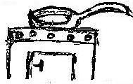 | fry
3 | 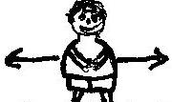 | fat
4 | 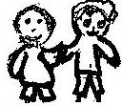 | friend
5 | 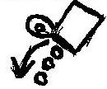 | fall
6 | 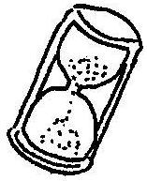 | fell
7 |  | smile
8 | 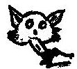 | licks
9 | 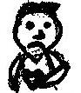 | felt
10 | 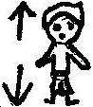 | tall
11 | 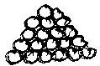 | many
12 | 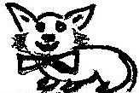 | pretty

Bingo

Instructions:
- Preparing the game:
- Glue the two tables of words onto cardboard.
- Glue the list of “clue words” onto cardboard and then cut out each word separately.
- Put these words into a bag.
- Have a collection of small buttons or stones to use as markers.

- How to play:
- The teacher and the learner each have a table of words and a number of markers.
- The learner pulls a “clue word” out of the bag and reads the word out loud.
- Both players cover the word in their “word table” with a marker.
- The first one to cover a row of five words either down or across is the winner.
- The middle square marked xxxxxx is a bonus square.

Bingo
stand | fire | pick | my | life
ball | friend | Mike | daddy | are
that | she | xxxxxx | they | kind
baby | him | smile | fry | mine
fell | help | black | yes | like

Bingo
friend | baby | my | daddy | life
she | that | him | kind | are
black | pick | xxxxxx | yes | they
mine | smile | help | ball | fry
fire | fell | Mike | like | stand

Clue words: glue onto cardboard, cut out each word separately:

friend | baby | my | daddy | life | stand
she | that | him | kind | are | black
pick | yes | they | mine | smile | help
ball | fry | fire | fell | Mike | like

