A Day at the Sea
Here, grab my jeans!
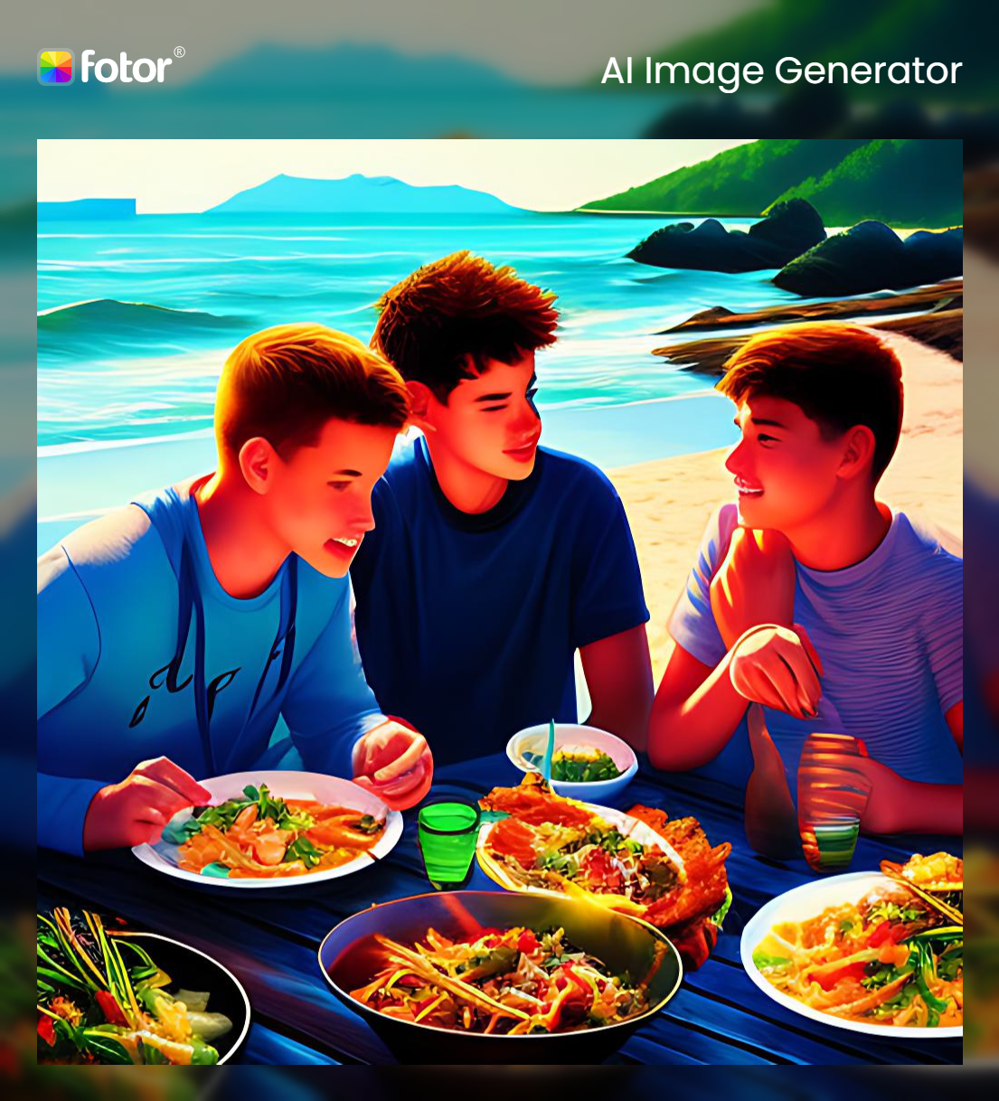  It’s a sunny day at the seaside. Dan and his team are having a meal.  I’d like some more peas, please! | 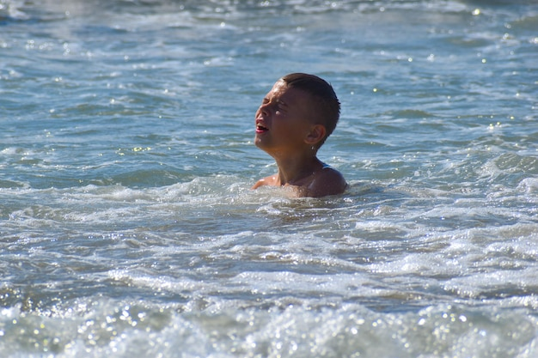  Suddenly, they hear a scream.  HELP!!!!
  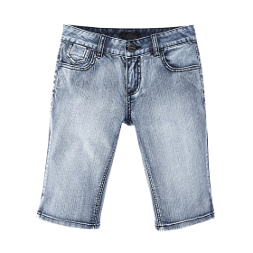  Dan jumps into the sea.    Thank you! You saved me from a scary sea! |   You’re safe, just breathe!  I vote for some ice cream for the team!
 |     

Word List
1 |  | team
2 |  | dream
3 |  | jeans
4 |  | sea
5 |  | eat
6 |  | help
7 |  | peas
8 | 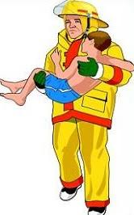 | save
9 |  | scream
10 |  | meat
11 |  | grab
12 |  | please

Online Game: https://wordwall.net/resource/52615284

Say the Sound, Find a Word Game:

Directions
- This game is for 2 or more players.
- Each person has a colored counter with a dice.
- Each player puts their counter on Start.
- Each player has a turn to throw the dice.
- When a player lands on a square, say the sound, find a picture with that spelling of that sound, and think of another word with the sound (even if it has a different spelling.) (The table of “Words for pictures” is so the tutor knows what the intended word is to name each picture.)
- The winner who reaches Finish first is the winner.
Words for pictures:
1 dog | 2 bike | 3 meat | 4 car
5 tree | 6 three | 7 shopping | 8 eat
9 star | 10 five | 11 rose | 12 hen
13 girl | 14 thirty | 15 ship | 16 umbrella
17 river | 18 storm | 19 drive | 20 spoon
21 queen | 22 night | 23 rope | 24 cake
25 bed | 26 snake | 27 forty | 28 nine
29 sleep | 30 sweet | 31 play | 32 bank

Word pictures
  4 |   3 | 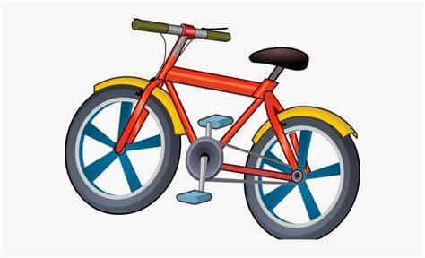  2 |   1
8 |   7 |   6 | 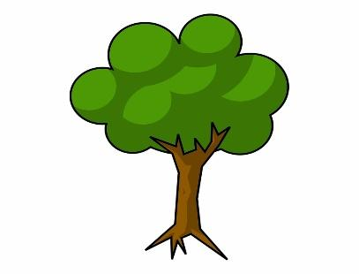  5
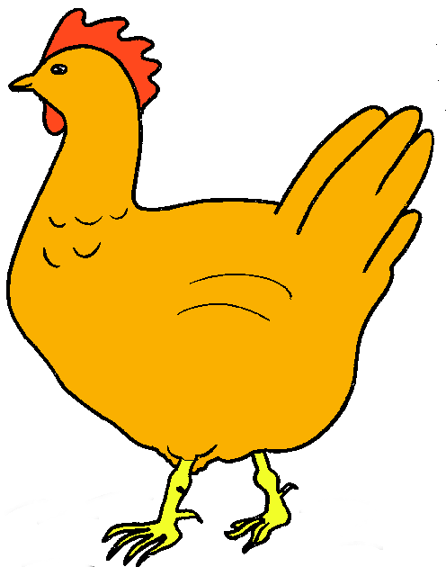  12 |   11 |   10 |   9
  16 |   15 |   14 |   13
  20 |   19 |   18 |   17
  24 |   23 |   22 |   21
  28 |   27 |   26 |   25
  32 |   31 |   30 |   29

Finish | 47  b | 46  ea | 45  h | 44  t | 43  a
37  ea | 38  or | 39  ay | 40  er | 41  sh | 42  nk
36  m | 35  n | 34  f | 33  -a_e | 32  c | 31  d
25  th | 26  u | 27  -i_e | 28  ea | 29  sh | 30  ar
24  ea | 23  ee | 22  -ike | 21  er | 20  oo | 19  sh
13  or | 14  -ing | 15  qu | 16  nk | 17  th | 18  ar
12  oo | 11  ea | 10  sh | 9  ee | 8  ay | 7  a
Start | 2  th | 3  -ike | 4  ar | 5  -o_e | 6  -a_e

