A Fun Game to Play

|  |  |
| --- | --- |
| Today is a Sunday in May. Jake and Tom wanted to play a game in the park.  Jake says, "Let's find a way to play a game like soccer, but with hands only, no feet and no kicking!" | Tom says, “We need a softer ball!” He pays for a softer ball at the store.  Jake and Tom make a rule: The players toss the ball with their hands. If the ball rolls away, the other player has to run and bring it back. |
| They played the game every weekday—Monday, Tuesday, Wednesday, Thursday, and Friday.  On Saturday, was Tom’s birthday, and they had a big party.  So a week passed quickly. | Sunday they say, “Yesterday was Saturday, it’s Sunday again, time to play!” They walk to the park. But today the sky is gray, they can’t play at the park. Jake calls his mom and asks, "May we stay in and play at home?" His mom agrees. |
| Jake tells Tom. "My mom says it’s okay to play at home, if we’re careful!"  So they walked to Jake’s home that day. | Jake and Tom played their game. They say, “We play on holidays, too!” |

Word List

|  |  |  |  |
| --- | --- | --- | --- |
| 1 |  | May |  |
| 2 |  | play |  |
| 3 |  | weekday |  |
| 4 |  | Friday |  |
| 5 |  | yesterday |  |
| 6 |  | stay |  |
| 7 |  | gray |  |
| 8 |  | okay |  |
| 9 | Image result for An image of a holiday | holiday |  |
| 10 |  | Sunday |  |
| 11 | Image result for An image of a home | home |  |
| 12 |  | park |  |

Games:

**Online activity-“Name That Day”- click on the link**

<https://view.genially.com/67f8fe55447681952c0fd659/interactive-content-name-that-day-the-letters-ay-sahar-and-vika>

1. **Board game:**

**Game Instructions: *Name the Day!***

**🎯 Objective:**

Be the first player to reach the finish by correctly answering questions about the days of the week.

**📦 Contents:**

* Game Board (print and laminate)
* Cards: (Print, laminate, and cut up the cards: )
  + 11 Question Cards (starting with *“Name the day that...”*)
  + 7 Day Cards (each day of the week)
  + 6 Action Cards ( “Move Forward”, “Go Back”)
* You need one player token per player
* You need one dice

**👥 Instructions for play for 2-4 players:**

Mix the cards and place the pile face down.

All players begin at Start.

First player rolls the dice, moves forward the number of spaces on the dice, and picks a card. Read aloud the day on the space (if there is one) and  
If they get a Question Card, they answer the question.

* If the answer is **correct**, move forward **one space**.
* If the answer is **incorrect**, stay in place.

If they get a Day card, they have to correctly read the day aloud.

If they get a **Special Card:**

* + “Move Ahead” → advance one *extra* space.
  + “Move Back” → move one space backward.

**Winning the Game:**  
The first player to reach the **Finish** space wins!

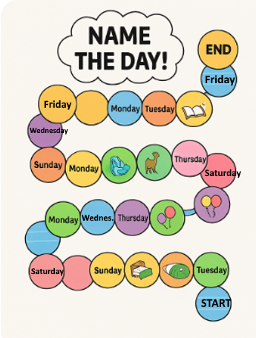

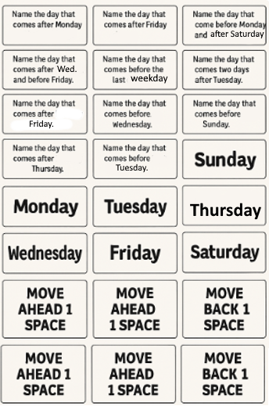

### Domino Cards:

### Preparation: Print, laminate, and cut up domino cards. There is only one way to assemble the line of cards but you can turn a corner by turning the matching card sideways.

### **How to Play:**

1. Shuffle the cards and deal **5 cards to each player**. Put the rest of the cards in a pile face-down.
2. Place one card **face up** in the center to start the domino line.
3. On your turn, **add a card** by matching a picture on either end of the line, and say the word that matches the picture (from the word list).  
   If you can’t make a match, pick a card from the pile and **skip your turn**.
4. The first player to place all their cards **wins the game**!

### 

