qpdb Butterfly
To help learners remember the directions and sounds of these letters that are all shaped the same but positioned differently:
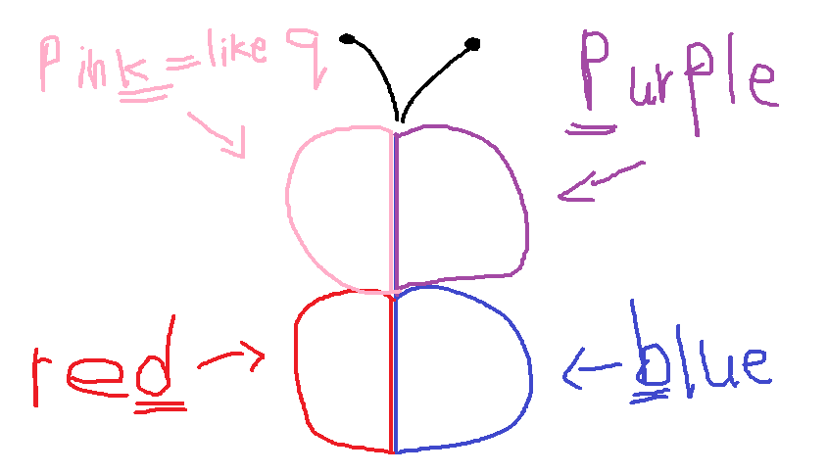
pink =like qqp purple
red db blue

