Today Was My Birthday!*
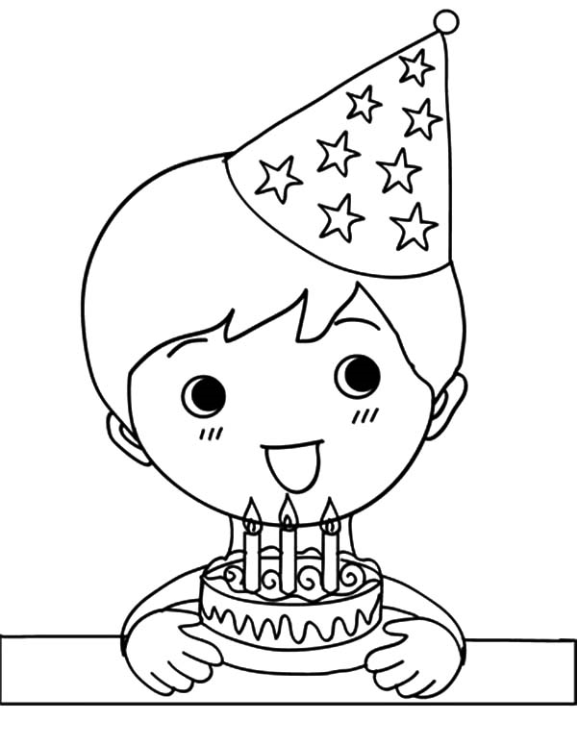  My name is Jay.  It was my birthday today! | 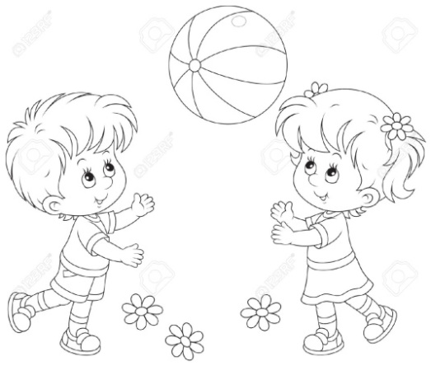  On my birthday  I played all day.
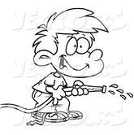  I sprayed water… | 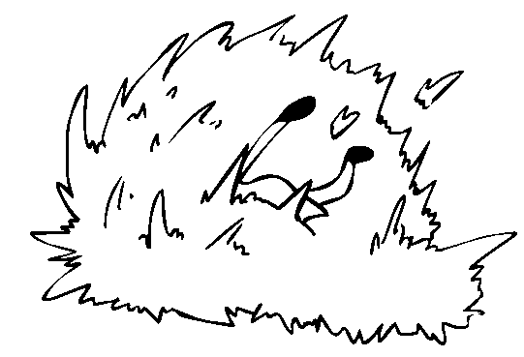  and hid in the hay.
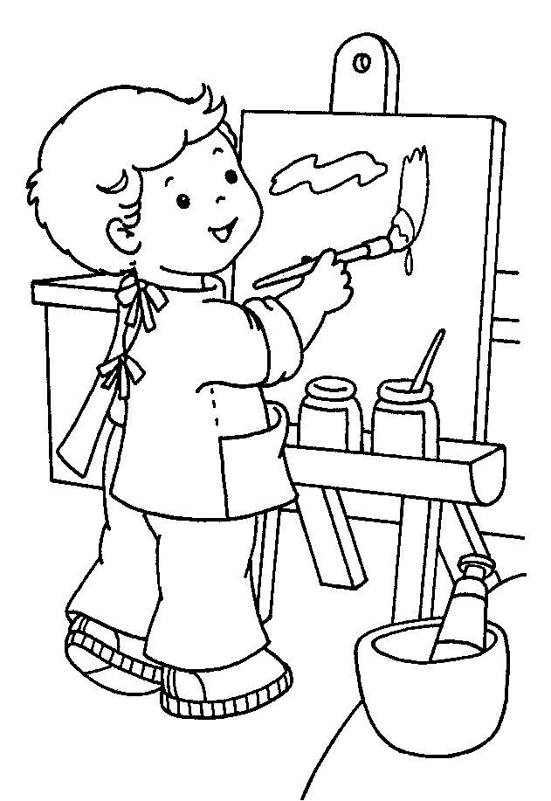  I made a picture  with my crayons… | 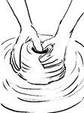  and played with clay.
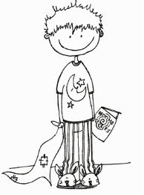  I even stayed up late! | 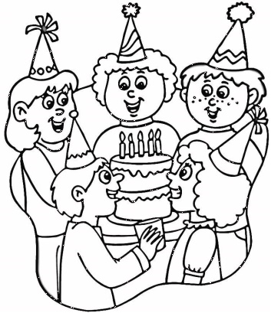  All my family was there,  like for a holiday! Hooray!
*Teach combination ir (er) – it comes later in Lesson 58 but "birthday" is a word for which we can make an exception!
Word List
1 |  | hay
2 |  | clay
3 |  | birthday
4 |  | spray
5 |  | sprayed
6 | 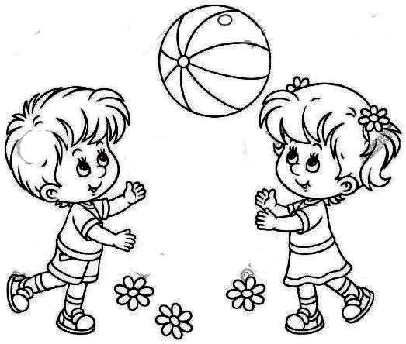 | play
7 |  | played
8 | 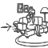 | hide
9 |  | hid
10 |  | today
11 |  | family
12 |  | crayons

Memory game:
Match the 'ay' word to the picture that describes it.
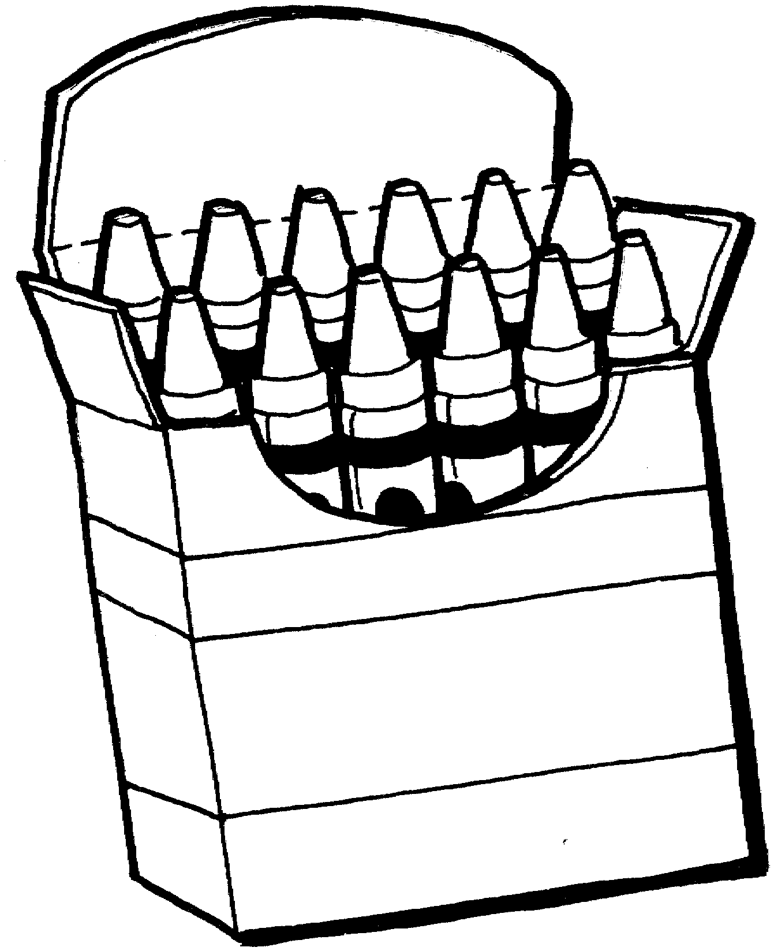 | crayons
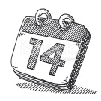 | today
 | birthday
 | clay
 | hay
 | spray
 | play
 | Hooray!
 | sprayed
 | played
 | hide
 | hid

