Lily and the Fish
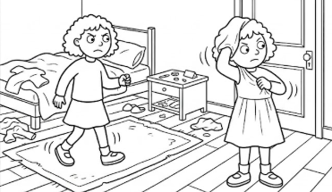  Lily is restless. She dresses. She likes pet fish. She plans a trip. | 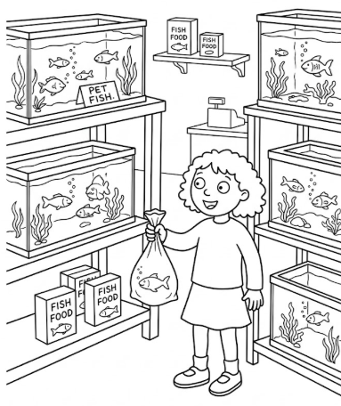  She finds a fish she can carry in a sack.
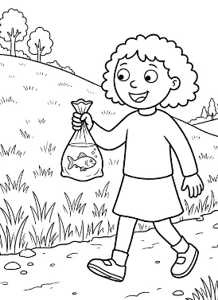  Lily passes happily by a hill. She has her fish in a sack. | 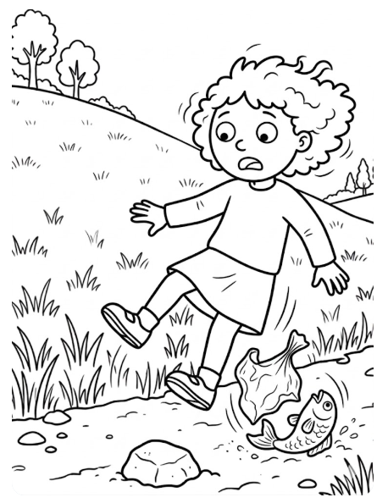  Lily misses the last step and falls. The sack falls, and the fish flips in the sand.
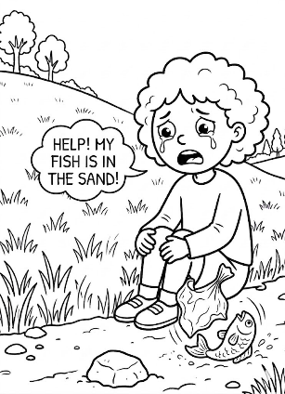  Lily sits sadly. She is helpless.  She calls, “Help! My fish is in the sand!” | 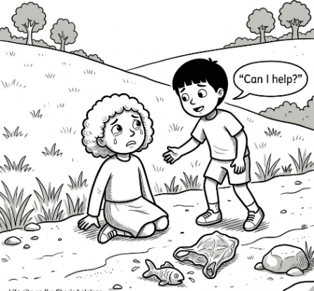  A kid in her class, Alan, passes Lily. He asks her kindly, “Can I help?”
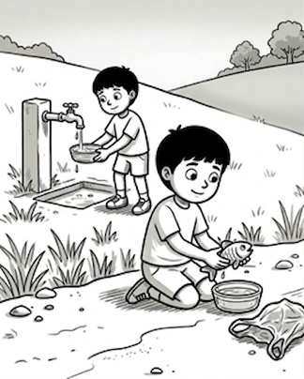  Alan isn’t helpless. He finds a dish in the sand and fills it. Alan kindly lifts the fish and sets it in the dish. The fish is in the dish and rests happily. | 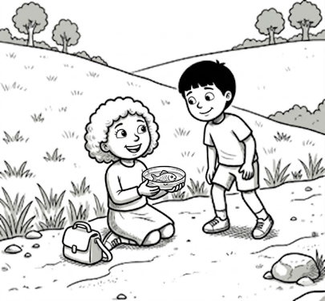  Lily smiles happily at Alan. Finally, Lily finishes her trip.  Her fish is safe in her dish. The fish and Lily are stressless.
Word List
1 | 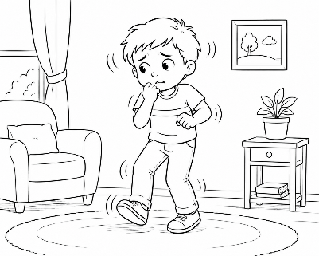 | restless
2 | 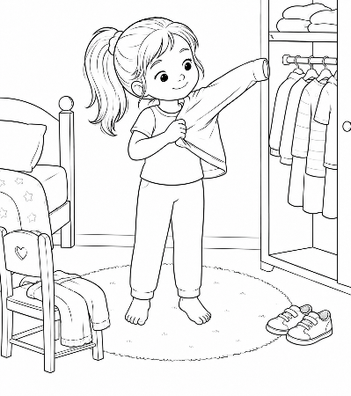 | dresses
3 | 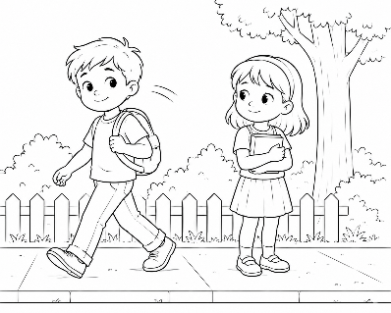 | passes by
4 |  | happily
5 | 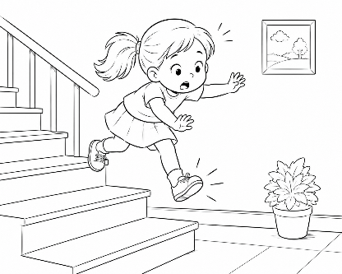 | misses
6 | 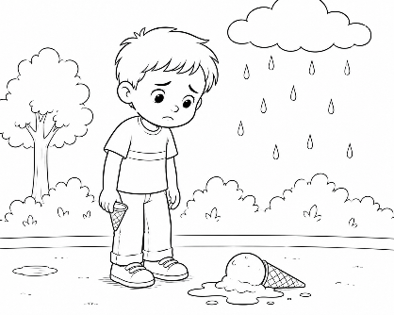 | sadly
7 | 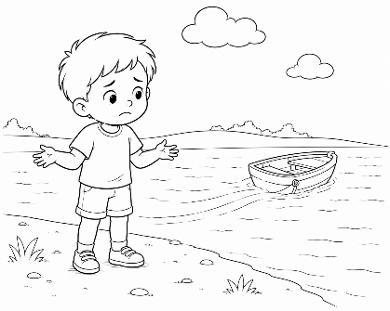 | helpless
8 | 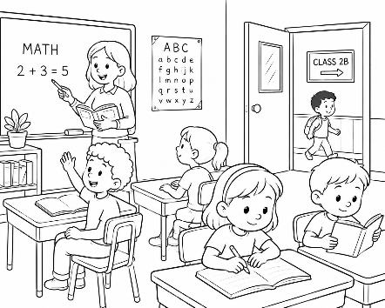 | classes
9 | 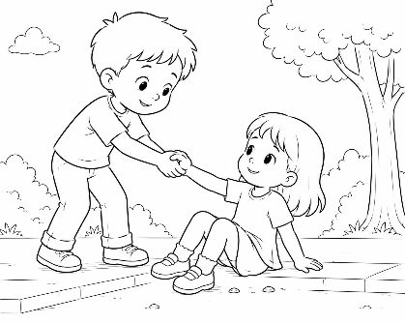 | kindly
10 | 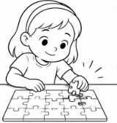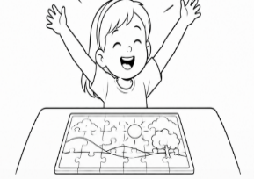 | finally
11 | 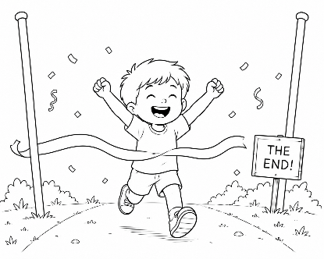 | finishes
12 | 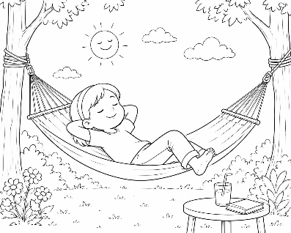 | stressless

Links to Online Games
https://wordwall.net/resource/113193416
https://wordwall.net/resource/113193533

Suffix Puzzle – Build the Words

Step 1 – Match the Pieces
The student looks for matching puzzle pieces.
The student connects a base word with the correct suffix.
Examples:
- help + less = helpless
- happy + ly = happily
- finish + es = finishes

Step 2 – Read the Word
After connecting the pieces, the student:
- reads the whole word aloud
- identifies the suffix
- says the base word
Example:
“helpless”
suffix: less
base word: help

Optional Extension Activities

Meaning Practice
Ask:
“What does helpless mean?”
or:
“What does stressless mean?”

Sort by Suffix
After building all the words, the student sorts them into groups:
- words with -less
- words with -ly
- words with -es

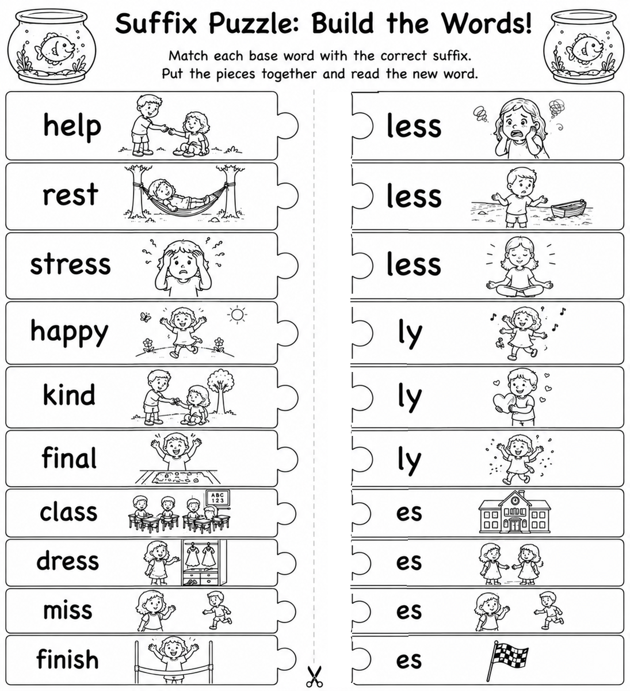

Teacher Instructions – “Help Lily and Her Fish!”
The teacher should bring:
* The printed game board.
* One die (dice).
* A small game piece (“player”).
* pencil or dry erase marker

How to Play:
1. Place the student’s game piece on START.
The student rolls the die and moves forward.
2. Complete the Task
When the student lands on a space, they complete the activity, such as: build a word, read a word, identify the suffix and find a word in the story
The student should always: read aloud, say the suffix, read the whole word again
Example:
help + less = helpless

Special Spaces:

“Oh no!”
The student reads the words in the box before continuing.

“Alan helps!”
The student moves forward one extra space.

“Find it in the story!”
The student looks in the story and finds a word with the target suffix.

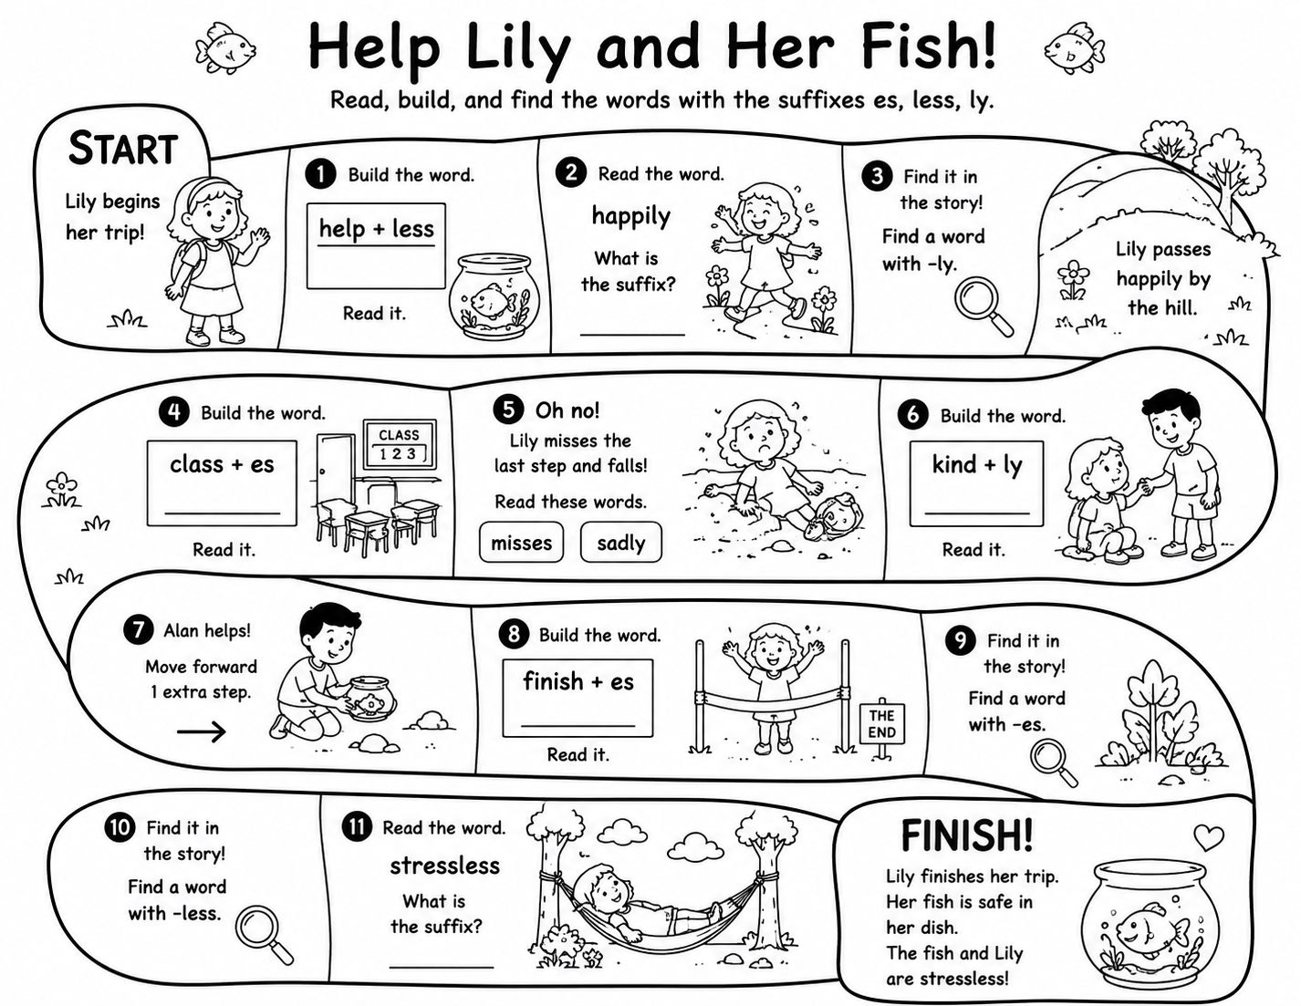

Present Simple Verb spelling rules S/ES for lesson 20
Some ideas for how to use these game cards in combination with speaking and spelling.
Print, laminate and cut out the game cards. Then cards can be used to:
1. Do a memory game - word and picture - when a pair is found student needs to add S/ES.
2. Have cards face up - student matches, then writes correct S/ES for third person.
3. Student picks word, choose S/ES and spells word - then says a sentence with the word.
4. Basketball spelling! Student/s gets a pack of cards (either words or pictures - depending on what you want the student to practice). Student picks a card, spells the correct third person form, then if gets it right - throws ball into basket. If doesnt get it right - doesn’t get a chance to throw the ball. This is great in a team.
5. The cards could be used in a race - students run get card, run back and write the correct form on the board.

