Father Goes Shopping
 + 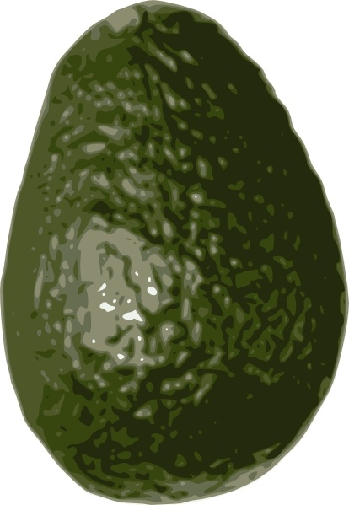 =  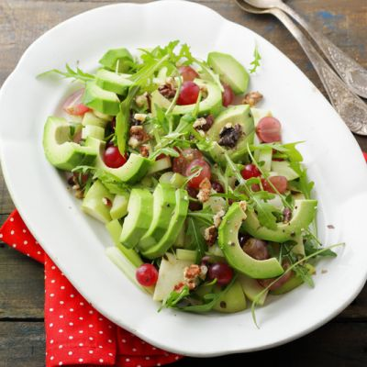  Father wanted apples and avocadoes for a salad. | 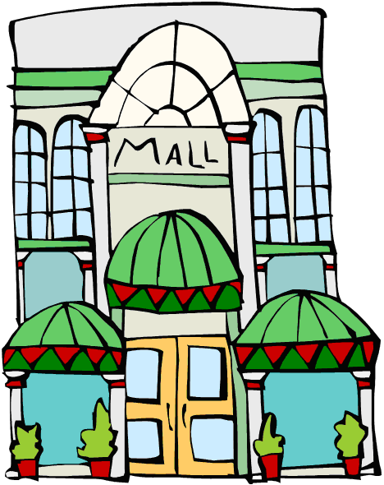  Father went to a store in the mall.
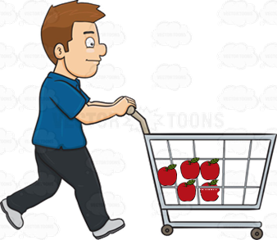  Father got some apples. They were waxed and washed. | 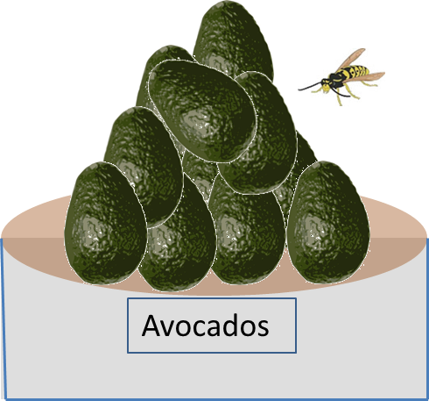  There was a wasp near the avocadoes.
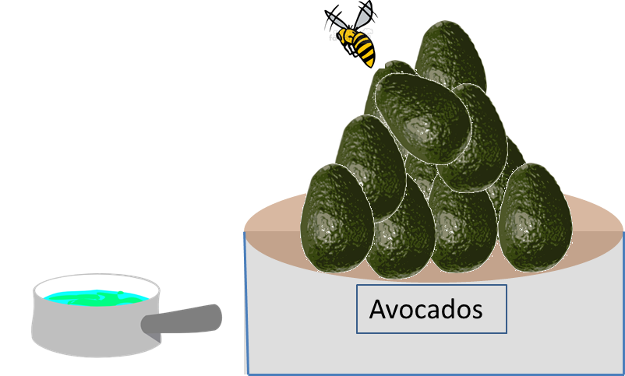  Father put out a pan of water to distract the wasp. | 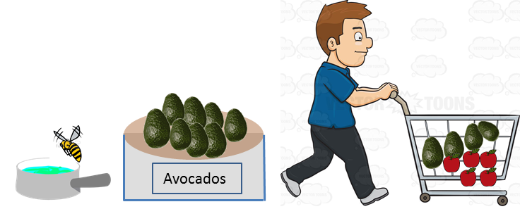  Father watched the wasp fly away and then grabbed some avocadoes.

Word List
1 |  | Father
2 |  | avocado
3 | 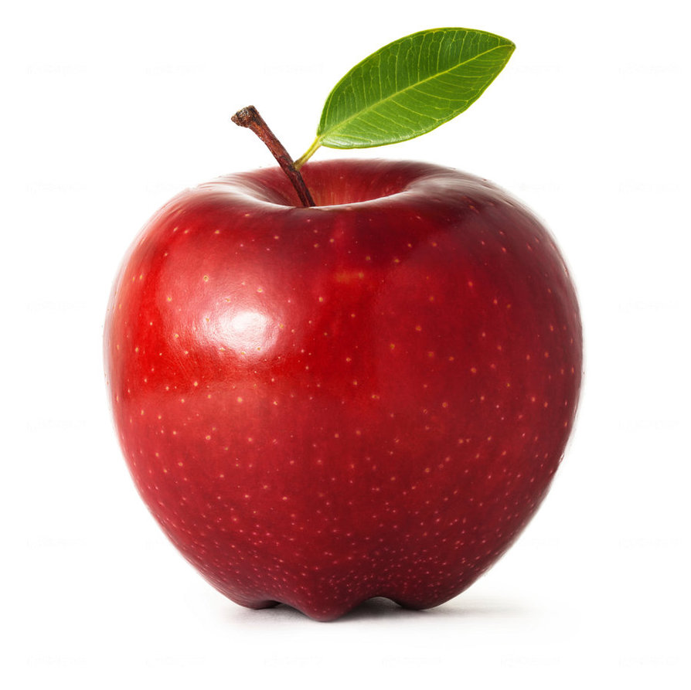 | apple
4 |  | mall
5 | 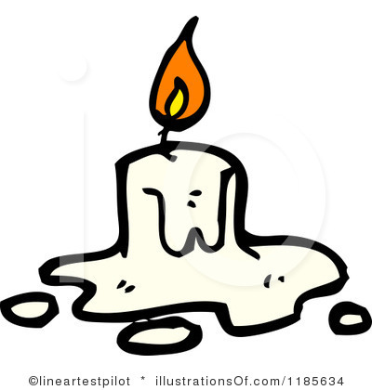 | wax
6 | 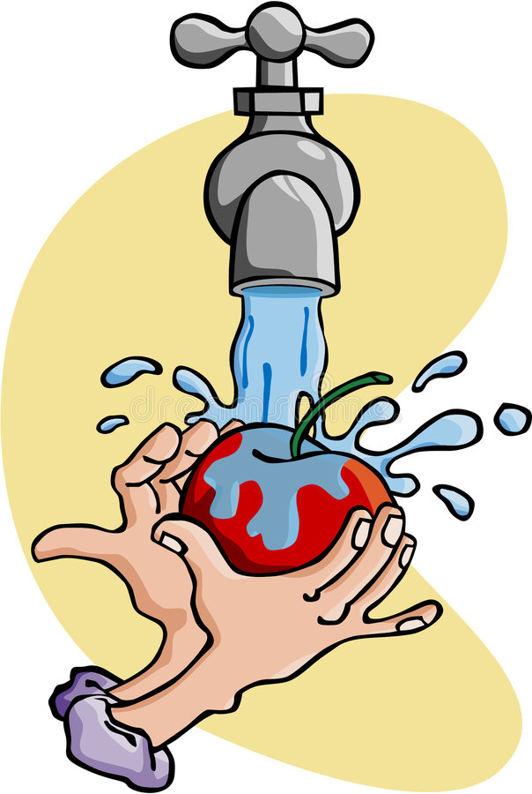 | wash
7 | 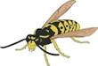 | wasp
8 |  | water
9 |  | distract
10 | 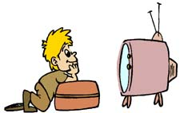 | watch
11 | 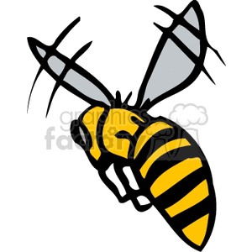))) | fly away
12 | 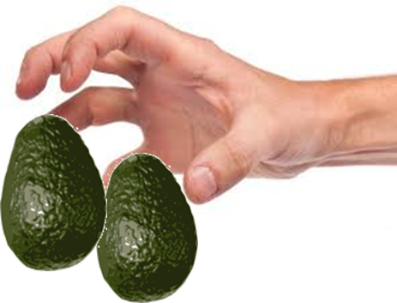 | grab

Ruler Matching Game:
Empty the “sargel m’shulav” numbers out of the clear tray and place the tray over the words.
Find the picture to match each word, and place its number over the word in the tray.
Check yourself: slide in the ruler cover, turn over, and compare to the diagram.

 | 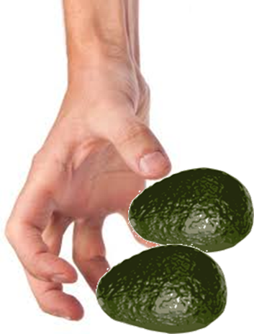 |  |  | 
 | 

 | 
 | 



