Nip's Test
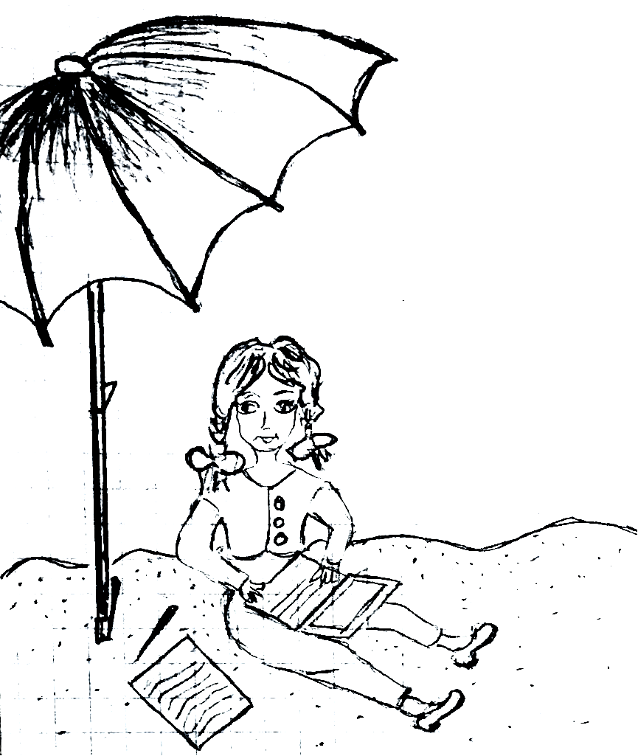  This is Nip. She sits in the sand.  She has a test. |  | 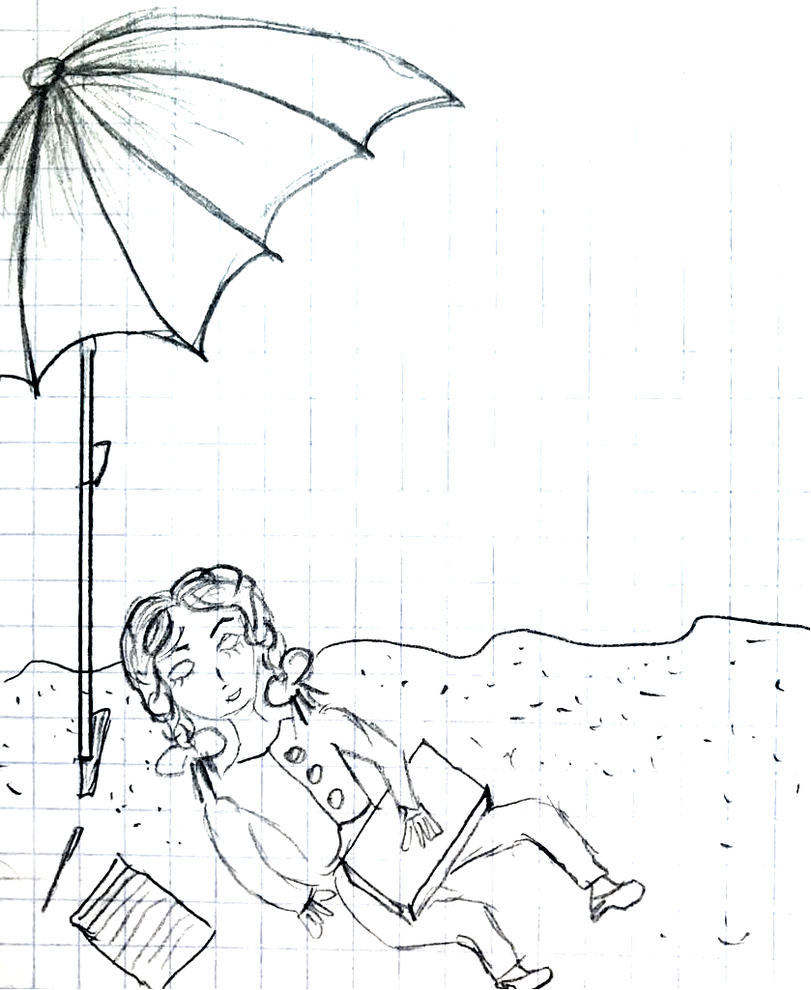  The test is a snap.  Nip naps! She naps and naps.  She didn't send the test.
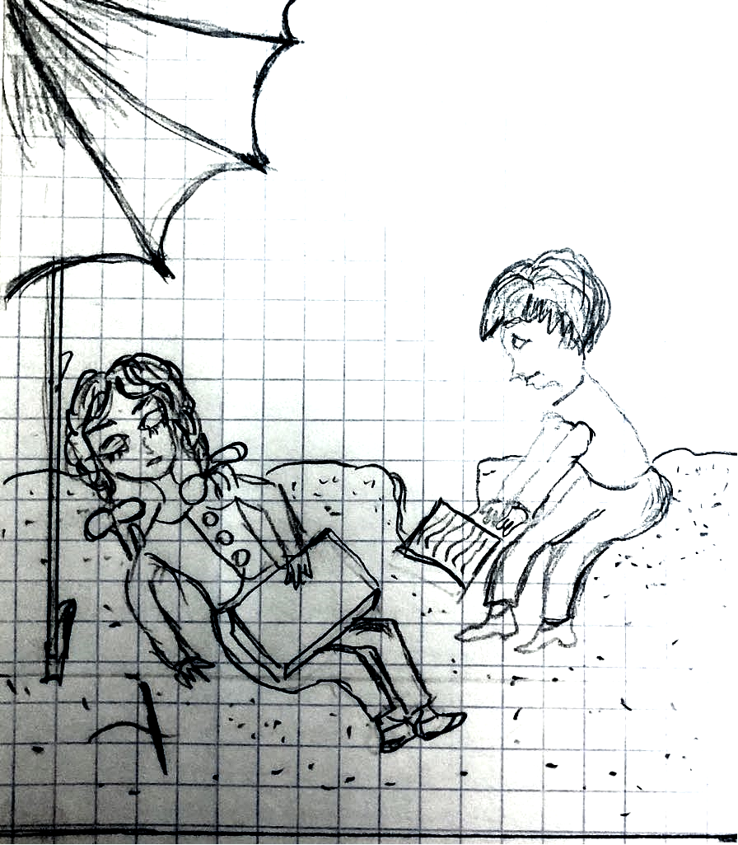  Sid hid the test in the sand.  He taps Nip. |  | 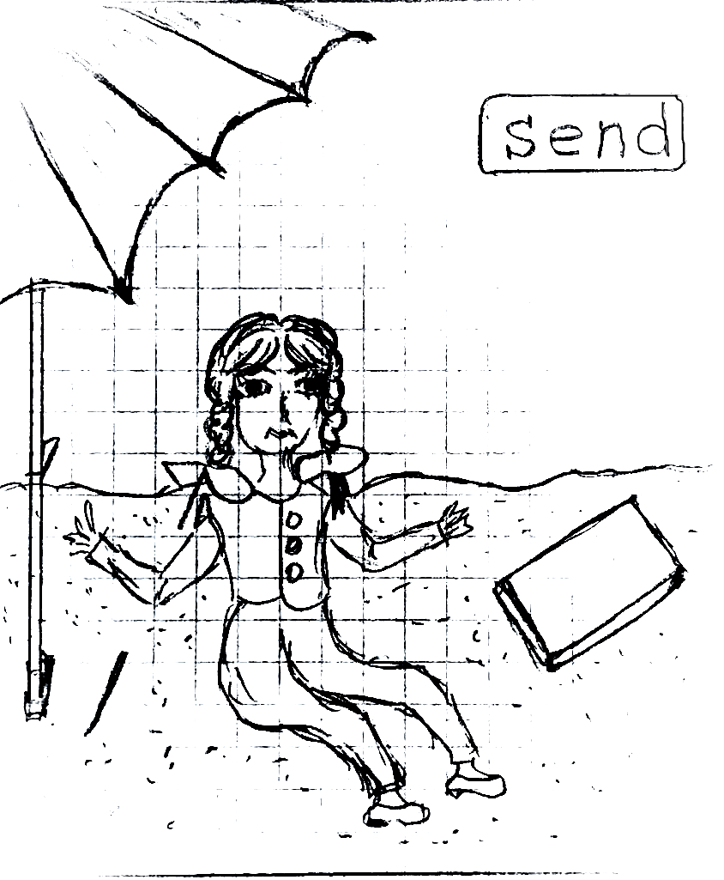  Nip sat.  The test? Nip didn't end the test, and she didn't send the test!
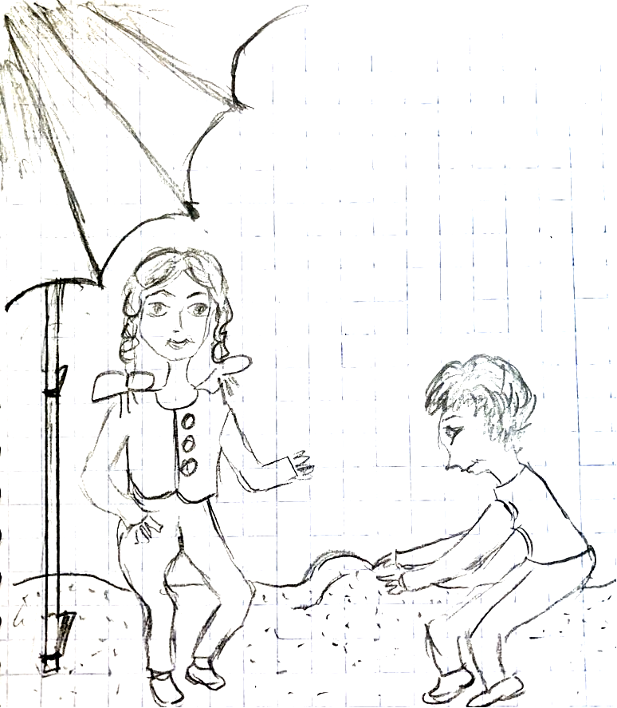  She steps past Sid…he has the test that is in the sand. Nip said, "Sid is a pest!" | 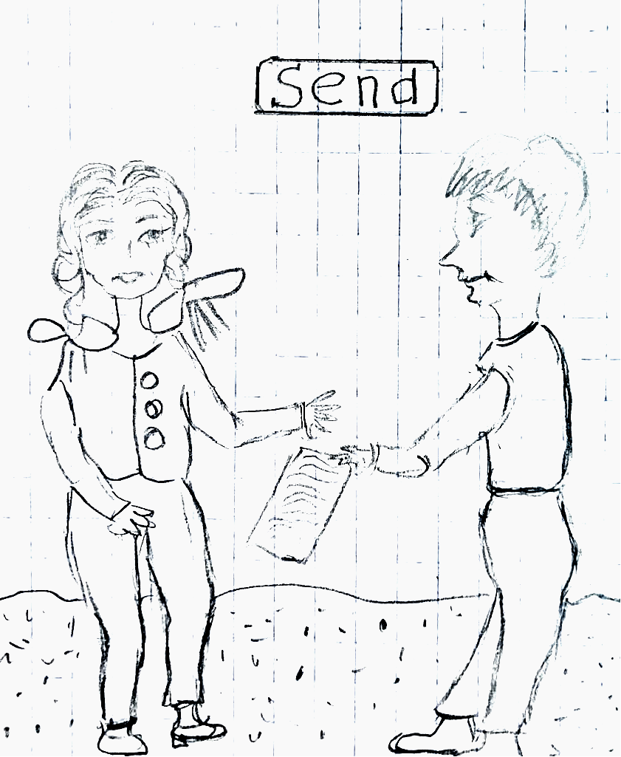  Sid said, "This is the test. Send it!" Nip said, "The test!" Nip sent the test. Sid isn't a pest. |  | 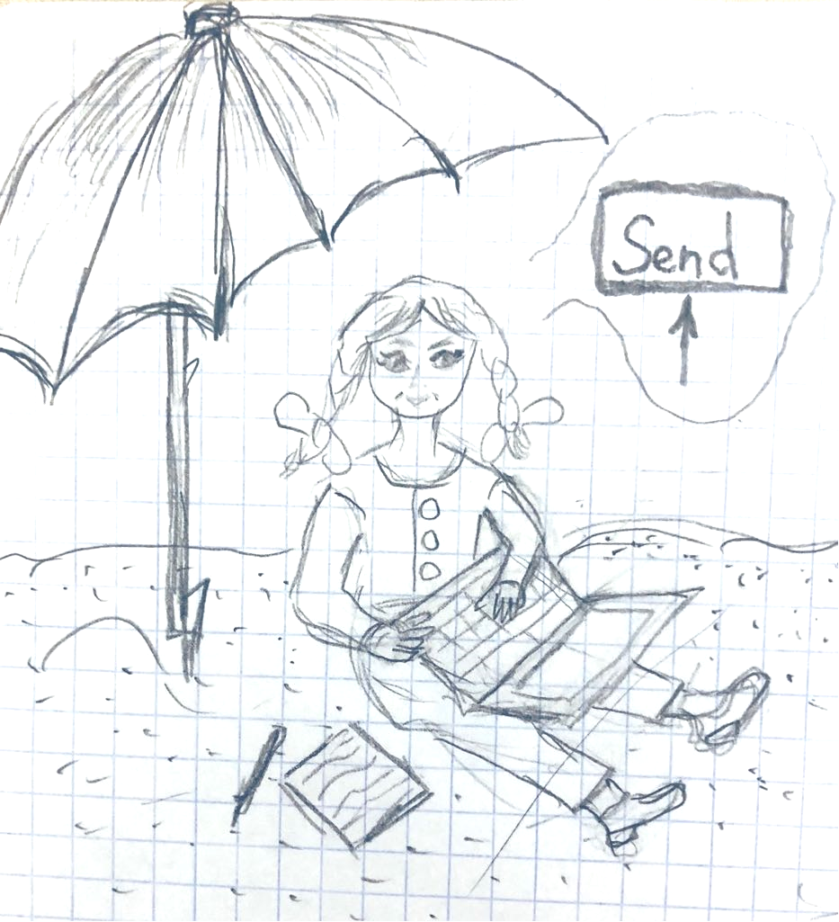  Nip taps "Send" and sends in the test.

Word List
1 |  | sand
2 | 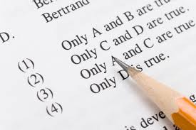 | test
3 | 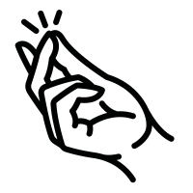 | snap
4 | 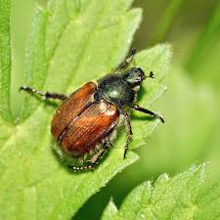 | pest
5 |  | this
6 | 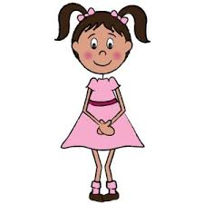 | she
7 | 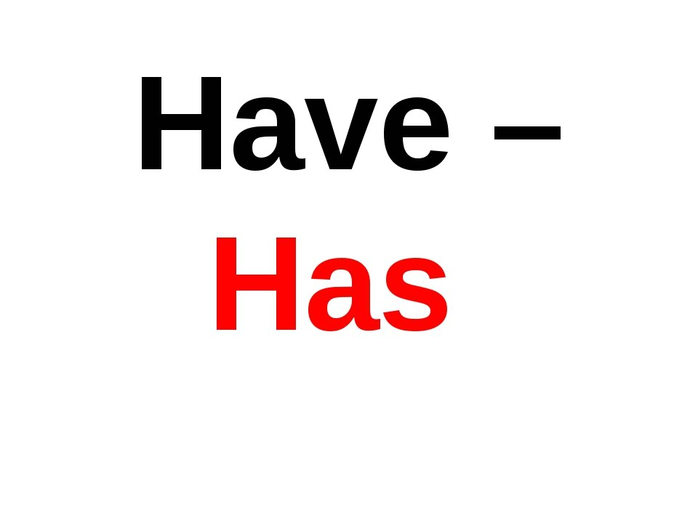 | has
8 |  | said
9 | 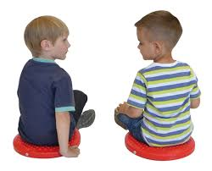 | sit
10 |  | nap
11 |  | send
12 | 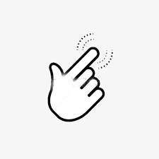 | tap

Game:
Can you find all the hidden words in this word search?
Words can go in the following directions:

p | s | k | m | n | p | t | p | y | k
f | i | b | b | d | a | a | h | t | r
t | h | e | n | d | n | y | e | a | r
j | t | e | i | i | t | s | k | s | t
n | p | a | n | s | t | s | j | u | t
w | s | e | t | n | r | t | e | f | a
i | k | f | b | i | s | l | m | p | p
s | e | n | d | h | s | a | h | w | o
r | w | a | e | u | k | o | n | s | k
o | m | c | u | b | l | a | a | t | l

end | has | nap
pest | said | send
she | sit | snap
tap | test | that
the | this

Puzzle: Help Nip Get Out of the Pit and Pass the Test
Instructions for preparing game:
- Glue this page and the next one onto cardboard or colored paper.
- Cut the words into puzzle pieces. Cut out Nip.
- Cut out the pit/puzzle “cover” from the third page, to cover the pieces in the pit that have not been filled in. Crease at the indicated lines. Tape with cellotape at the top of the pit.

sand test snap

she pest

has this

said nap

tap sit

send

Nip

Puzzle: Help Nip Get Out of the Pit and Pass the Test
To Play: cover this pit with the cover paper, except for the bottom word, place Nip on top of the cover at the bottom of the pit, and work your way up.
Fold under the lowest visible strip of the cover to expose each line of puzzle pieces.



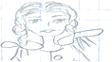

Cover for uncompleted part of puzzle: Crease backward on dotted fold lines, then unfold to start puzzle. Fold under from bottom to uncover layers of puzzle one by one.

