Len Finds Track
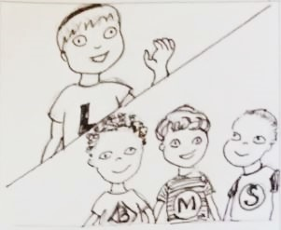  This is Len. Len Lambent.  These are Ben, Mike, and Sam. | 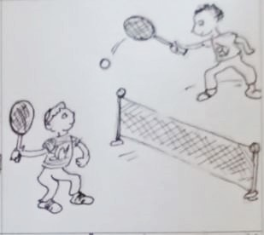  Mike likes tennis. He has a racket.  Ben likes tennis. He has a racket.  They hit and hit.
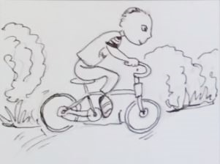  Sam likes bikes. He rides and rides, miles and miles. | 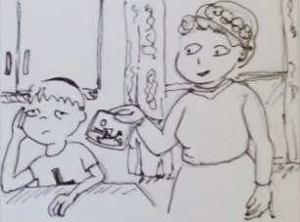  Len hasn't a racket. He can't hit.  Len hasn't a bike. He can't ride.  Len sits inside. He is sad.  Len talks. Mrs. Lambent listens.  "Can this help?"
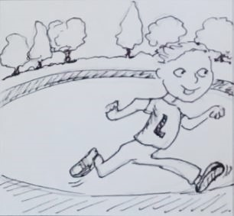  Then Len smiles. "I like track!  I can sprint laps and laps!"  Len ran laps and laps. He ran a mile!  At last, he's tired. | 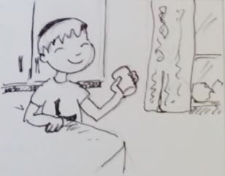  He sits inside, sips his milk,  licks his lips, and smiles.  Len likes track!

Word List
1 | 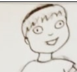 | Len
2 | 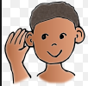 | listen
3 |  | likes
4 | 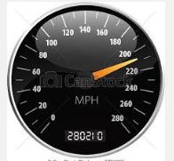 | miles
5 | 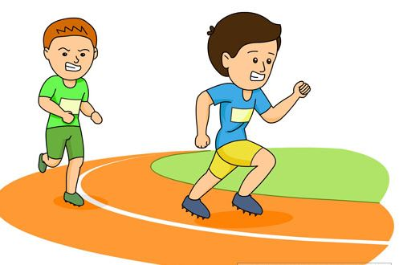 | laps
6 | 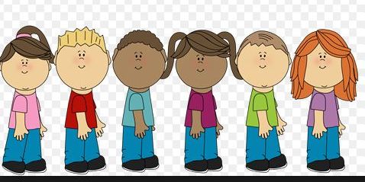 | last
7 | 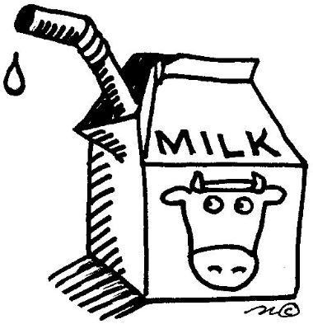 | milk
8 | 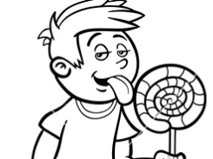 | licks
9 |  | lips
10 |  | smiles
11 |  | talk
12 |  | sprint

Game:

Help Len Sprint a Lap!

Directions: Print out the following pages. Cut around game outline. Combine the first four pages to make a board for a board game. Cut cards from pages 5 and 6. For best results, glue the game and cards onto cardboard.

To play, you will need a die and game player pieces for each player.
Put the tennis cards on the racket and the bike cards on the bike.

Players roll the die and move the number of spaces on the board. If they can read the word written on the space, they get to stay there. If they roll a 1, they can choose to pick a "bike card." (Some are helpful and some are harmful, so it's a gamble.) If they roll a 6, they can choose to pick a "tennis card." (Same gamble.)

The first player to move the playing piece around the track wins.
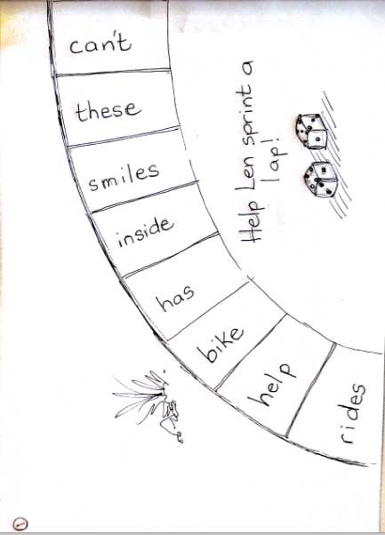

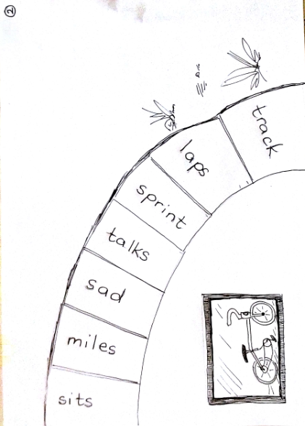

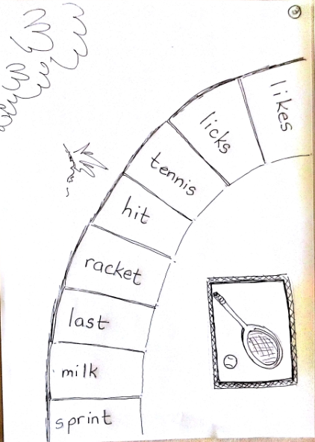

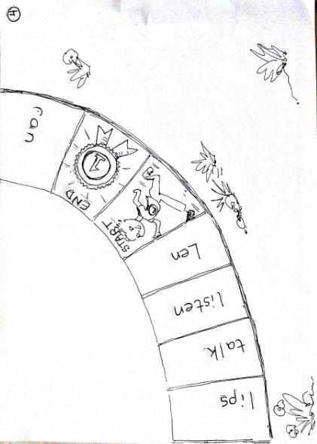

Bike Cards  Ride back 4! ☹ | Bike Cards  Ride fast 4! ☺
Bike Cards  Ride back 2! ☹ | Bike Cards  Ride fast 2! ☺
Bike Cards  Ride back 5! ☹ | Bike Cards  Ride fast 5! ☺
Bike Cards  Ride fast 1! ☺ | Bike Cards  Ride fast 3! ☺

Tennis Cards  Help find the racket.  Rest here.  (1 turn) | Tennis Cards  Sprint to the end! ☺
Tennis Cards  Len is tired.  Rest here. ☹  (1 turn) | Tennis Cards  Sprint 4! ☺
Tennis Cards  Sprint 5! ☺ | Tennis Cards  Len is tired.  Rest here. ☹  (1 turn)
Tennis Cards  Look for the racket.  Back 2! ☹ | Tennis Cards  Sprint 6! ☺

