Sue and Stu’s Stew
On Tuesday Sue and Stu went for a stew! | On the menu there was no normal stew, I’ll give you clue…  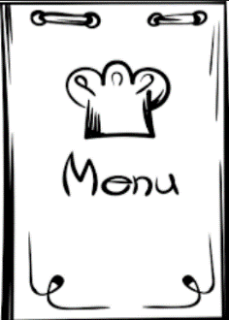
It wasn’t made from glue, but it was blue!  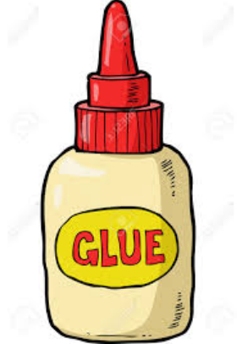  X | “A blue stew!” Stu said to Sue,  “I’d rather jump in a pool!”
"That’s rather cruel," said Sue to Stu. | “True,” said Stu. “At least it’s not made out of goo!”
1 |  | Tuesday
2 |  | Sue
3 |  | Stu
4 | 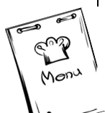 | menu
5 | 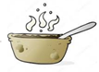 | stew
6 |  | clue
7 | 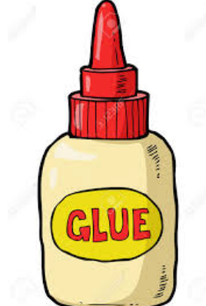 | glue
8 |  | blue
9 |  | pool
10 |  | cruel
11 |  | true
12 |  | goo
Bingo
Preparation: Lamination optional. Print two copies of the first board and one copy of the second. Cut one copy of the first board into word squares and put them in a bag. Have markers (beans, buttons) ready to mark words or laminate boards and use erasable markers to mark boards.
Play: Have the learner draw words from the bag and read them aloud. Place a marker on the word on your board. Three in a row in any direction wins. Have the learner read aloud the words in the completed row, and translate them for bonus points.

Lesson 60 - BINGO!
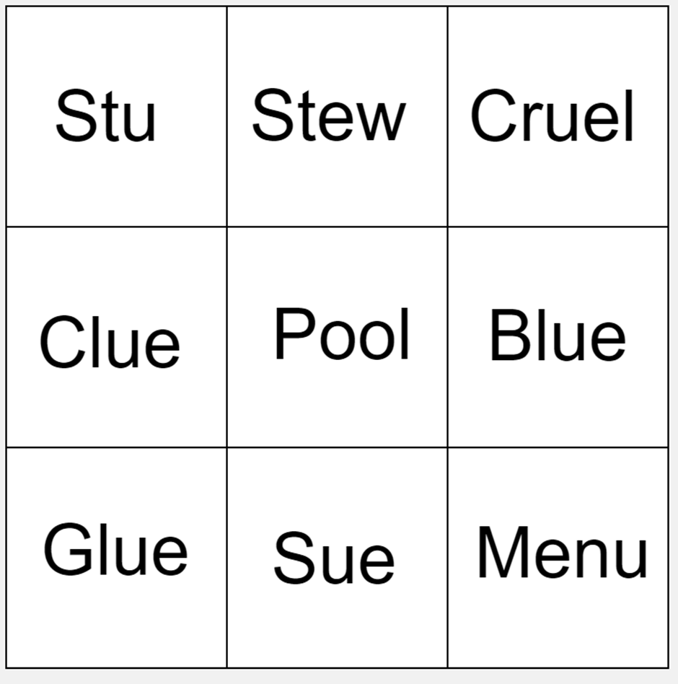

Lesson 60 - BINGO!
