Jay’s Essay

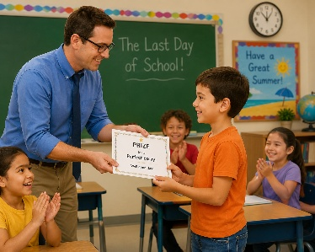
It was the last day of school. The sun shone and Jay’s class was happy.
Mr. Clay said, “Jay’s essay was perfect!
He wins a prize!”
Jay grinned.
May, his best friend, sat next to him.

“Let’s stay after class to help Mr. Clay,” said May. “It’s a way to say thanks.”
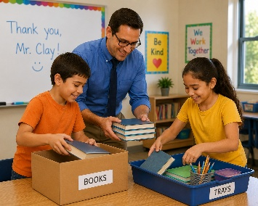
Jay grinned again. “Okay!”
At noon, the bell rang. The kids ran away to play in the yard, but Jay and May stayed in the class.
They helped Mr. Clay pack books and tidy trays.
When Jay got home, he suddenly remembered, “Oh no! I forgot my essay! I wanted Mom and Dad to see it!”
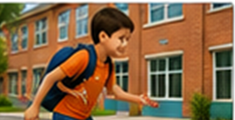
Jay ran all the way back to school. Mr. Clay was just locking the class door.
“Good!” said Mr. Clay with a smile. “Here is the prize essay!”
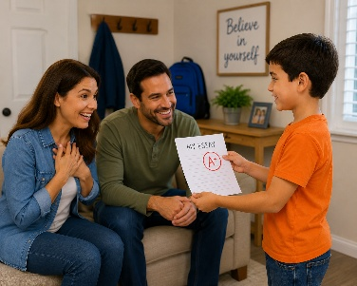
Jay smiled happily. “This is the best day!”

Word List
1 |  | Jay
2 |  | May
3 |  | essay
4 |  | day
5 |  | play
6 |  | stay
7 |  | away
8 |  | way
9 |  | okay
10 |  | say
11 |  | tray
12 |  | clay

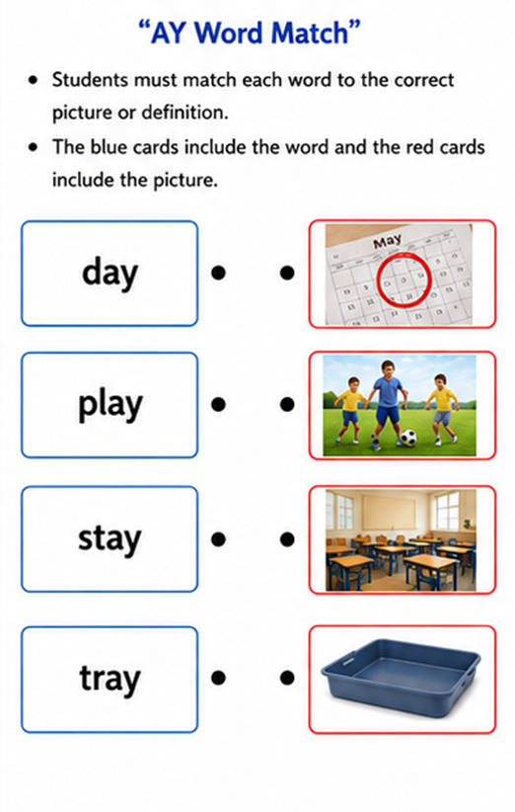

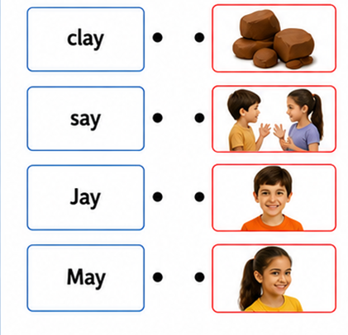
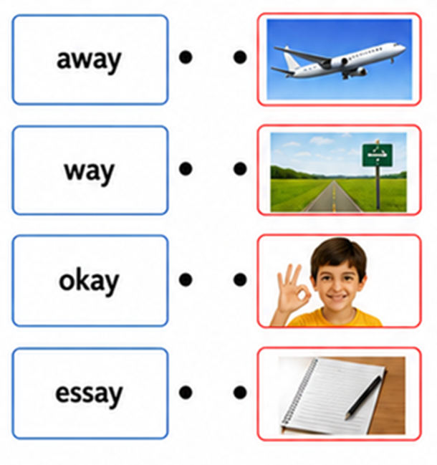

Online Game:
A Wordwall game using the same AY words and pictures.
https://wordwall.net/resource/113446435

