"A Vision Mission"

Jean and Sean took a shortcut behind the school. They passed a garage with peeling paint.
"Let’s take a look," Sean said. Jean hesitated. “I’m under the impression this place hasn’t been opened in years.”

Inside, sat a television with a cracked screen. Next to it lay a circular cardboard wheel covered in strange letters.
“It’s a decoder!” Jean said. “Like the ones spies use on secret missions.”



Beside the decoder was a notebook titled "A New Vision for the Future." Sean flipped through the pages. There were drawings, calculations, and symbols—all carefully labeled. “This person was a real professional.”


Jean held up a page with detailed notes. “It’s like a puzzle.”
The two friends sat down and began turning the wheel, trying to match the symbols to the alphabet.

“I think I’m getting it,” Sean said after a few minutes. “But there’s so much tension in the way this is written—like they were in a rush.”
Suddenly, the television flickered. A pixelated image appeared of a man in a lab coat. His voice was low but clear: “You’ve found my decoder,” the man said.



“Now you must draw your own conclusion. My invention was never meant to be a possession of the powerful. It was a gift. Use it wisely.” The screen went black.
Jean and Sean looked at each other. “So... what now?” Jean asked. “We decode the rest,” Elijah said. “This was only the first version of the message.”



Word List
1 |  | impression
2 |  | mission
3 |  | vision
4 |  | professional
5 |  | television
6 | 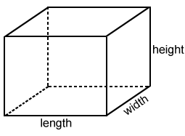 | dimensions
7 |  | tension
8 |  | conclusion
9 |  | possession
10 | 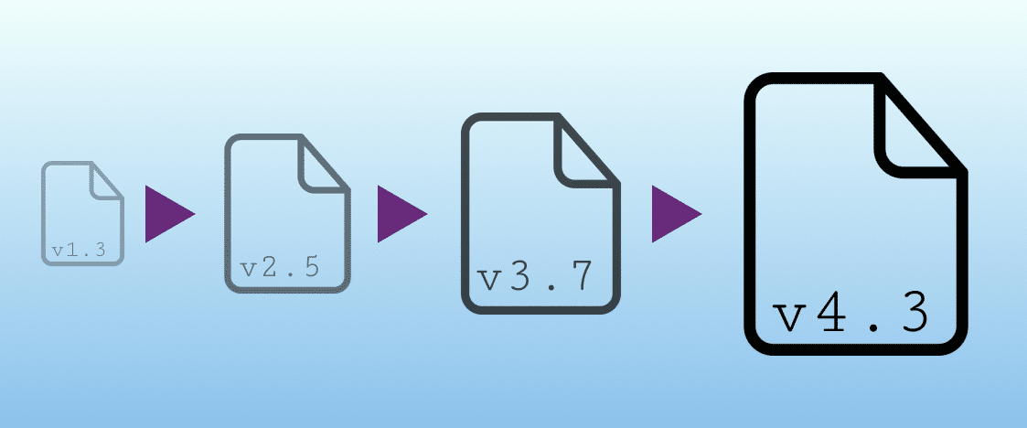 | version
11 |  | solution
12 | 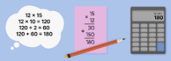 | calculation

Caesar Shift Cipher

How to assemble your decoder:
Step 1: Print the two wheels on the next page, preferably on cardstock. Cut them out. Step 2: Place the larger wheel on the bottom and the smaller wheel on top.
Step 3: Poke a round paper fastener (aka, brad) through the middle of both wheels. Ensure the wheels can rotate freely.

How to use your decoder to encrypt a message:
Step 1: Write your message in normal text.
Step 2: Select a rotation (ROT) between 1 and 25 to encrypt your message.
Step 3: Turn the small wheel so the ROT number you’ve selected matches up with the red A on the large wheel. Once you’ve positioned the wheels for this step, be sure they do not move again. You may wish to use a paperclip to keep them in position.
Step 4: For every letter in the message you wish to encrypt, first find it on the larger wheel. Then locate the corresponding letter right below on the smaller wheel and write it down as part of your encrypted message. For example, to encode the word HELLO with ROT2, you would write JGNNQ. To encode the word HELLO with ROT12, you would write TQXXA.
How to use your decoder to decrypt a message:
Step 1: The decryption process is the reverse of the encryption process. However, to properly decrypt the message you need to know what ROT was used.
Step 2: Turn the small wheel so the ROT number of the code matches up with the red A on the large wheel. Once you’ve positioned the wheels for this step, be sure they do not move again. You may wish to use a paperclip to keep them in position.
Step 3: For every letter in the encrypted message, first find it on the smaller wheel. Then locate the corresponding letter right above on the larger wheel and write it down. For example, the word JGNN! encrypted with ROT2 would be decrypted to say HELLO. The word TQXXA encrypted with ROT12 would also be decrypted to say HELLO.

Sentences for decoding:
"The decoder reveals a hidden version of the truth, but only those with vision will understand its mission."
Shift +4:
"Xli higshi vievpew e lhhir zivwmsr sj xli xvyxl, fzx srpc xlswi amxl zivmsr ampp yrhivwxerh mxw qmwwmsr."
Shift +12:
"Fbt psohdq dovpmewe m ttbtz hloeqcb bz fbt jljfd, rlm adbt fbtda mbiw hloeqcb meid jzhpbftfd vfi ayfftcf."
"What you see is not the whole dimension. Look deeper, draw your own conclusion."
Shift +4:
"Alex csy wii mw rsx xli aspsh hmqirwsr. Pssp hii tiv, hvea csy sar gsrgpywsr."
Shift +8:
"Elib gwc aam qa vwb bpm dwtxl lqumvwwb. Twwt lmm xmd, lzhe gwc wex kwtkxcwzb."
Shift +12:
"Ipmd kyg eeq ue zaf fqt haxbp puyqzaae. Xaax ppq bqh, pdit kyg bai oapobgade."

"Every version of the message contains a layer of passion, expression, and meaning."

Shift +4:
"Izcvs zivwmsr sj xli qiwweki gsrrexmrw e peciv sj tewwmsr, ibtvwwsmsr, erh qiermrk."

https://inventwithpython.com/cipherwheel/

