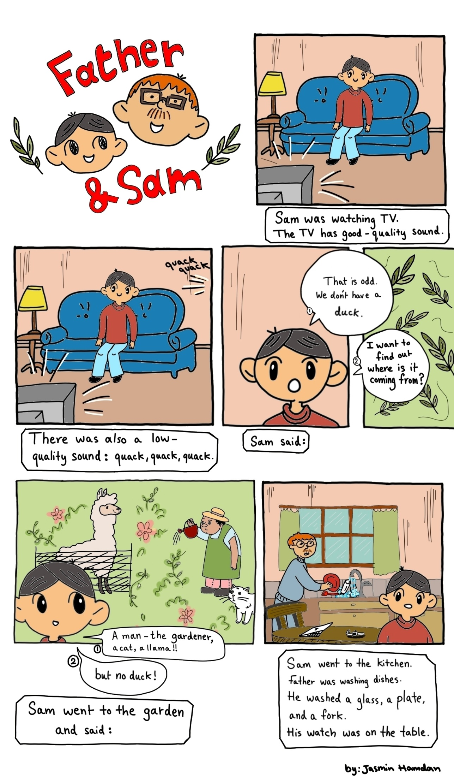
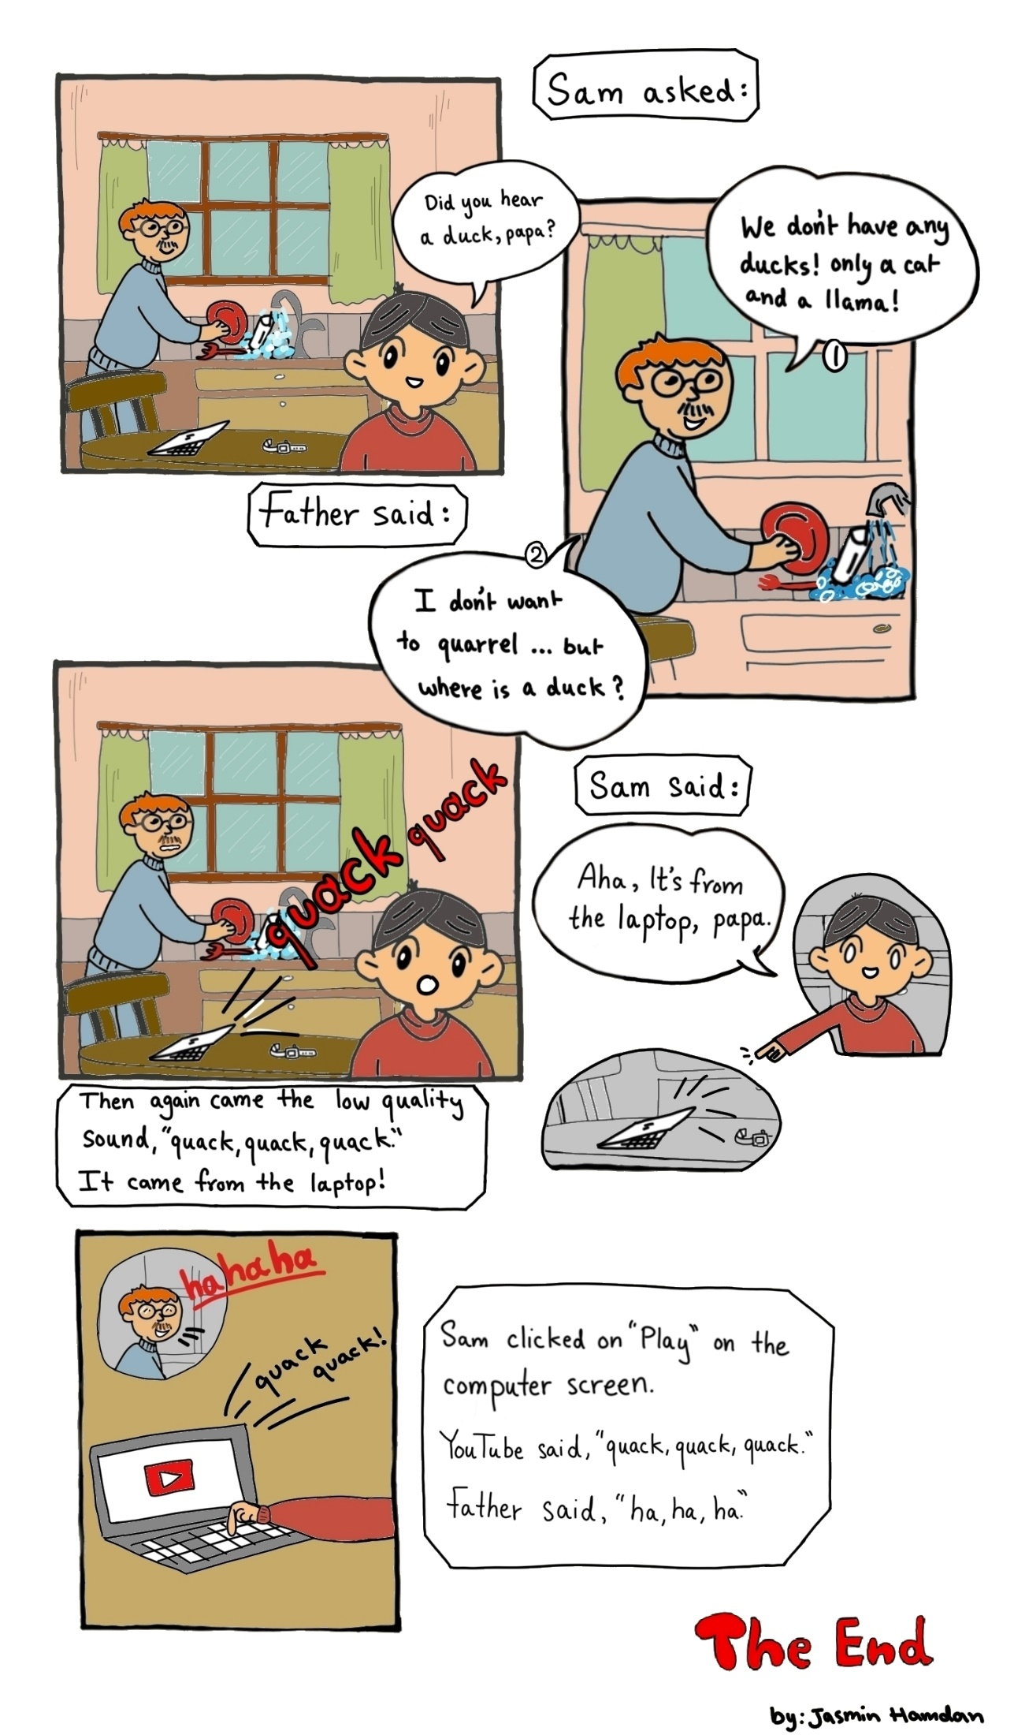

Word List

1 |  | father
2 | 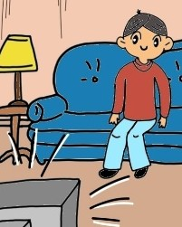 | watch
3 | 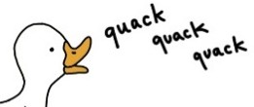 | quack
4 |  | wash
5 |  | llama
6 | 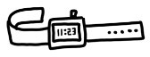 | watch
7 | 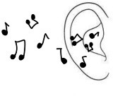 | hear
8 |  | asked
9 | 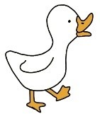 | duck
10 |  | low
11 |  | high
12 | 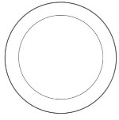 | plate
13 |  | fork
14 |  | glass
15 | 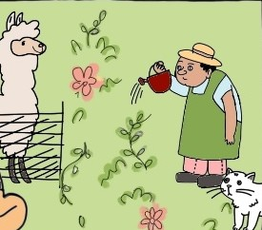 | garden
16 |  | laptop

Memory Matching Game
Online version: https://wordwall.net/resource/52501629
Paper version, Preparation:
First, print the cards listed below. Second, glue them on cardboard or coloured paper (all the same colour). The third step is to cut them out, and you're done!
How to play:
This game is like any memory game. Up to 5 players can play this game.
First, we start with all cards (images, words) face down and players (students with/without a teacher) take turns to turn over any two of the cards on table. If they chose two cards that match (e.g., card 1 - image of a duck, card 2 – the written word "duck"), then they can play another round, and keep the cards they won. If not, turn the cards back over. The next student starts his/her round and so it continues. At last, when there are no cards left on the table, each player counts their cards. Whoever has the most pairs wins!

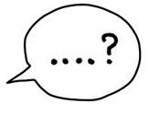 | asked
 | fork
 | father

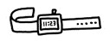 | watch
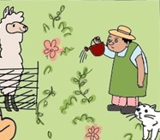 | garden
 | laptop
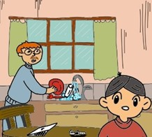 | kitchen
 | low
 | high
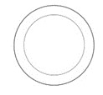 | plate
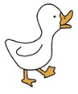 | duck
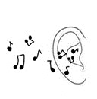 | hear
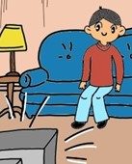 | watch
 | llama

A Different Kind of Memory Game
To play online, download the accompanying PowerPoint file and follow the instructions in the separate document.
Preparation:
- Cut out coloured rectangles, below (to cover the picture cards).
- Cut out the table of numbers-to-colours.
- You need one dice.
- Use the image (picture) cards from the above matching memory game in this game also.
How to play:
Up to 5 players can play this game.
- Set out six of the picture cards on the table. Players should study the six images on the table for less than a minute and try to memorize their places.

- Cover the picture cards using coloured rectangles.

- Now, a player should roll the dice and the number indicates a certain color (see figure 1). The player should guess (or try to remember) which image is hidden under that color card, and say the word in English. After they answer, uncover the image to reveal what's hidden. If they guessed right, the player can take the card and put another one from the "still–not–used" cards. The winner is the one who took the most cards.
Figure 1:
Throw dice and uncover this color:
1 | pink
2 | blue
3 | green
4 | yellow
5 | brown
6 | orange

Coloured squares to cover the picture cards for memory game (or cut out colored paper)

1 | 2
3 | 4
5 | 6

**********************************************************
Sorting Game (sounds of “a”)
Many Sounds of the Letter “a”

Online version: https://www.liveworksheets.com/tj3342728qa

Preparation:
Laminate and cut out the six round boards and the pentagonal word cards on the following pages.

How is it played?

This game can be played with one player or more. First, make a pile of the word cards – the written words facing down – on a table. Place the 6 round boards on the table for the player to see and to add the word cards on them later on. Second, instructions should be explained to the players. That is: a player takes one card from the table and says its meaning in his/her native language or acts it out without words. Players should guess what it is and say the word in English. Together they think which circle it belongs to, then they add it there. The next player will do the same, until they fill all the six circles. At last, for cards remaining in the pile, even though the circles are filled, the player should say where the card belongs to, and give a sentence in English (if they can’t, they can search for the word in the text (story) and read it, then translate it to their native language).
Enjoy!

