True or False?
By Yara Rezeq and Maya Hirsch Kupchik
Preparation: Choose a Hickey lesson and make up true/false statements that use words the learners can read and understand only through that lesson. (Suggestions: use the Hickey Word List, or revise sentences from stories the class has read.) Find pictures (your personal pictures or from public sources, i.e. Google images) that illustrate the sentence (or not, if false).
This can also be a great homework assignment- have each student take a picture and write a sentence that is true or false to share with the class.
Play: Student is presented with a picture and a sentence. After reading the sentence out loud, they decide if it is TRUE or FALSE. For each correct answer, they get 2 points. You can award a special prize if they reach a certain score. To play in a large group (whole class) you might organize the pictures and sentences in PowerPoint and project them on the wall; for smaller groups or individuals, print the pictures and the sentences and hold them up.
The special idea behind this game is to use real life pictures of the teacher or students, instead of using pictures of anonymous people. It makes the game much more interesting and has the benefit of getting to know each other better.
Some examples we used:
“No boys yet”- picture of the teacher with her sisters (girls only).
“Maya is sad”- picture of teacher with a sad/happy face.
“Dad is the best”- picture of teacher’s husband holding a happy baby.
Following are some pictures we found online- just to give you an idea. We believe your own “real-life” pictures will be more authentic and interesting for your students!

Figure 1: Dad is the best!

Figure 2: Maya is sad

Figure 3: Yara isn't sad
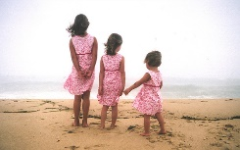
Figure 4: No boys yet!

Figure 5: Yara is sick in bed

Figure 6: Yara isn`t sick

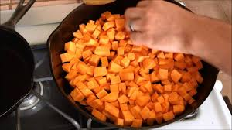
Figure 7: Yams are in a pan

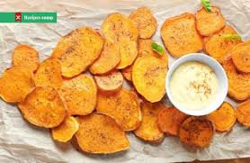
Figure 8: Yams are the best snack

