Game 1: Rules 1-11
How to prepare the game
To make the game, prepare a circle that is divided into four parts, and color each part a different color. Each part will represent a different type of question.
In this example: 1) What? 2) Yes/No questions 3) Why? 4) Give an example. (You can choose other types if you like) . (Now that I have played the game, I suggest you also add a fifth section, "Wild," that will allow players to choose the color of question to answer, since the goal of the game is to answer one question of every color and they would otherwise need to skip turns if they already have the color that the hour hand points to.)
Label each section with the question type, to show which color represents each type of question. After preparing the circle and its parts, put an hour hand that spins in the middle of the circle.
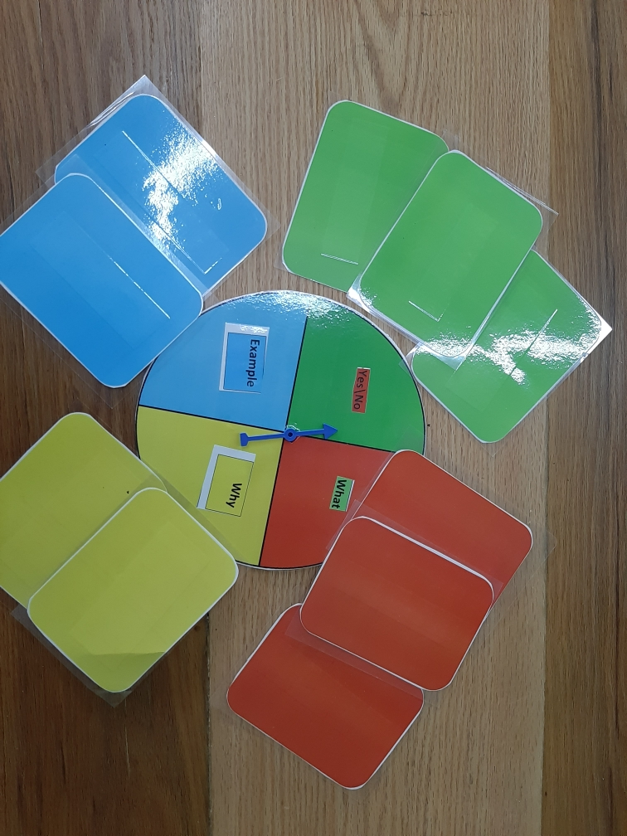

Prepare cards. You can make as many cards as you like; there should be enough for the number of players. This example has 12 cards, with each 3 cards for each type of question. On those cards, write the questions you want to ask in the game. Glue each question card to a backing of the color that matches the type of question.
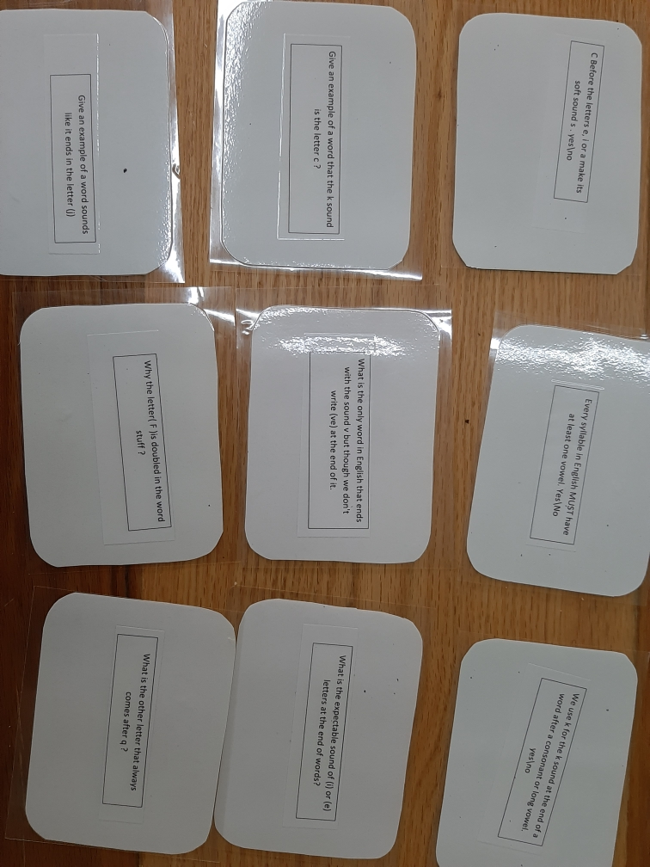

Question Cards
Give an example of a word where the sound (k) is spelled with the letter c . | Why do we need to add "-es" when making plurals of words ending in hissing sounds?
Give an example of a word that sounds like it ends in the sound (j). | Why aren’t there two l's in the word "welfare" ?
Give an example of a word with a final "e" where we keep the final e when adding "ly" to the word, but we drop the final e when adding "ing" to the word. | Why is the letter "f" doubled in the word "stuff" ?
What is the other letter that always comes after q ? | Every syllable in English MUST have at least one vowel. Yes\No
What letter can be expected to make the sound (ī) or (ē) at the end of a word? | We use k for the sound (k)  at the end of a word after a consonant or long vowel. Yes\No
What is the only slang word in English that ends with the sound (v) where we don't write (ve) at the end of it. | "C" before the letters e, i or a make its soft sound (s ). Yes\No
How to play the game
Two players or more can play this game, but make sure that you have enough cards.
Sort the question cards by color, and stack them in four piles of the same color, face down.
Each player should spin the hour hand and answer a question according to the section that the hour hand points to.. If he answered the question correctly, he keeps the card. If the hour hand points to a color that he already has, he skips his turn. You may decide to let a different player answer a question that another player could not answer.
The first player who collects four different colors is the winner.

Game 2: Rules 12-21
How to prepare the game:
Prepare two groups of cards: the first group contains cards with questions, the second group has the answers to those questions.
How to play the game:
Two players or more can play this game. Spread the cards on the table (the questions and the answers). The players should read the questions and then try to find the correct answer as quickly as they can. When a player finds the answer to a question, he should take the two cards. The player who collects the most cards - wins.

Questions
In which case do we double the last consonant before adding an ending? | When do we use  -ck, -dge, or -tch  in words? | Why do we drop the final e from a root word before adding an ending in some words but, in another words we keep it?
C followed by which letters says the sound s ? | Before adding any ending(except-ing) to a word that ends in a consonant plus y we must … | How do we make a plural from a noun ending with a single f ?
g followed by which letters says the sound (j)? | In which cases do we use  -ce ? |  | In which case is the sound (ĭs) or (ēs) often spelled  -ice ?
In which cases does i come before e ? | In which case do words that start with w say (wer) as in worm? |  | How do we form the plural for words ending in an o preceded by a consonant?

Answers
In one-syllable words ending in a single vowel  plus a single consonant, we always double the last consonant before adding an ending  beginning with a vowel. | -ck, -dge, -tch may only be used  after a short vowel.  -ch (like -tch)  can come after a short vowel. | We drop the final e from a root word before adding an ending beginning with a vowel –but keep it if the ending starts with a consonant.
When c comes directly before the letters e, i or y we use the sound s | Change the y to i before adding any ending (except -ing.) | We change the -f to -v and add -es.
g followed by e, i, or y says (j).  Otherwise, g says (g). | We use -ce after a long vowel sound.  We also use -ce after a ‘vowel +n’ pattern. | In words of more than one syllable, (ĭs) or (ēs) is often spelled -ice.
When it is pronounced (ē) except when it follows c  or when sounded like (ā),  as in neighborhood and weigh. | When w comes before or, it often says (wer) as in worm. | Words ending in an o preceded by a consonant usually add -es to form the plural.

