Animal Experiments
"Hi there and good morning!   | As liberal people, one of our goals is to protect animals from unusual and unethical experiments.  
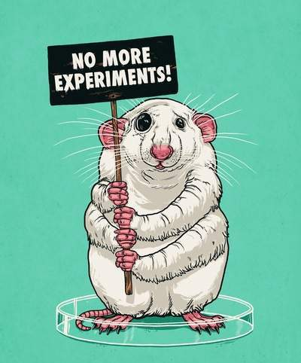  These experiments are a trial for the poor animals. | They also bring the animals to their final days!  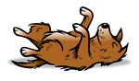
Several worldwide experts support us  although they usually keep their personal opinions to themselves.       |   For donations,  please dial:    555-7829"

Word List
1 | 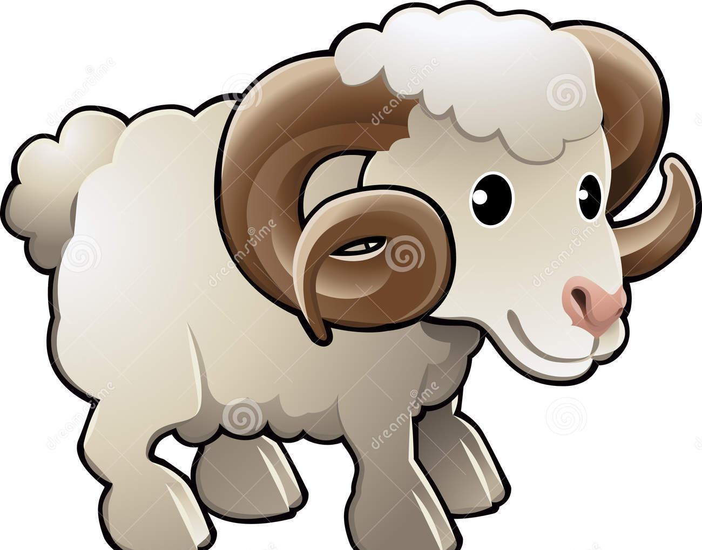 | animal
2 |   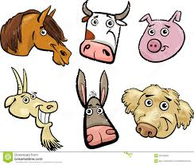  several animals | several
3 | unusual  shoe | unusual
4 |  | also
5 |  | goal
6 |  | trial
7 |  | dial
8 |  | liberal
9 |  | final
10 | 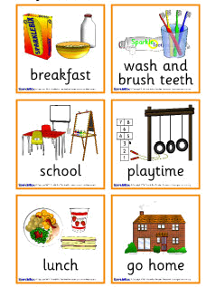  Things  That  I usually do | usually

Trivia Game

Questions | Answers
In what tense does a time expression usually appear? | Present Simple
Means “a few” | several
Human beings use them for food, clothing, pets, research, etc… | animals
The last one | final
My purpose for something is actually my… | goal
Very weird, strange and out of the ordinary | unusual
In addition, furthermore | also
Another word for a problem that also means “the situation in which a person is judged by a court” | trial
An open-minded person who fights for equal rights for all | liberal
In order to call someone I must ______ his number | dial

Compete with your friend by filling in the following chart.
Whoever finds the most words in 5 minutes is the winner.

Words that start with al- | Words that end with -al
Example: although, alright | Example: several, final

