The Dare
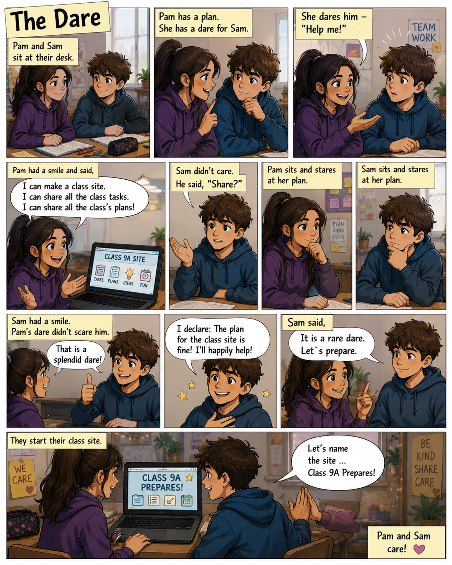
Word List
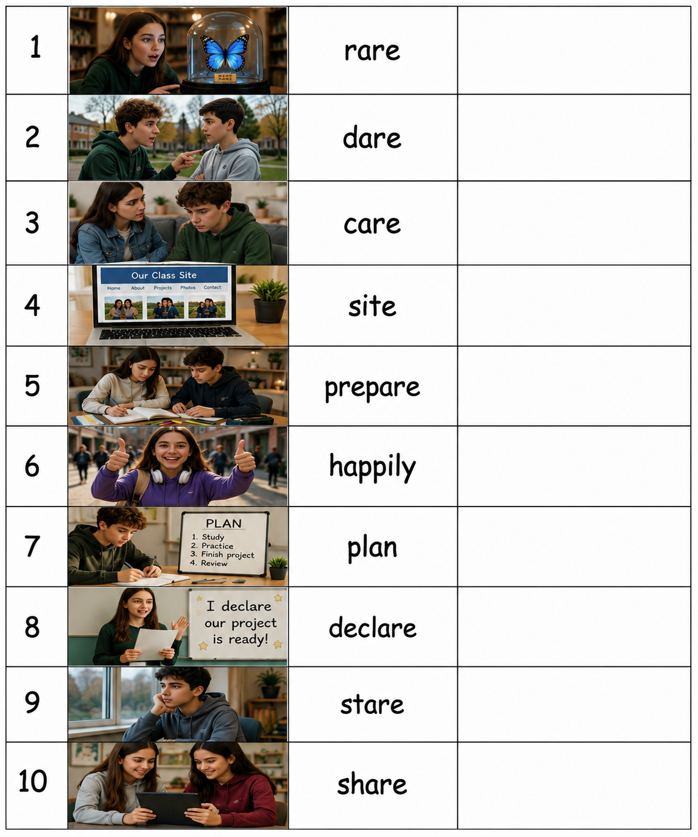

Online game: Play and practice vocabulary meanings.
https://dashboard.blooket.com/set/6a6292c21fa9ffba030ab13e

“Dare, Scare or Share?” Game
Preparation: Print board and cards. Cut out the task cards. You will need a die and game pieces.
How to play:
The participants put their game pieces on START. Everyone rolls the die and the one who gets the highest number starts the game. Roll the die and move your piece. Take the top task card, read it aloud... Now decide! You have 3 options:
- Dare! You think you can do it? Complete the task and move forward 1 extra space.
- Scare! The task is too difficult. Do not do the task and stay where you are.
- Share! You don't want to do it. Choose another player and let that player decides: DARE, SCARE or SHARE again (only once). If the second player also chooses SHARE, they must do the task.
Bonus spaces:
Whenever you land on:
5, 15, 25, 35 Roll again!
10, 20, 30 Take two task cards. Choose one.
The first player to reach FINISH wins. If you roll too many spaces, move to Finish anyway.

