Mr. Tim and the Imp
  Mr. Tim is a timid man. |   He is in a camp.
Mr. Tim met an imp in his tent.  His name is Sam.    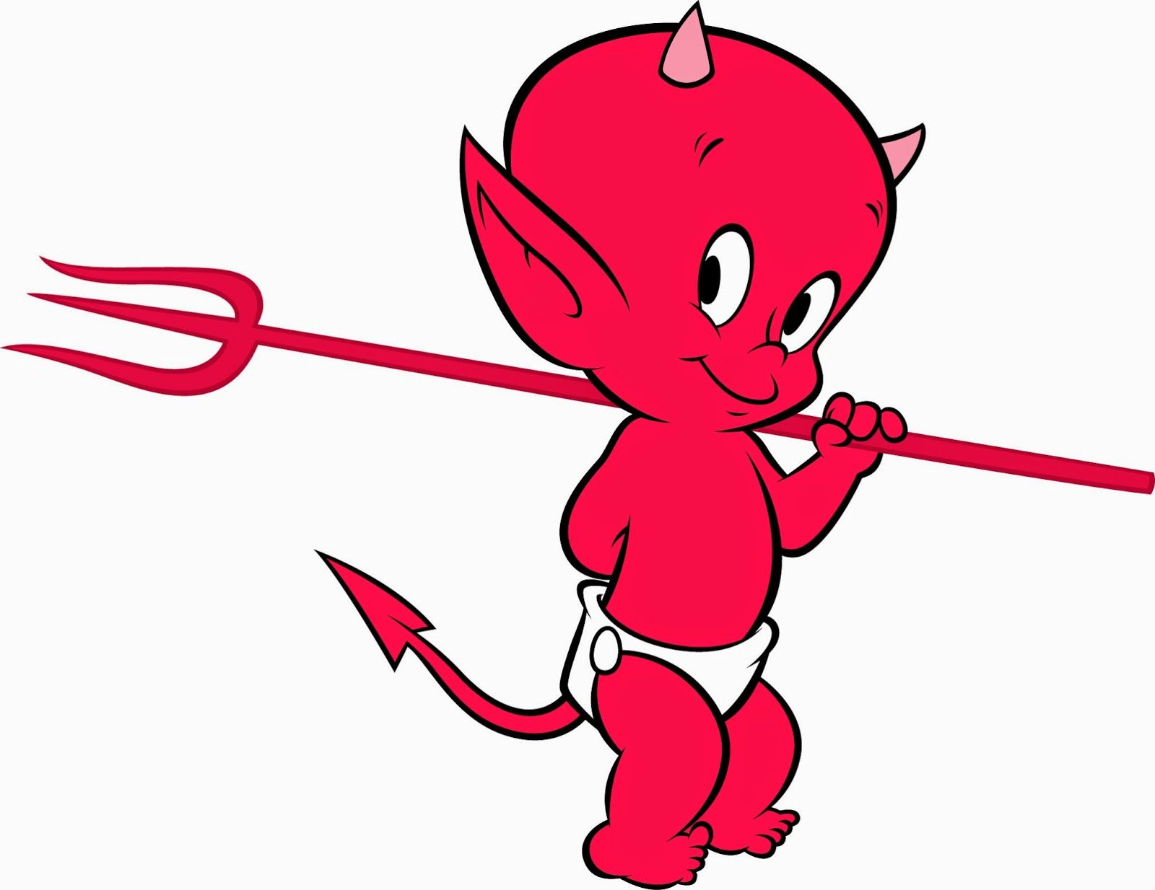 | 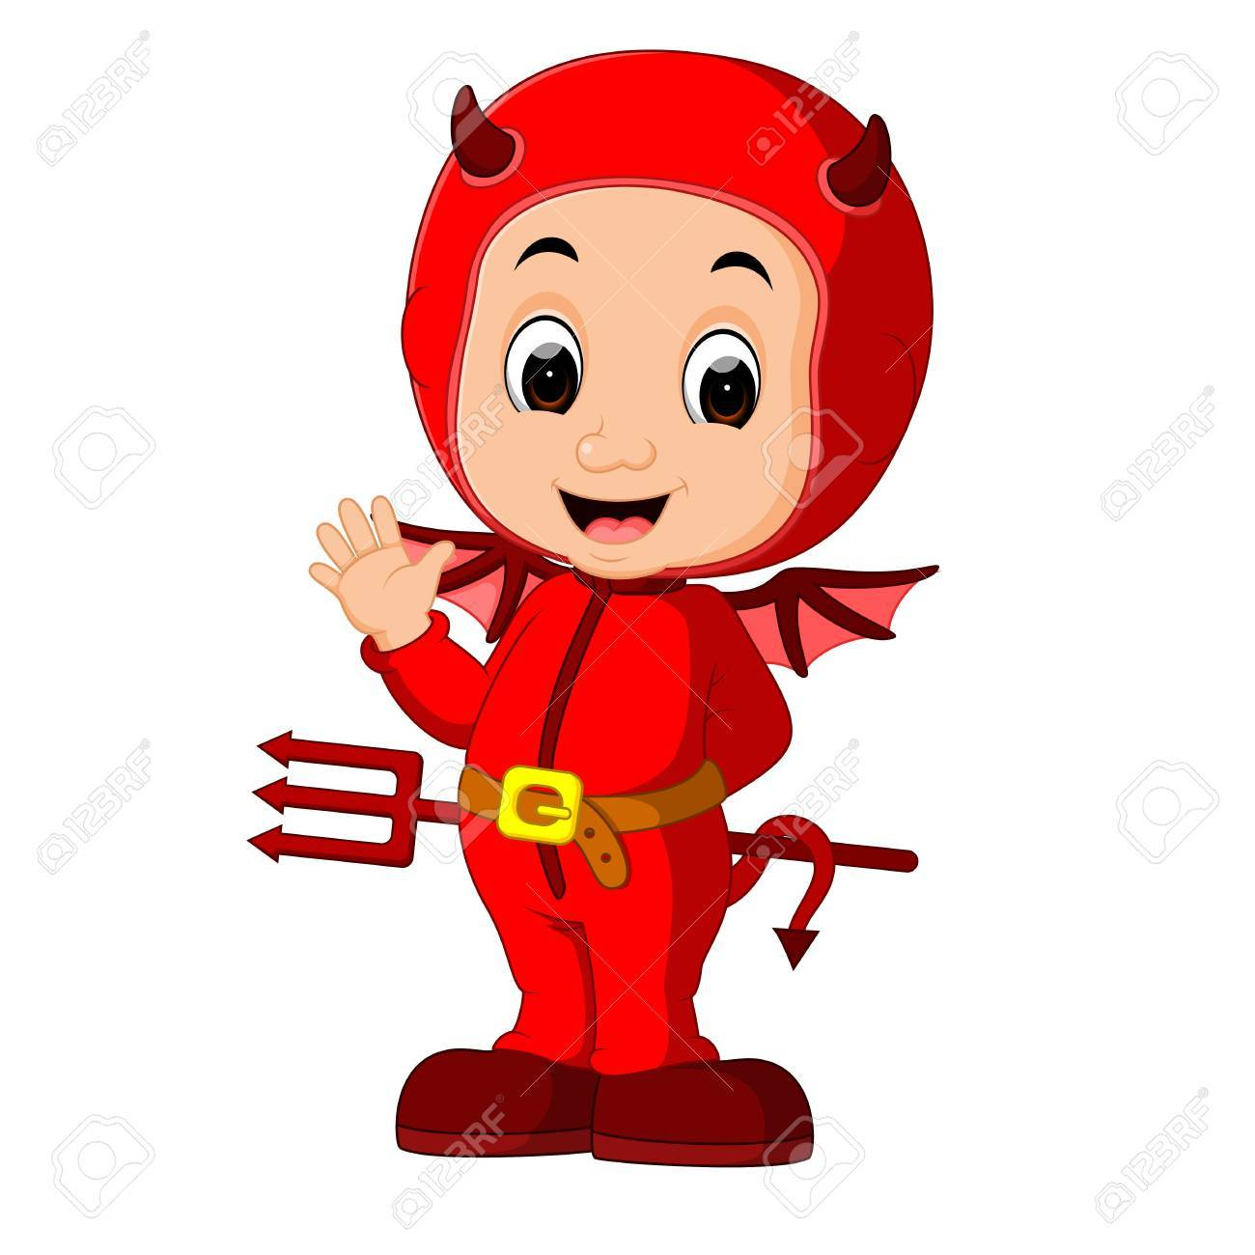  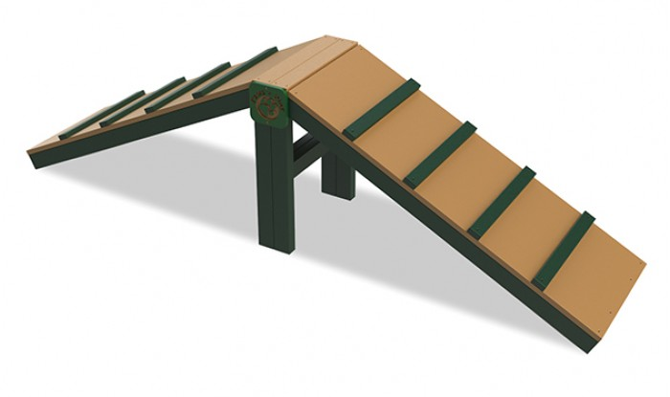  There is a ramp in the camp.  Sam the imp ran and said:  "I am Batman in red".
Mr. Tim is at the ramp.      Sam stamps and hits him in the hand. |   Mr. Tim and the imp Sam are sad.

Word List
1 |  | Mr. Tim
2 |  | timid
3 |  | man
4 |  | camp
5 |  | imp
6 |  | tent
7 |  | ramp
8 |  | I am
9 |  | Batman in red
10 |  | sad
11 |  | stamp
12 |  | hand

Memory Game
Instructions:

Preparation: Cut out the following 12 word cards, lamination optional.
How to Play: Place the cards face down.
Each player picks two cards in his turn. If the cards match than the player wins the cards. The winner is the player who collects the highest number of matching cards.

 | Mr. Tim |  | ramp
 | timid |  | I am
 | man |  | Batman in red
 | camp |  | sad
 | imp |  | stamp
 | tent |  | hand

