Winnie's Pie
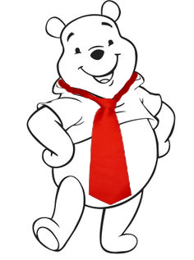  Winnie has a red tie.  Winnie likes to bake pies. | 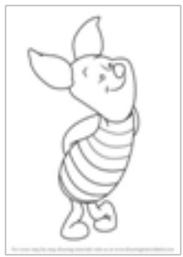  Dear Brie,  Come have a big piece of pie.  Your friend,  Winnie    Winnie invited over his friend Brie to eat a big piece of pie.
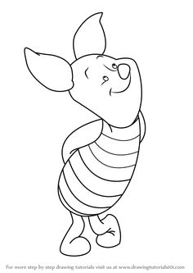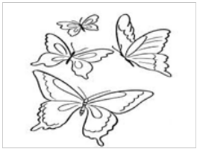  Brie walked to Winnie's home  by way of the field.  On the way, he saw many butterflies! |   But as he came close, he saw a thief stealing Winnie's big pie…  and Winnie's red tie!
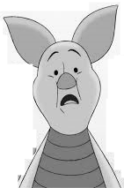  Brie shrieks! Winnie lies and cries!  The thief took Winnie's pie  and his red tie! | 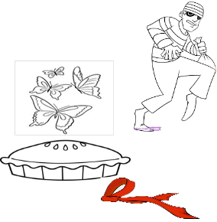  Their shrieks and cries scared away the thief.  He ran from the field…and left behind the pie and the tie.  "Mmm, good!" said the butterflies.

Word List
1 |  | pie
2 |  | tie
3 | 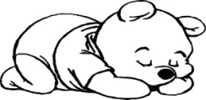 | lies
4 | 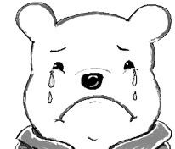 | cries
5 |  | butterflies
6 | 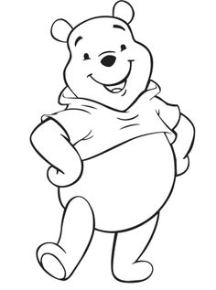 | Winnie
7 |  | Brie
8 |  | piece
9 | 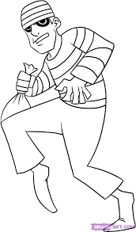 | thief
10 | 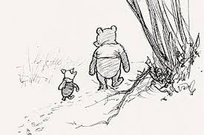 | field
11 |  | shriek
12 | 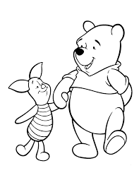 | friend

Game: Concentration/Matching game
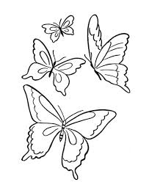 | Butterflies fly in the sky.
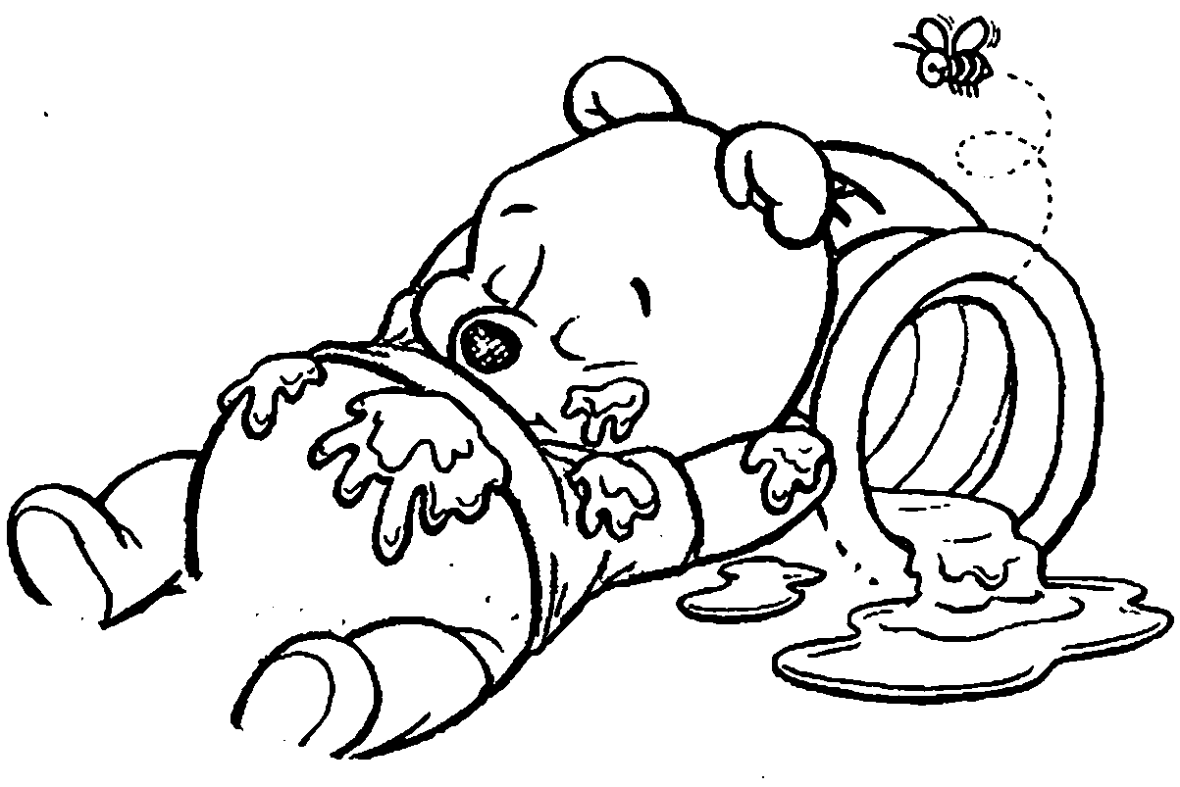 | Winnie lies and naps.
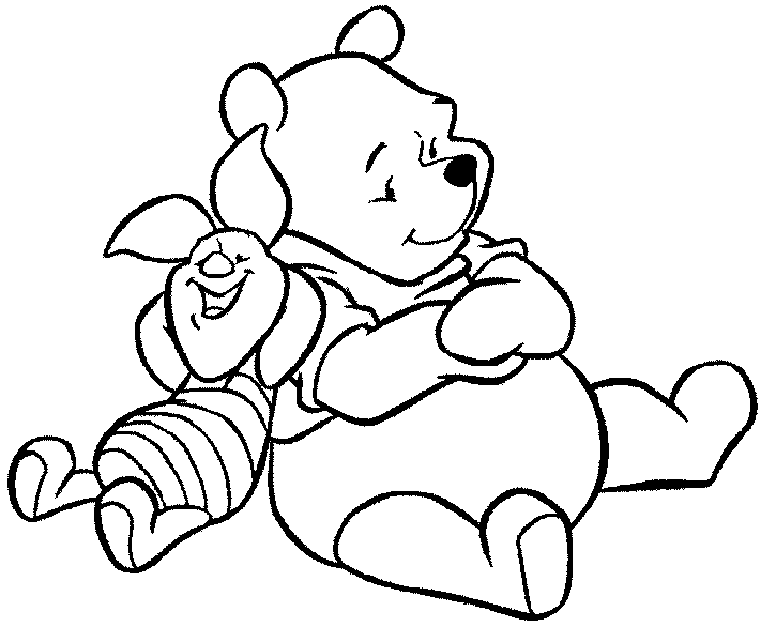 | Winnie and Brie with the pie.
 | He ate a piece of pie.
 | Winnie and Brie are friends.
 | Winnie cries.
Lotto: ie (ē) against ie (ī)
Cut out the two boards. Cut out the words and put them in a bag. Learner pulls words from bag and reads them aloud. Wichever player has it – puts a marker on their board on the matching picture. First one to fill their board wins (after they repeat the word for each picture on their board.)

ie (ē)

ie (ī)
☞ | ☞

piece | field | lies
Brie | shriek | pie
Winnie | cries | butterflies
thief | pies | tie

