Fred the Firefly

My friend Fred is a firefly.  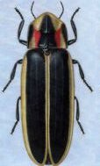 | He and his family fly in the  sky.  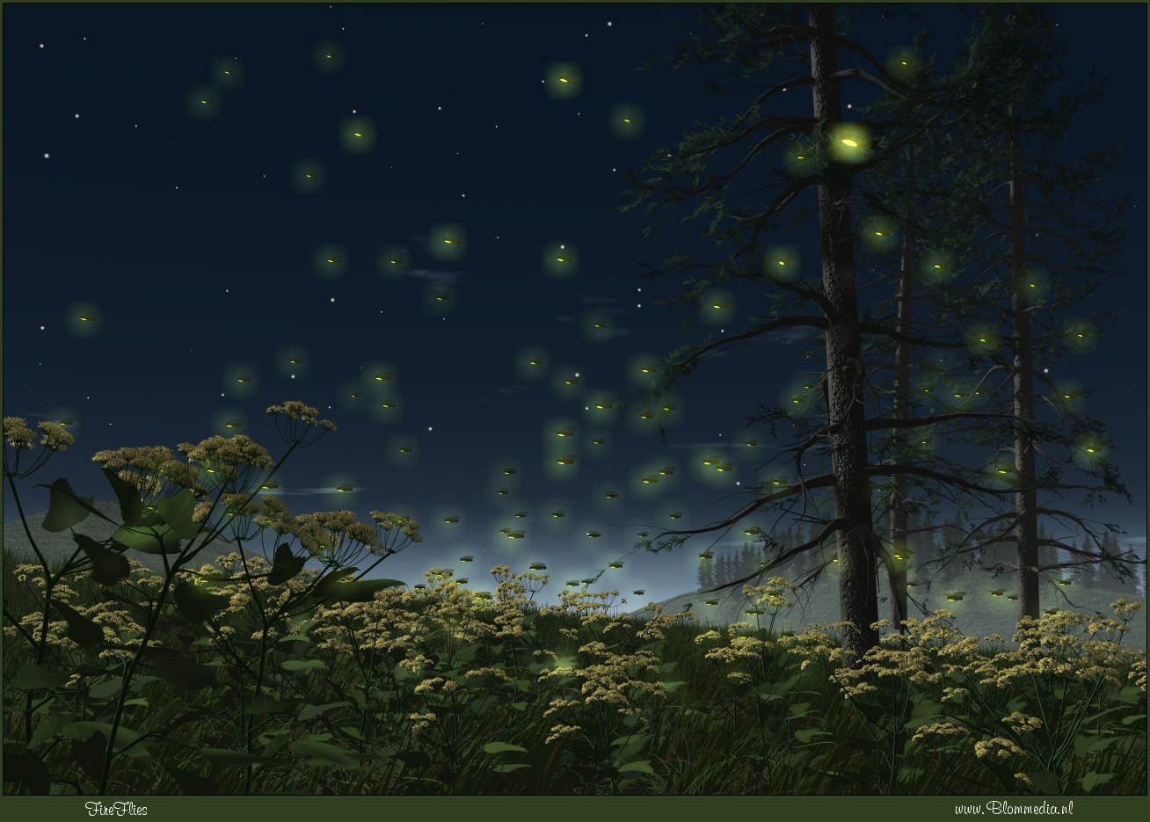
Fred is small. He’s fat and black. | I felt him pass behind my back.  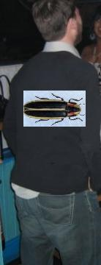
Then he sat in my hand. 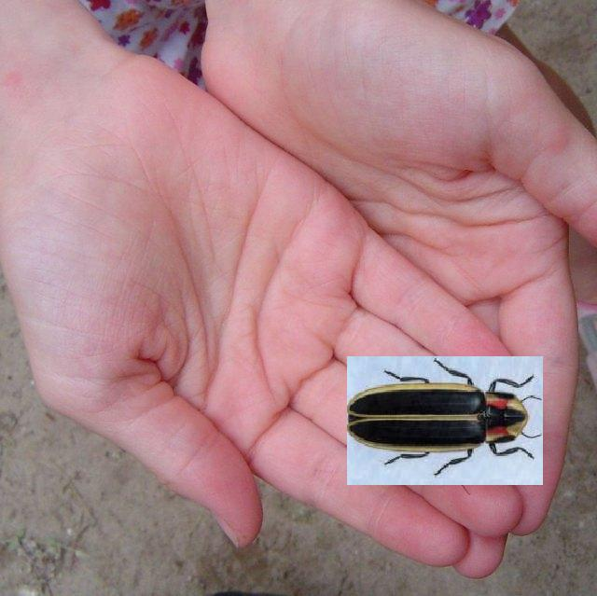 | Then Fred fell in the sand.  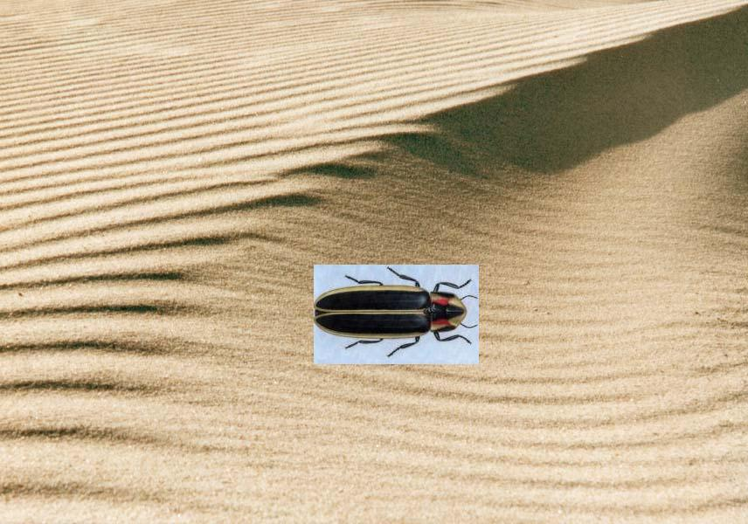
He lifts himself, back in my lap…  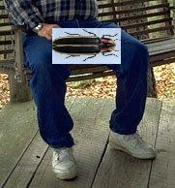 | And said, “I’m tired, it’s time I nap.”  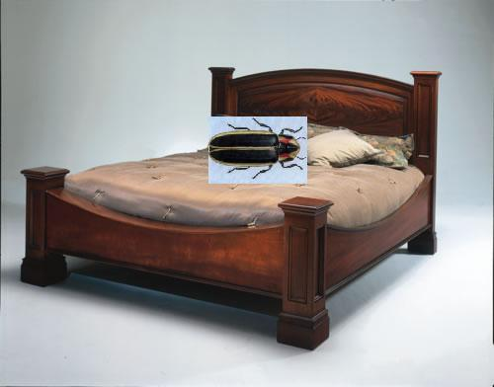
Word list
 | friend
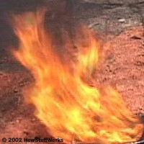 | fire
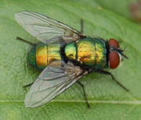 | fly
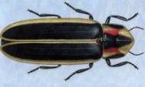 | firefly
 | family
 | fat
 | back
 | black
 | hand
 | nap
 | fast
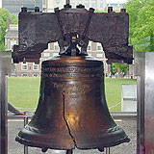 | bell

Matching game (cut up cards)
friend
fire
fly
firefly
fast
bell
nap
hand
black
back
fat
family

Word search

the "f"word

g y p y e y f b k o
w r i r l i x e c q
c g i v r i e l a b
a f x e v h m l l p
y l f b a c k a b g
f l d n e i r f f p
y a d t a k h a j a
r a s o a x w b v n
g r j t r f j k g c
z f e r x y r h u x

back
bell
black
family
fast
fat
fire
firefly
fly
friend
hand
nap

