George, Jack and the cage
This is George.  George’s age is seven. | George has a gorilla.  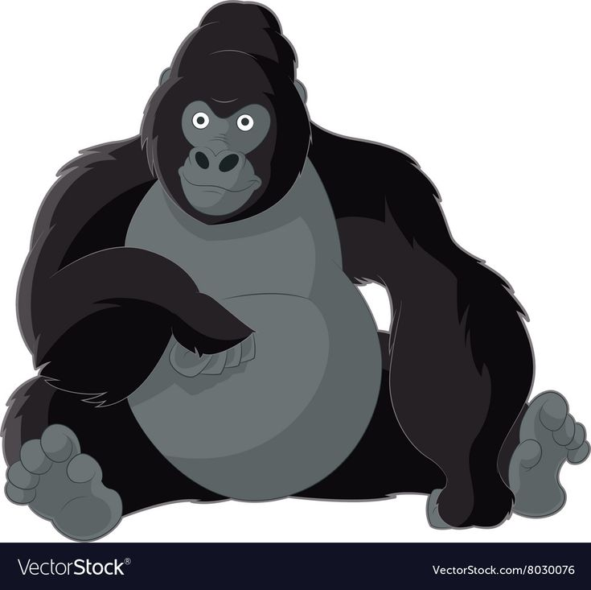  His name is Jack.
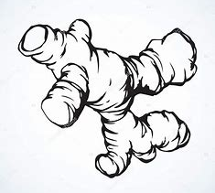  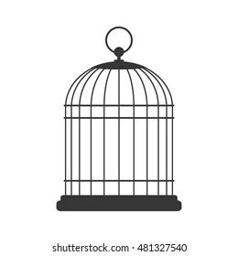  Jack stays in a huge cage.  Jack likes oranges and ginger. | 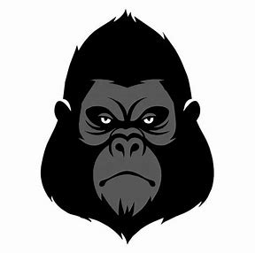  George is very gentle with Jack, but Jack is sad. Jack sits unhappily in his cage.
Jack is sad to be in a cage. George opens the large cage. George doesn’t like to see Jack cry.  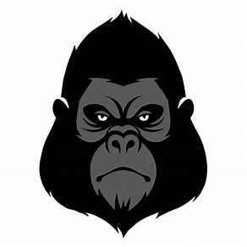 | George gives an orange to Jack. Now both George and Jack are happy.

Word List
1 |  | George
2 |  | Jack
3 | 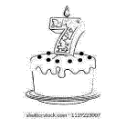 | age
4 |  | gorilla
5 |  | huge
6 | 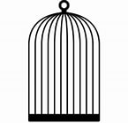 | cage
7 |  | orange
8 | 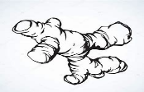 | ginger
9 | 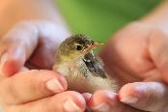 | gentle
10 | 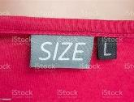 | large
11 | 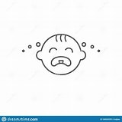 | cry
12 |  | this
Memory Game (Concentration)
gentle |  | George
large |  | Jack
cry |  | age | 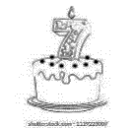
this |  | gorilla
cage |  | huge
ginger | 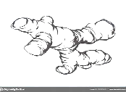 | orange
Memory Game
For this game you need to print and cut out all the squares. Carefully mix and spread the cards picture-side-down. Players take turns, turning any two cards picture-side-up. The cards must be turned over completely, so that all players can see them.
- A Match: A player makes a match if the two cards turned picture-side-up are identical.
When a match is made, the player takes both cards and places them in front of him or her. That player then takes another turn, and continues taking turns until he or she misses.

- A Miss: A player misses if the two cards turned over are not identical. When a player misses, he or she turns the two cards picture-side-down again, in the same place.
That player's turn ends-and all players try to remember which cards were turned over, for future matches.
The game continues until all cards have been matched and removed from the playing area. All players then count up their matching pairs.

The online version:
https://wordwall.net/resource/28655826

