Tim's Neat, Clean Room
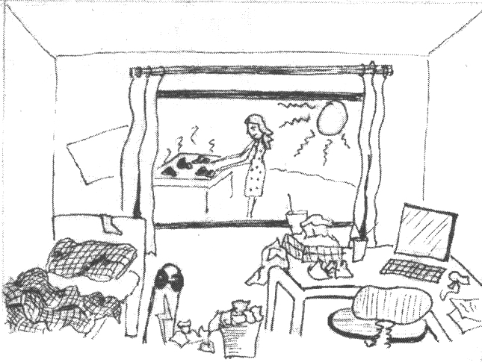  It’s a hot day. Tim's mum is cooking meat on the grill. Tim's room is a mess. | 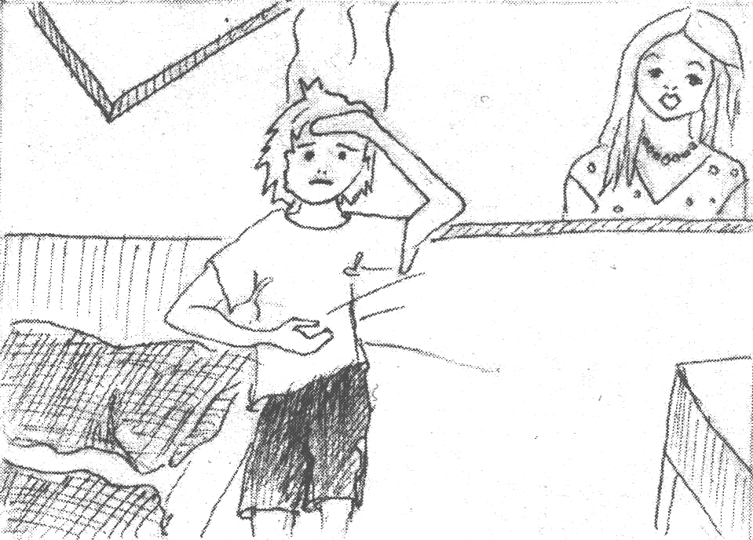  Tim's mother says, "Please clean your room before we eat.”  “It's not easy to clean my room in this heat, I am too hungry!” Tim protests.
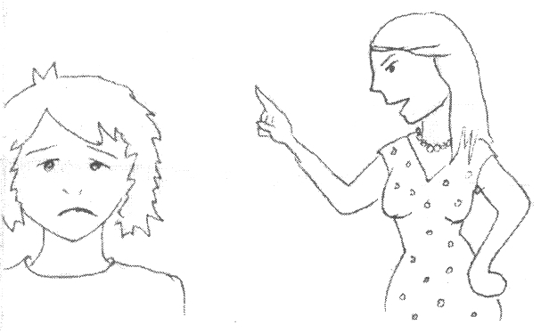  “You can't leave your room until it is clean, and I mean it!" says Tim’s mother.  "I hear you," Tim agrees sadly. | 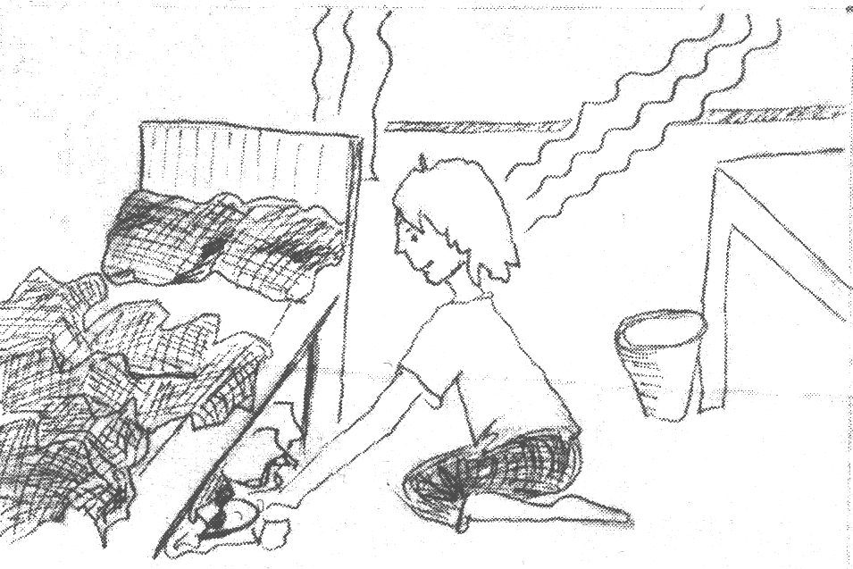  A beautiful smell enters Tim's room. Tim is very, very hungry.  So he quickly pushes everything under his bed.
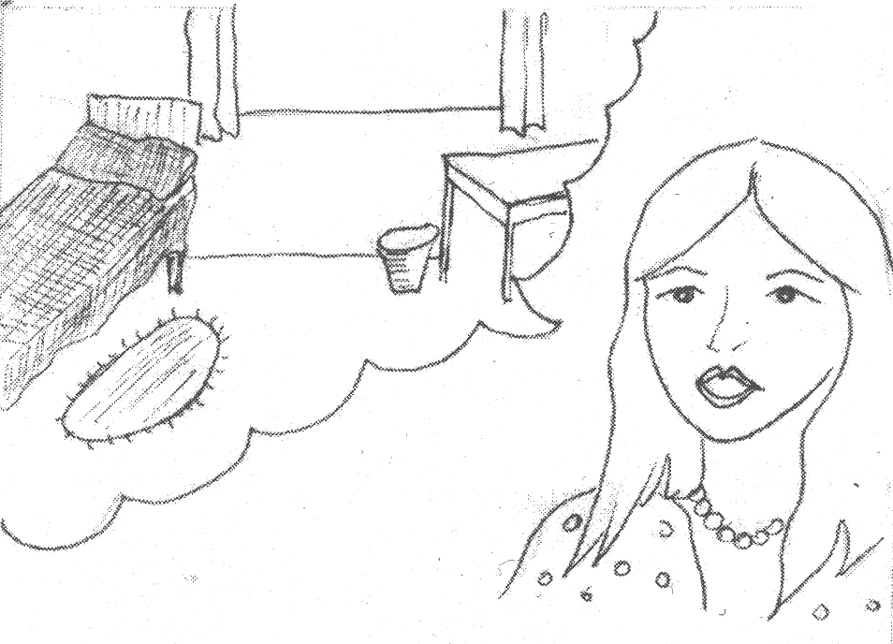  Tim’s mum comes back.  "The meat is almost done. Is your room neat and clean yet?" she asks. | 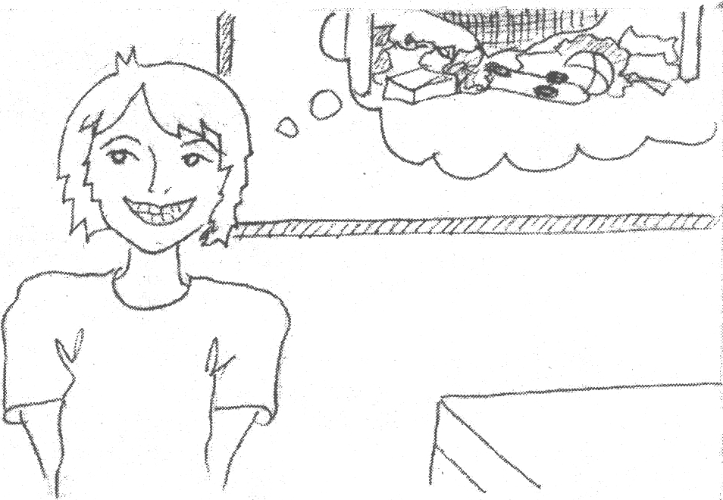  “Yes, Mum! It is neat and clean!” Tim tells her happily.  He prays, “Just don’t look under my bed!”

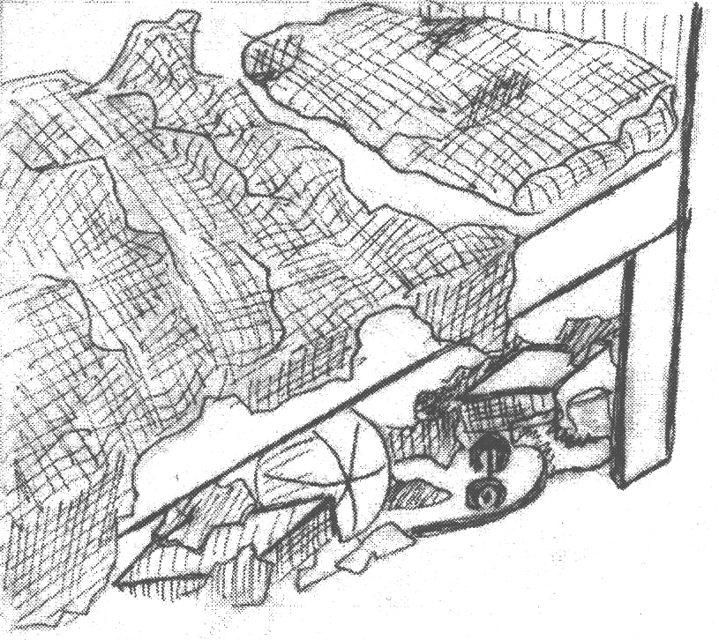  Luckily, she doesn't look under his bed. "Very nice!" she beams. "Come eat!" | 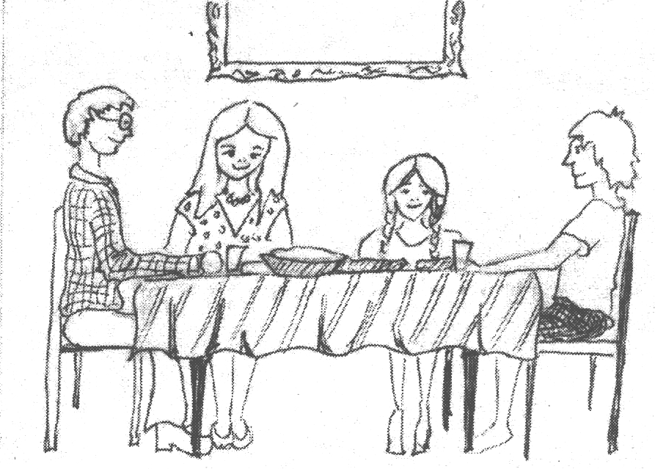  He sits with his family for dinner:  grilled meat, baked sweet potatoes and rice.
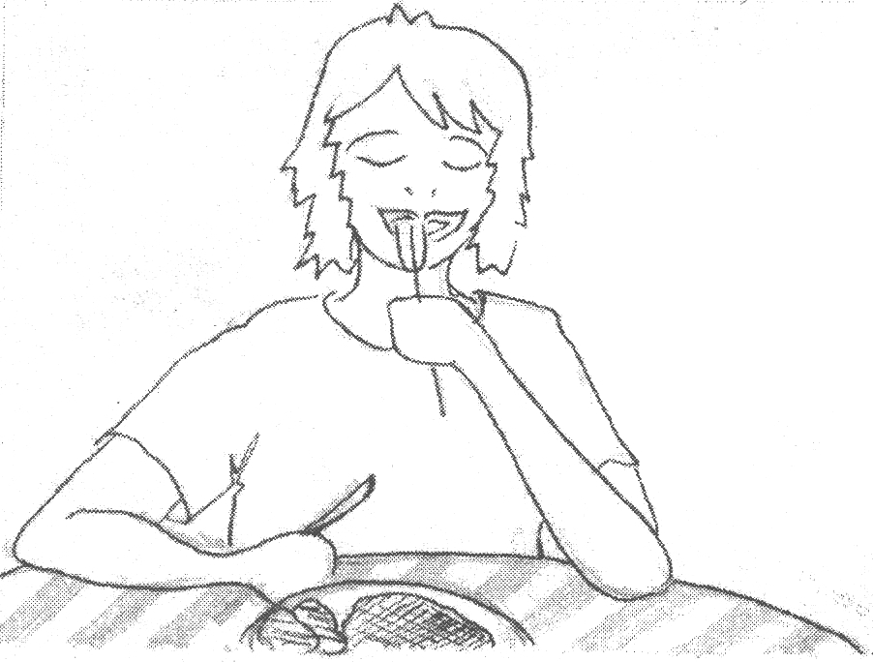

"Mmmm, this is the best meal I’ve had all year!" says Tim.
He thinks to himself, "Maybe I'll finish cleaning my room in the cool evening!"

Word List
1 | 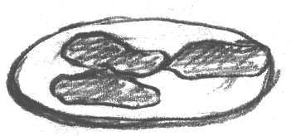 | meat
2 | 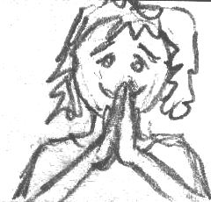 | please
3 | 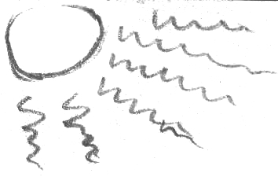 | heat
4 | 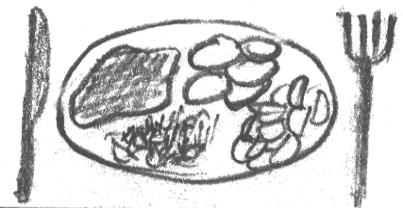 | meal
5 | 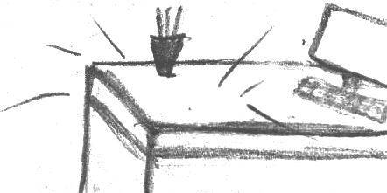 | clean
6 | 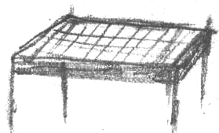 | grill
7 | 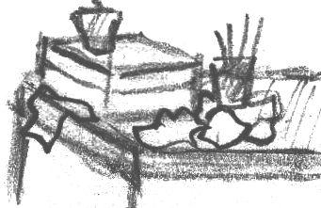 | mess
8 | 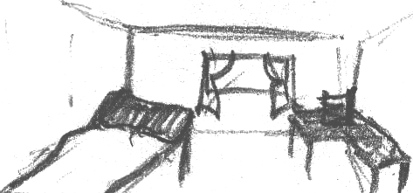 | room
9 | 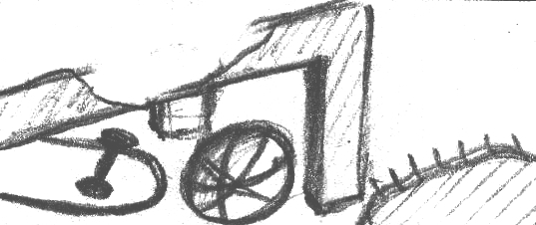 | under
10 | 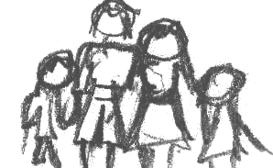 | family
11 | 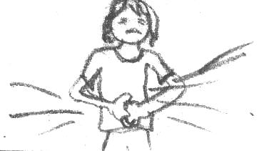 | hungry
12 | 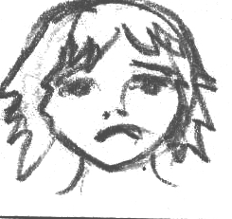 | sadly

Word Search

Circle the words in the puzzle from the word bank, below.

M | U | N | D | E | R | T | E | B | H
V | E | Y | L | I | P | P | A | H | O
L | A | E | M | L | N | K | U | E | T
R | A | U | T | A | E | N | A | A | S
D | L | L | I | R | G | M | E | T | O
U | M | O | O | R | U | N | S | R | M
N | E | E | Y | L | I | M | A | F | L
D | S | Y | T | U | A | E | B | M | A
E | S | A | E | L | P | A | I | N | P
R | C | D | O | T | A | T | O | P | E

happily dinner hot
under beauty sea
family smell cat
please under meal
neat seat day
room Tim bake
meat heat manga
mess potato hungry
almost clean mum

