Holiday Season
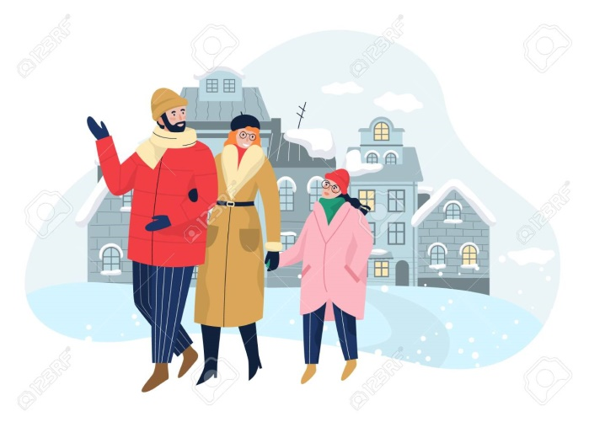  It is holiday season; families explore the different cities. | 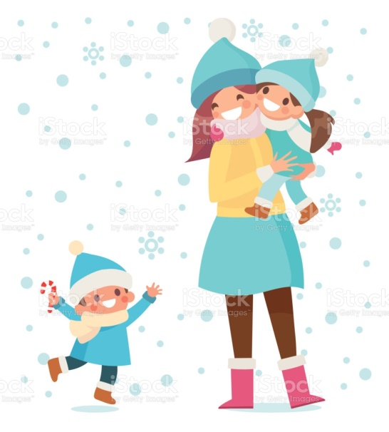  Mommies carry their babies.
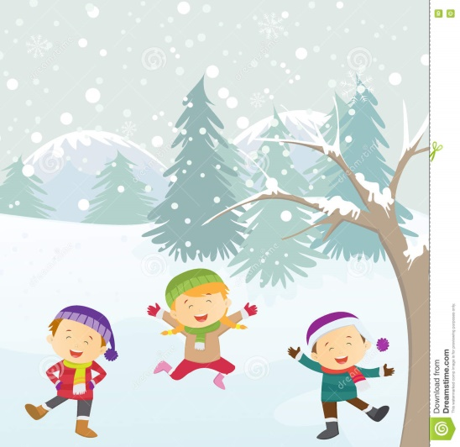  The skies are cloudy and grey but the girls and boys are happy. | 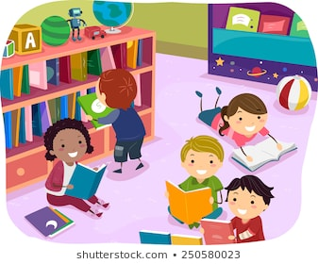  The libraries have opened their doors and stories come to life.
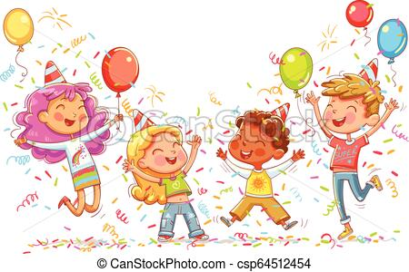  The cries of excited children are heard from parties across town. | 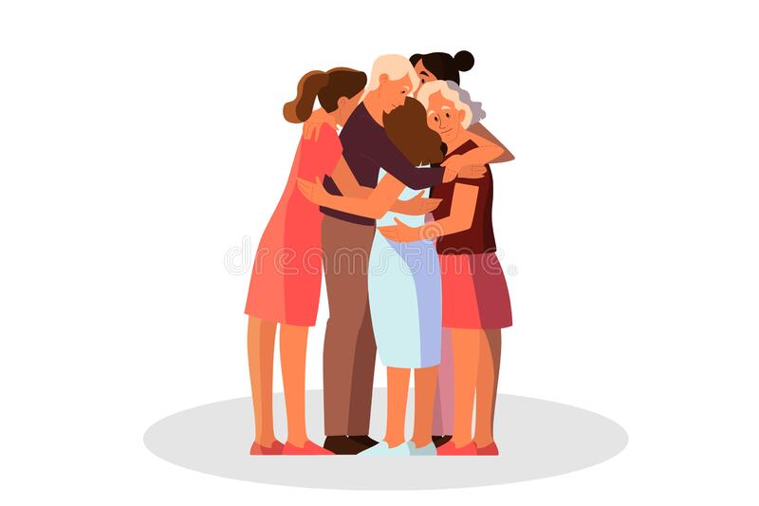 Worries are forgotten and good memories are made.

Word List
1 |  | parties
2 | 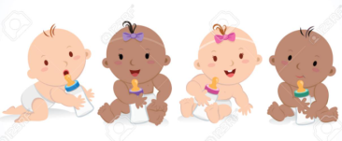 | babies
3 | 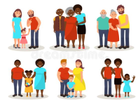 | families
4 |  | cities
5 |  | skies
6 | 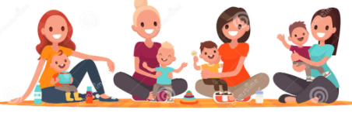 | mommies
7 |  | worries
8 | 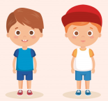 | boys
9 | 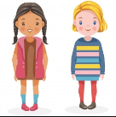 | girls
10 | 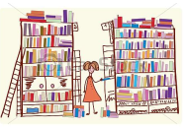 | libraries
11 |  | stories
12 |  | boy

Lotto
In Lotto, each player has a board containing completely different words from those on any other player's board.
Cards are pulled from a bag, and the first player to completely fill his board wins.
The boards here give you two options: print the ones with pictures only to challenge learners to remember meanings of the words. Or, for more reading practice, use the second set of boards with the words beneath the pictures . You can also use both: play first with the boards where the pictures are labeled to scaffold comprehension, then once the learner has practiced the word meanings, switch to the boards with the unlabeled pictures to challenge memory of the words' meanings.

Preparation: Print one copy of the following boards- the first set, the second set, or both, depending on your learning goals. Print the word cards table.
Laminate. Cut up the table of words into 18 individual cards, store cards in a bag.

Play: Learner draws a card from the bag and reads the word in English. The player with that word on his board places the card on his board in the appropriate spot. The player to fill his board first – wins.

Lotto boards requiring knowledge of the meanings of the words.
LOTTO - Player 1 |  |  |  | LOTTO - Player 2
 | 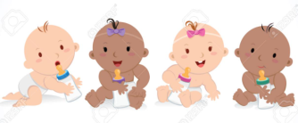 | 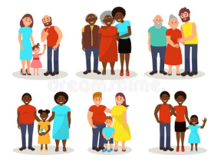 |  | 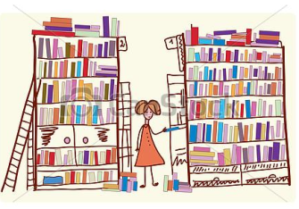 | 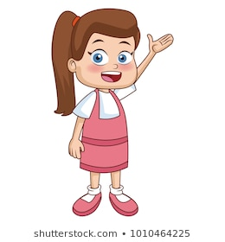 | 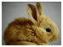
 |  | 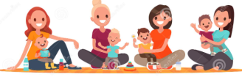 |  |  |  | 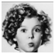
 | 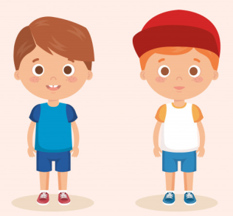 | 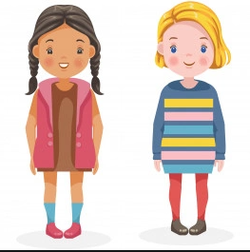 |  |  | 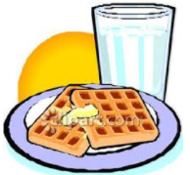

Laminate and cut up these individual word cards, store in a bag.

parties | babies | families | libraries | girl | furry
cities | skies | mommies | stories | strawberry | curly
worries | boys | girls | boy | breakfast | purple

Lotto boards for more reading practice and to scaffold knowledge of the meanings of the words
LOTTO - Player 1 |  |  |  | LOTTO - Player 2
parties | babies | 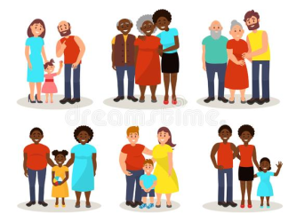  families |  | libraries | girl | furry
cities | skies | mommies |  | stories | strawberry | curly
worries | 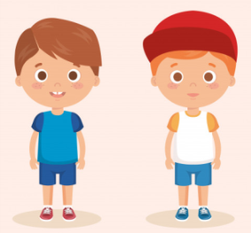  boys | girls |  | boy | breakfast | purple

