Teaching Spelling:
Multiple Spellings of the Same Sound,
and how to choose among them

“I am teaching a native-speaker student with learning disabilities who reads fluently, has a wide vocabulary, but writes riddled with spelling errors. I am doing selected Hickey lessons/cards with her.

She can easily read words like:
boat, float and tote, joke, chore
But she spells them wrong.”

Q1: How do we teach WHEN to use magic e spelling in writing versus other vowel team combinations? Is there a rule?
A1: Give her the Long Vowel Choices table (with examples) and discuss it. The spellings are in the order of frequency - magic e is the most frequent, followed by vowel teams (see below for empirical evidence). So if she doesn't know which way to spell a word - try magic-e, it's a better bet. That is why we teach the "magic-e" vowel combinations before the vowel teams.
That said - of course there are words with vowel teams. Sometimes they are homophones and differentiate the meaning of the word from the magic-e spelled word: mote and moat, for example; or pale and pail. But there is no rule for which to use (except perhaps whether the word is of Greek, Latin, or Anglo-Saxon origin, which we wouldn't expect her to know; Anglo-Saxon words are more likely to end in magic e, for example).
If you are not teaching Hickey in the standard cumulative way with all the reading, you can still go in the Hickey lesson order (because it is organized by frequency) and teach the spelling together with the list of words that she is most likely to need that uses that spelling. If you prefer, go in order of the Long Vowel Choices table from left to right and teach multiple spellings of the same long vowel sound (phoneme) in sequence.
The list of words she is most likely to need for each individual spelling are the vocabulary words she is expected to know by the Ministry of Education English Inspectorate. Find these in the orthographically-sorted pages of the vocabulary spreadsheet (at TeachEnglishLiteracy.org > About > Vocabulary words or TeachEnglishLiteracy.org > Documents for Download > Phonics for Classrooms).
You will find there Band 1 by Orthographic Patterns and Band 2 by Orthographic Patterns (we are now organizing Band 3 but you could look at the list itself for more examples, if you have access to it). So for example:
The -o_e words in Band I (elementary school) are:
o_e
note
notebook
home
close
closed
hope
chose
phone
mobile phone
telephone
iPhone
smoke
suppose
whole
alone
The oa words in Band I are:
oa (long o)
road
coat
boat
soap
goat
The -o_e words in Band II (JHS) are:
o_e
code
role
home
telephone number
phone/ phone up
suppose
devote
vote

The oa words in Band II are:,
goal
download
throat
broad (exception)

*Note: For some multiple spellings of the same sound, there are rules. See below for an example.
Q2: I am confused about how to add on to previous white, blue, or pink cards as a learner progresses and learns new ways to write/read same sounds.
- How do I know when to leave room on a card for future spellings?
- What do the cards look like when they have all important spelling combinations for their sounds?
- Which cards will ultimately have multiple spellings listed?
- Will I have many different blue cards for the long o sound? (O) as in flow, (o) as in float, and (o) as in choke?
- But should all these somehow appear on the letter o white card? I think these sounds have different pink rule cards.
A2: How to organize the cards regarding the same sound:
- You know a sound (phoneme) is the same when the phonetic representation on the Hickey Lesson Order is identical to one that you have taught before. Example: the phonetic representation ( ō ) denotes the phoneme for o, -o_e oa, one sound of ow, and oe in the Hickey lesson order.
- A second way to know what is coming up, for long vowel spellings, is via the Long Vowels Table - the spellings in a line all represent the same long vowel sound.
- A third way is to look at the list of English Sounds and their Multiple Spellings. The spellings for each phoneme go from most common to least common.
White cards: Every spelling (grapheme) has its own white card, because the student has to be able to recognize and decode it.
Pink cards: you can introduce the magic-e pink card with examples of spellings of magic-e words with different vowels you have learned up to the current lesson. Because she already reads well, it shouldn’t overwhelm her. The pink cards don't change from lesson to lesson, except for possibly adding examples with new spellings learned.
Yellow cards just contain a list of words she can read and write with the spellings you have taught to date. Keep adding words to the same or new cards, probably 8 to a card is enough.
Blue cards: The relevant issue here is blue cards. When you are teaching a new spelling of a sound you have already taught (example from above, ( ō ) ) you add the clue word for the new spelling to the previously-made blue card for that sound.
You should always start your clue words high up on the card to leave room, but especially for the long vowels. Other sounds that have multiple spellings are (k) with spellings c, k, ck, ch (school)*. You can look at English Sounds and their Multiple Spellings to get a sense of how many spellings you will want to teach for each sound.
Example for the phoneme of ( ō ), called ‘long o’ : The first time you teach long o (open syllable, just the vowel) is in lesson 23. At the end of lesson 23 the blue card looks like this:
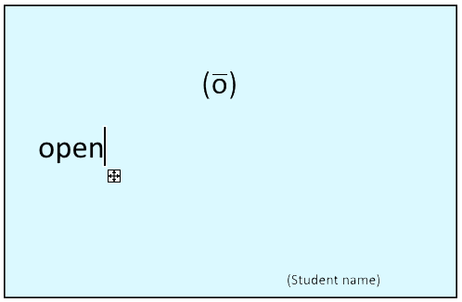
Then you teach an additional spelling of the same sound again in L24, -o_e so at the end of L24 the blue card looks like this:
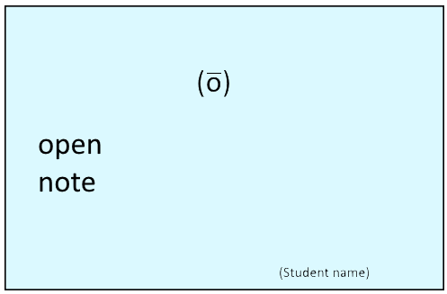
Then you teach a third spelling of the same sound in L52, oa so at the end of L52 the blue card looks like this:
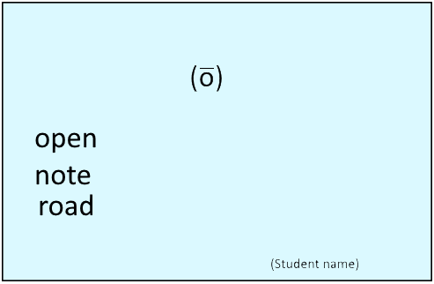
In L53 you will learn the ow spelling at the end of a word (in the Hickey lesson order the ow was missing until recently, the updated list is now on the website) so at the end of 53 your blue card will look like this:
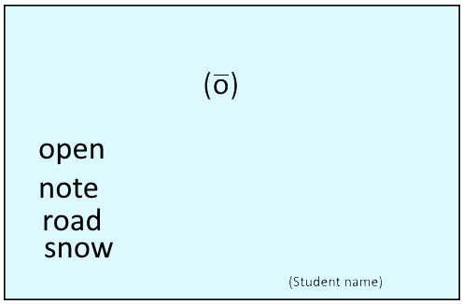

Then in L79 we teach the far less common "oe" so at the end of 79 it would look like this:
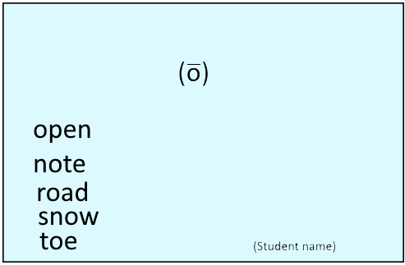

Good luck!

* Pink cards for how to choose among multiple spellings of the same sound:
Example – the (k) sound.
We have a pink card for ‘c’: Use c for the sound (k) before all letters except e, I, and y.
We have a pink card for ‘k’: Use k for the sound (k) before e, I, and y.
We have a pink card for ‘-ck’” Use -ck for the sound (k) at the end of one-syllable words, after one short vowel.
The (k) ch combination (school, chemist) does not have a pink card, but the language origin often determines the sound (phoneme) to choose. Words including ch of French origin (champagne, chauffeur, chiffon) have the (sh) sound. Words including ch of German origin (school) have the (k) sound.
Likewise, the letter ‘g’ makes its soft sound before e, I and y (exceptions: girl, gift, get) but its hard sound before the other letters. Therefore it’s a good bet that you would use ‘j’ to spell the soft sound before the other letters (jam, jump, jockey) though not 100% guaranteed (exceptions: jelly, jest).

