Gal’s Hope
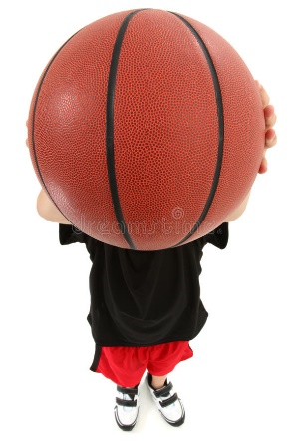  Gal has a ball, and he is in a basketball game.  He has to get the ball into the rope net. | 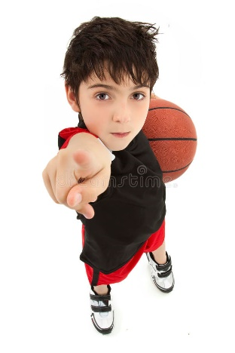  Gal comes close to the rope net, the ball in his hands. Only one shot and the game is done!
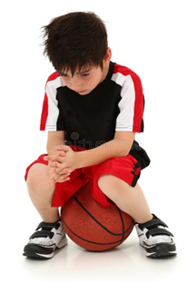  Can he do it?  Gal misses the hole in the rope net.  On his second try, the same. | 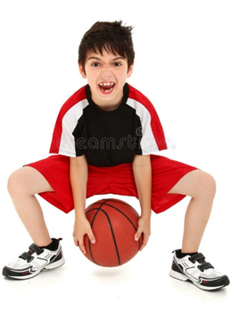  Yet, Gal has hope that he can get the ball into  the hole in the rope net.
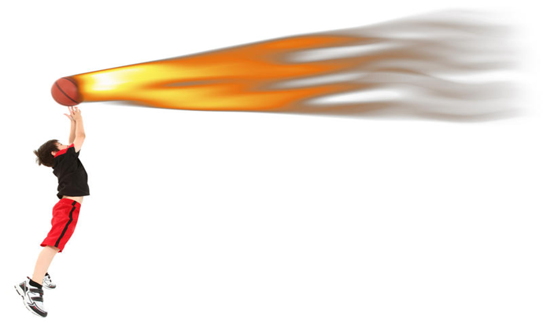

Gal stands alone on the green grass, his eyes on the basket.
The ball takes off, it goes into the basket, and Gal is the star of the game!

Word List
1 | 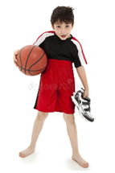 | Gal
2 |  | basketball
3 |  | game
4 |  | hope
5 | 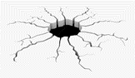 | hole
6 | 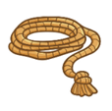 | rope
7 | 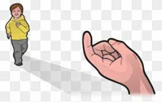 | come close
8 | 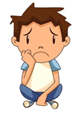 | alone
9 |  | one
10 |  | done
11 |  | grass

Word Search!
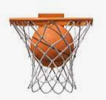

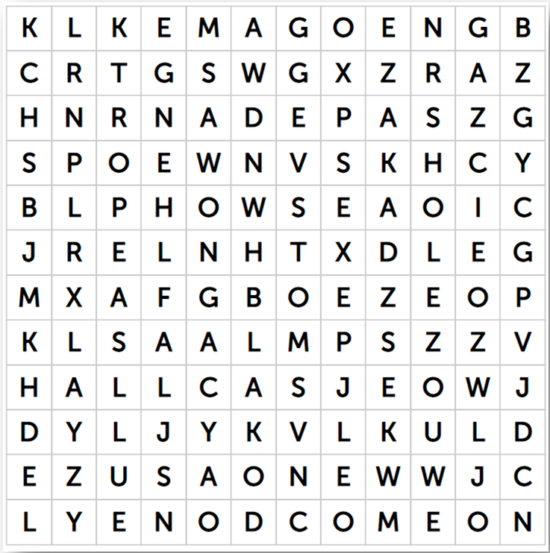
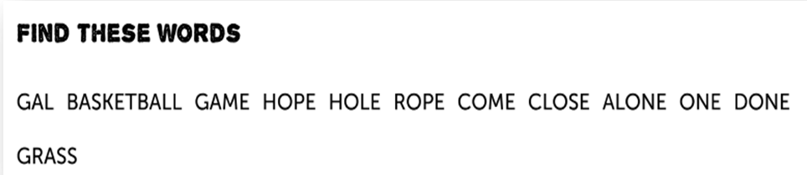

You can also do the word search online at: https://puzzel.org/en/wordseeker/play?p=-MtE5YrEjFQn80J___dt
