Dan, Pat, Rena and the Rat
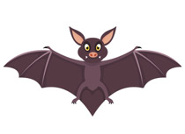    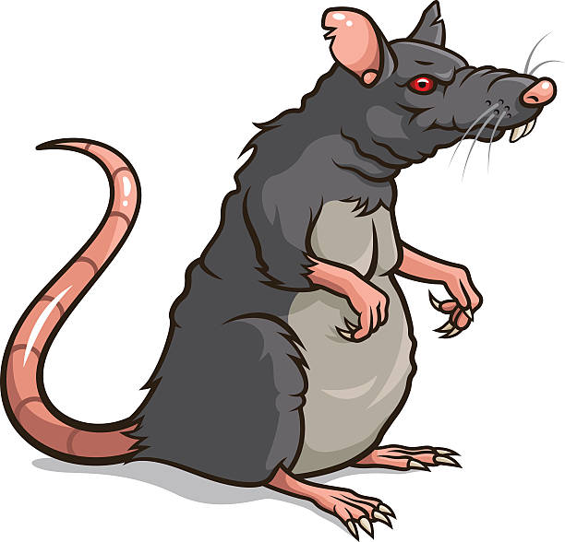  Pat and Dan sit at their desk.  "Is that a bat?" asks Pat.  "That is a rat!" Dan said. | 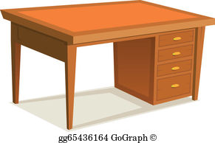  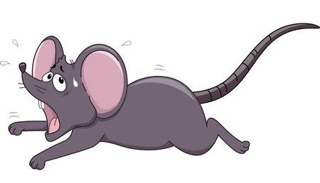  The rat ran past the desk.
  The rat ran past Rena. |     Rena sprints to her desk.
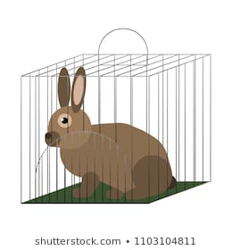  The rat ran past the pet rabbit. | 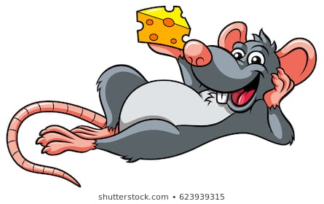    The rat rests in the red trash bin.

Word List
1 | 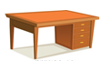 | desk
2 |  | bat
3 |  | rat
4 |  | ran
5 |  | sprints
6 | 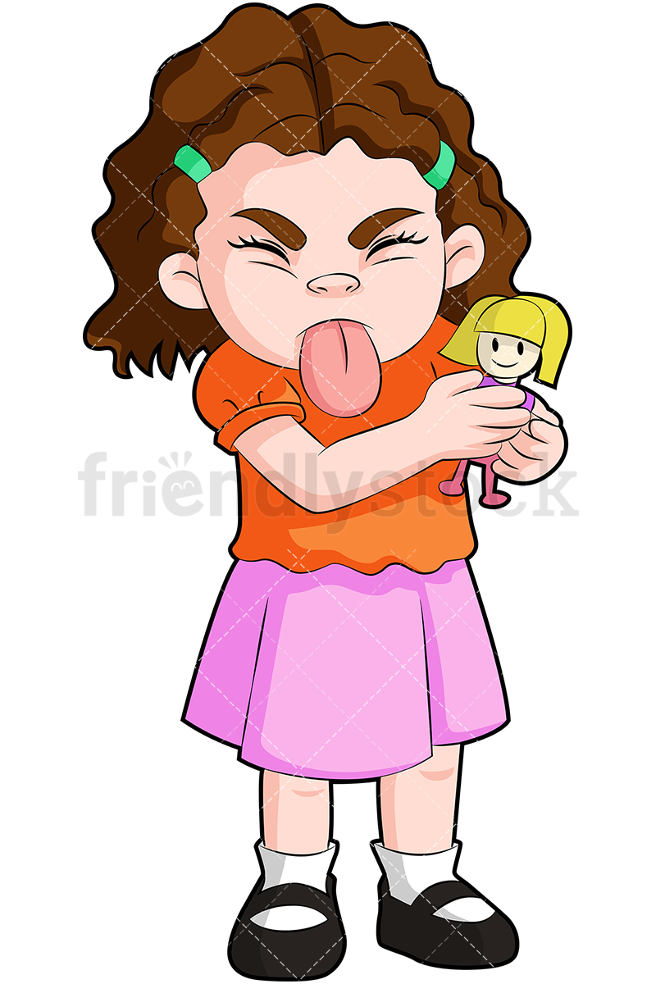 | her
7 |  | rabbit
8 | 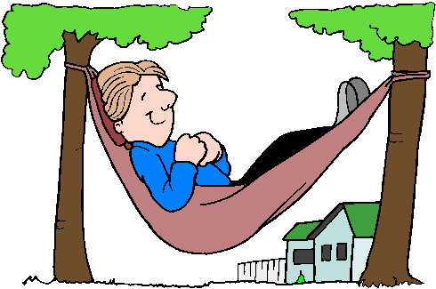 | rests
9 |  | red
10 |  | trash bin
11 | 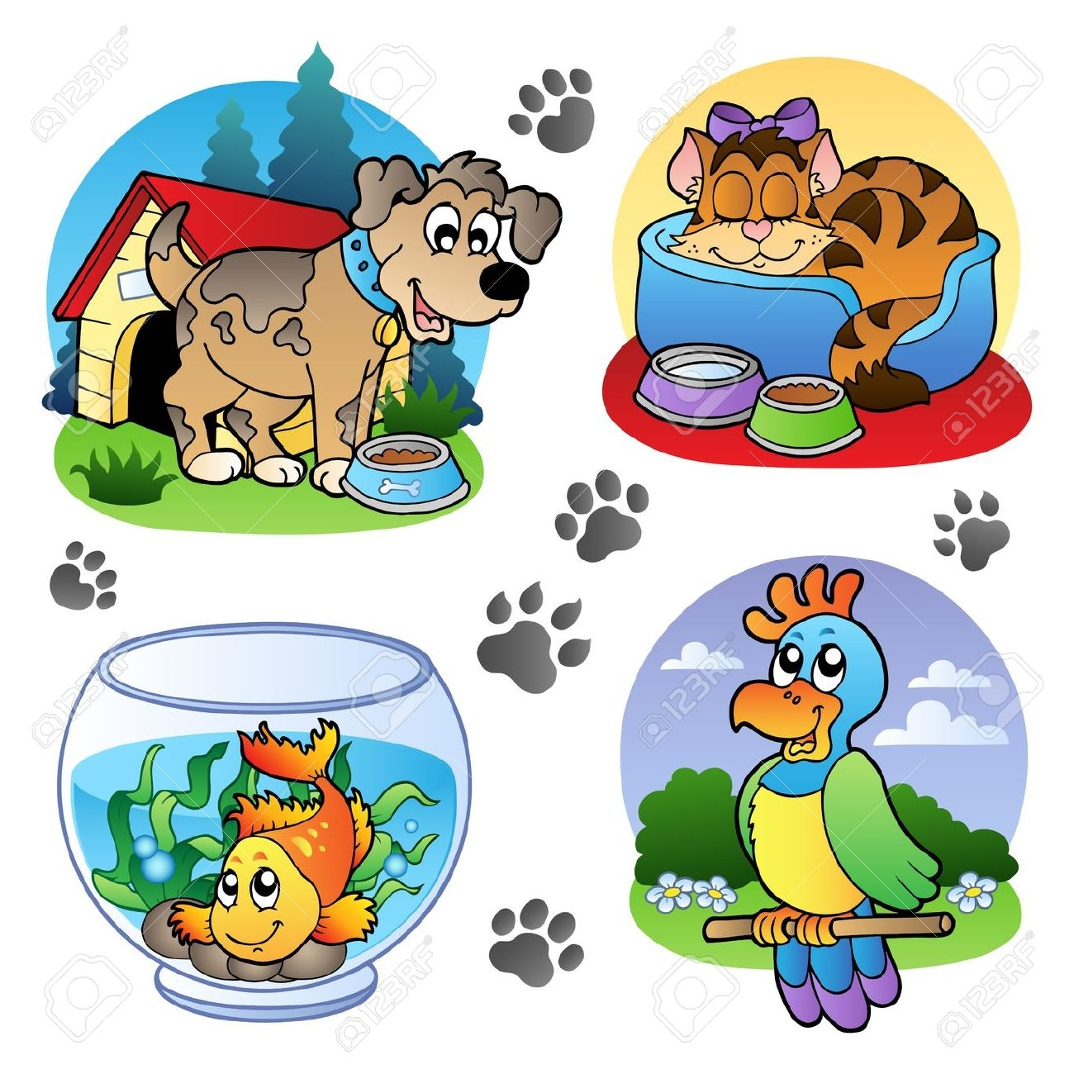 | pet
12 | 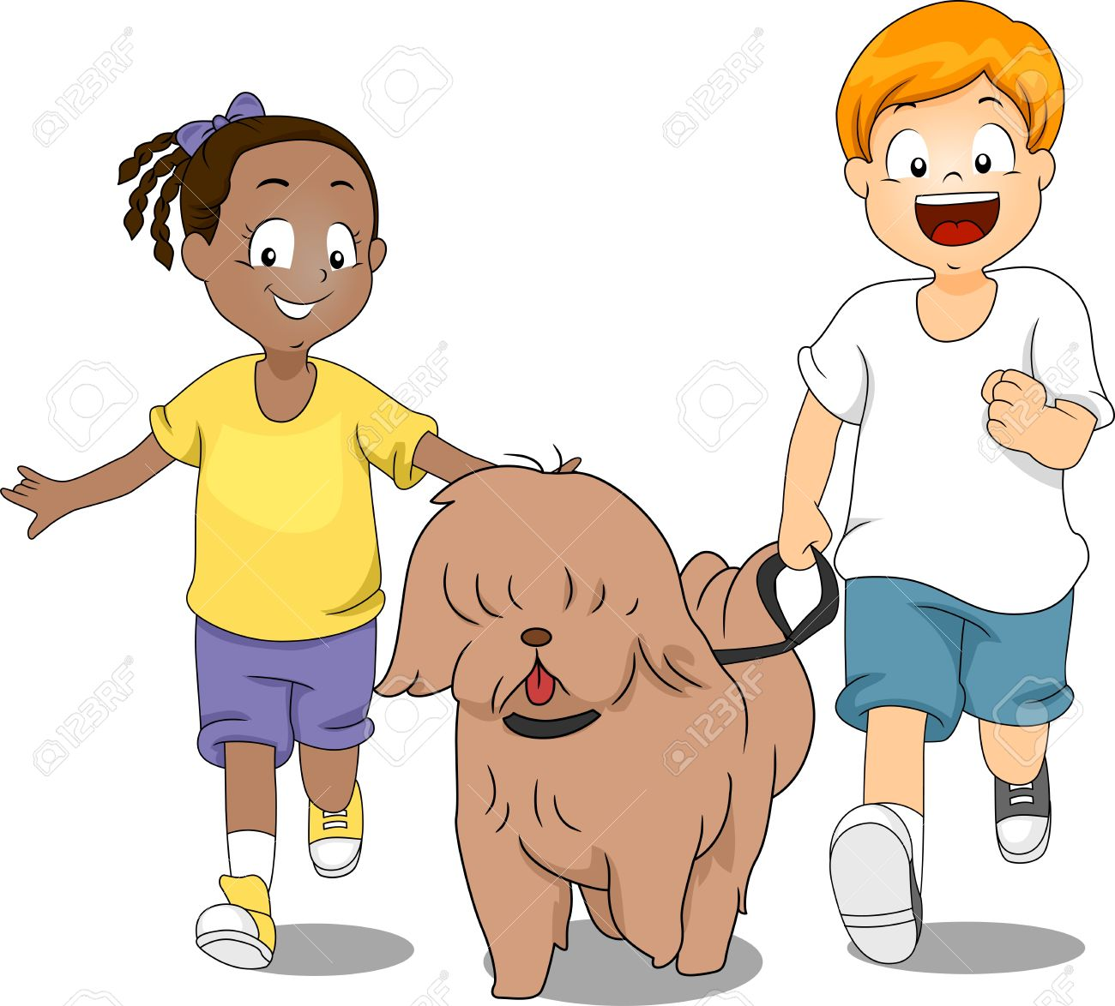 | their

Memory Game (Concentration)

Instructions:

Preparation: Print and cut out the 12 words and pictures below into playing cards.

Each player chooses two cards on his or her turn. If the cards match the player keeps the cards, if not he or she returns the cards back in place. The winner is the player who collected the highest number of matching cards.

desk
bat
rat
ran
sprints
her
rabbit
rests
red
trash bin
pet
their

