At the Sea
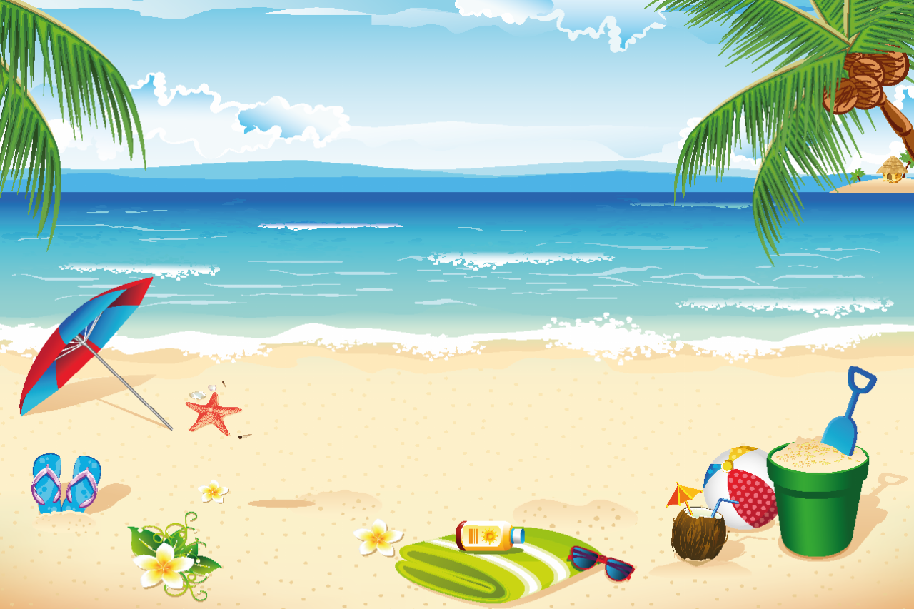  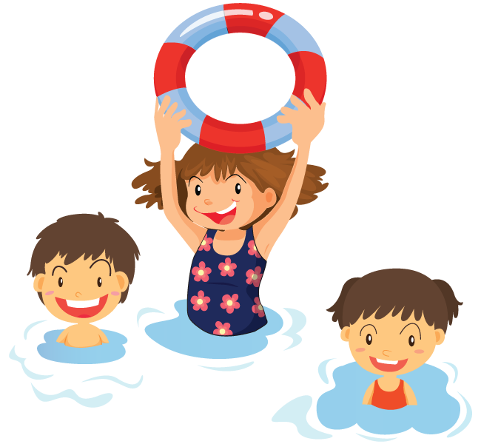  This year it is hot! The kids are swimming in the sea. | 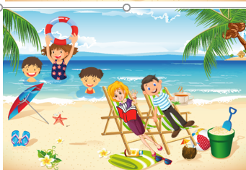  Mom and dad are at the sea too.  They read a book and drink tea.  We don’t want to leave the water  Mom and Dad are at the sea too. They read a book and drink tea.
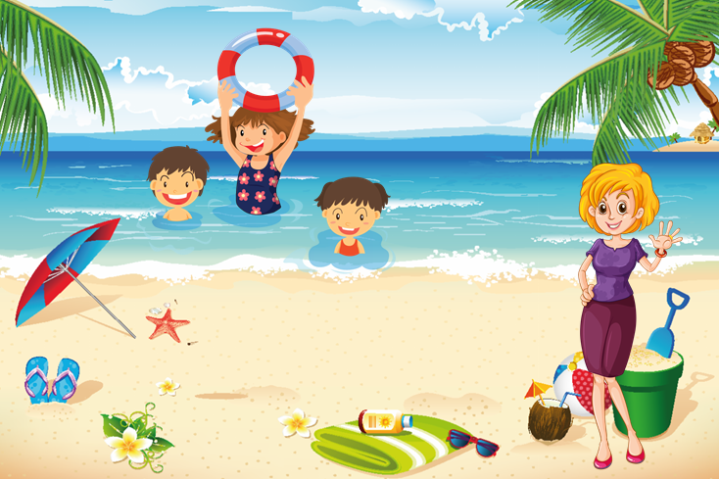  Dear kids, come to eat please  The sea is really clear and beautiful.  Mom: "Dear kids, come to eat, please." | 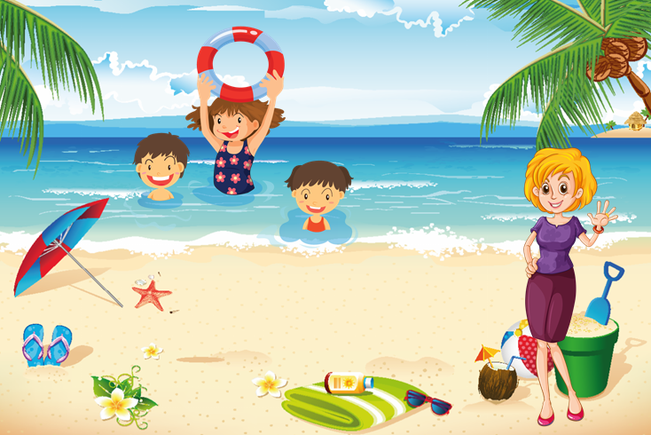  The kids don’t hear her. She yells, “COME TO EAT PLEASE!”  Kids: "We don’t want to eat! We don’t want to leave the water!"
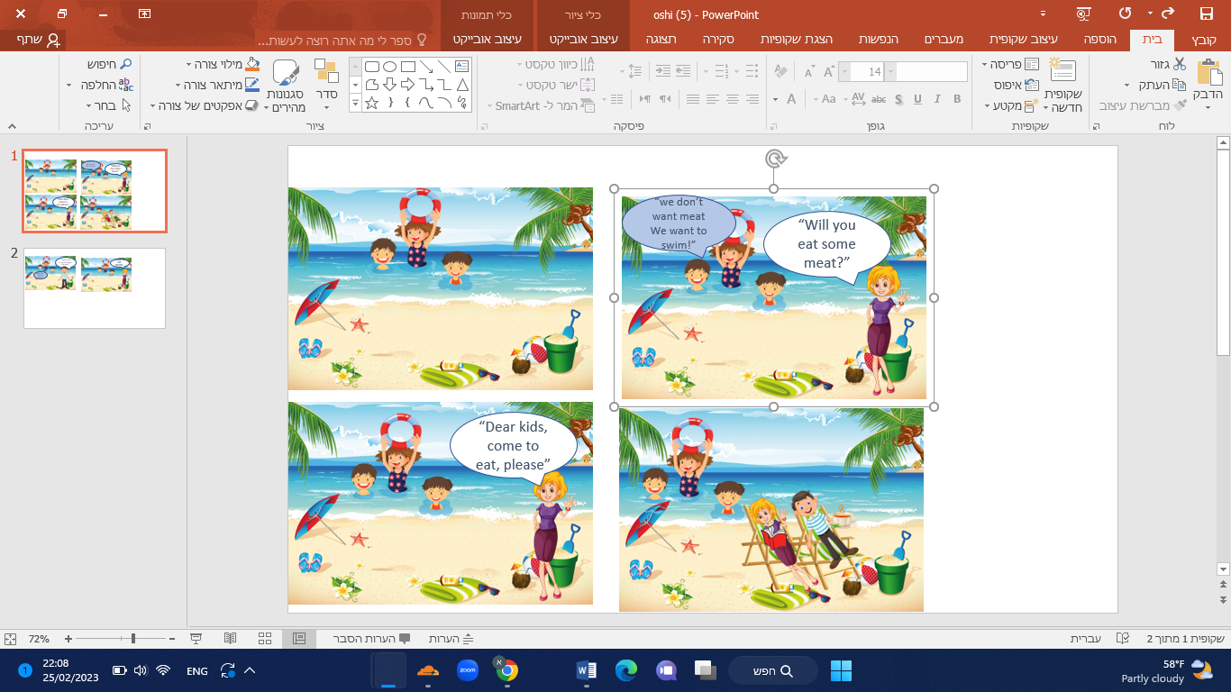  Mom: "Will you eat some meat? "  Kids: "We don’t want meat! We want to swim!" | 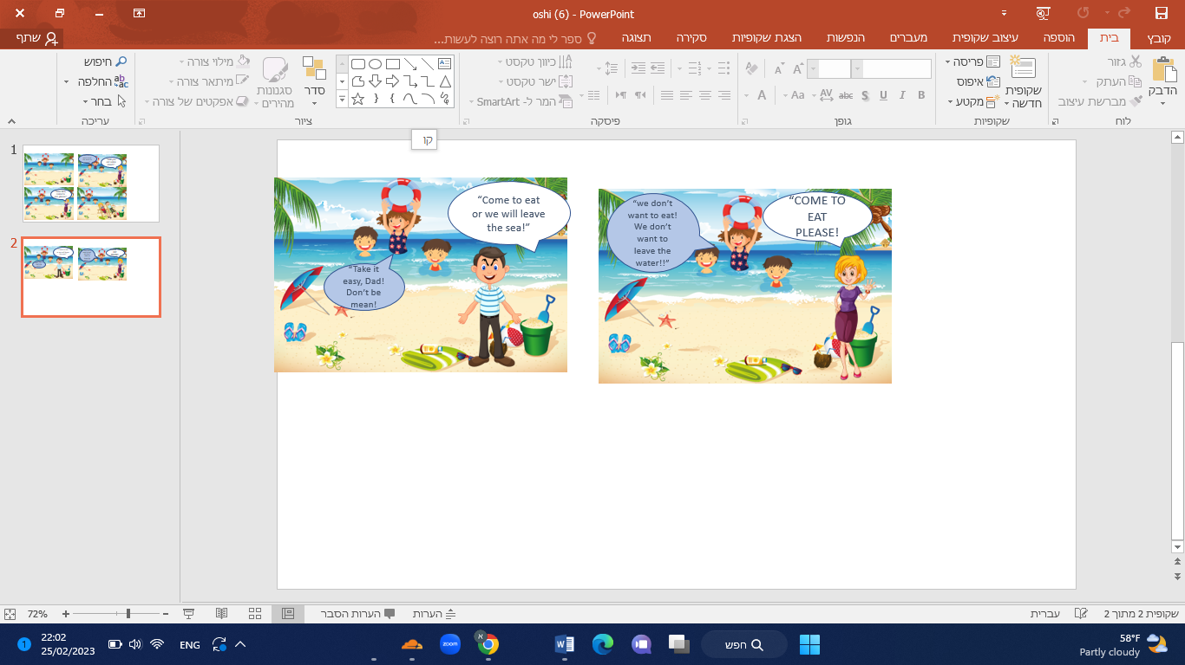  Dad: "Come to eat or we will leave the sea!"  Kids: "Take it easy, Dad! Don’t be mean!" And they came to eat.

Word List
1 | 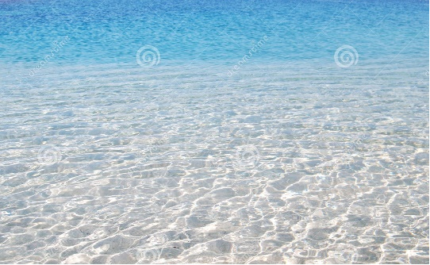 | sea
2 |  | read
3 | 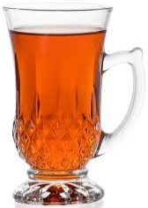 | tea
4 | 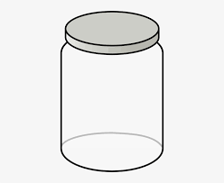 | clear
5 |  | beautiful
6 | 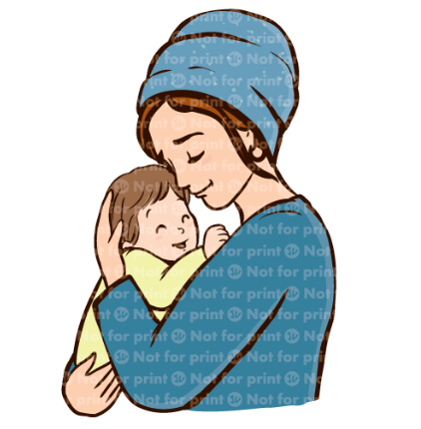 | dear
7 | 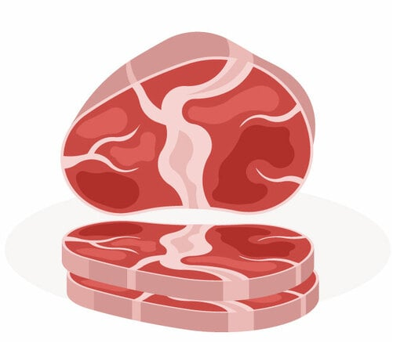 | meat
8 | 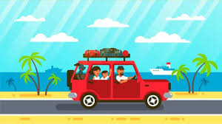 | leave
9 | 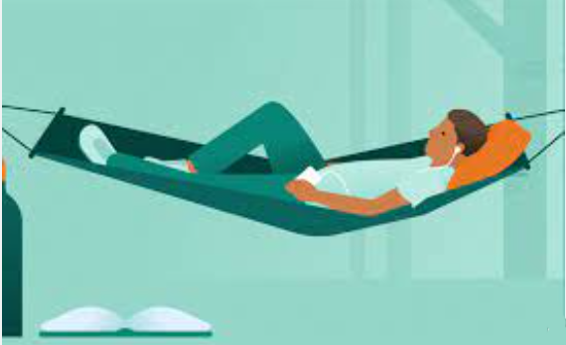 | take it easy
10 |  | please
11 | 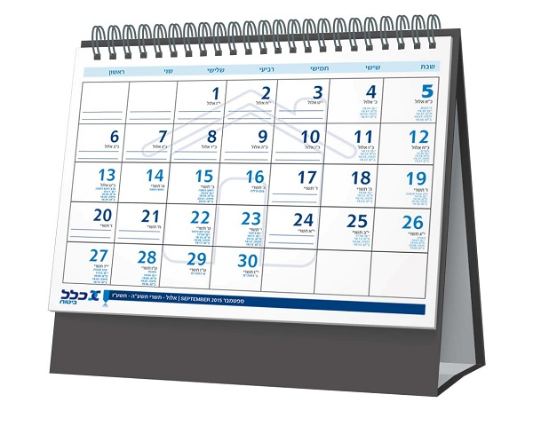 | year
12 |  | mean

Online game: https://wordwall.net/resource/52986229/ea-hickey-method

Concentration or Matching Game
Cut apart the squares. Match each word or sentence to the picture it describes.
 | beautiful kids
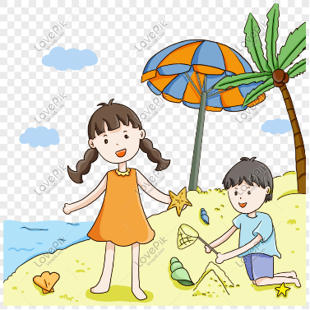 | The kids are at the sea.
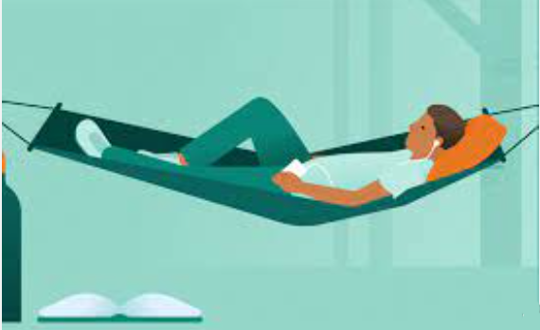 | take it easy
 | meat
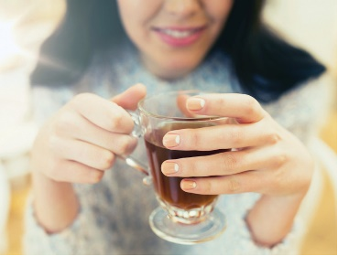 | Mom drinks tea.
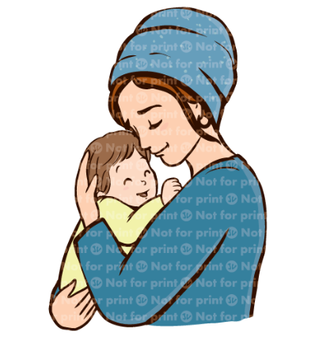 | a dear kid
 | please
 | clear sea
 | leave
 | clear
 | read

