Welcome, Wonderful Vampires!
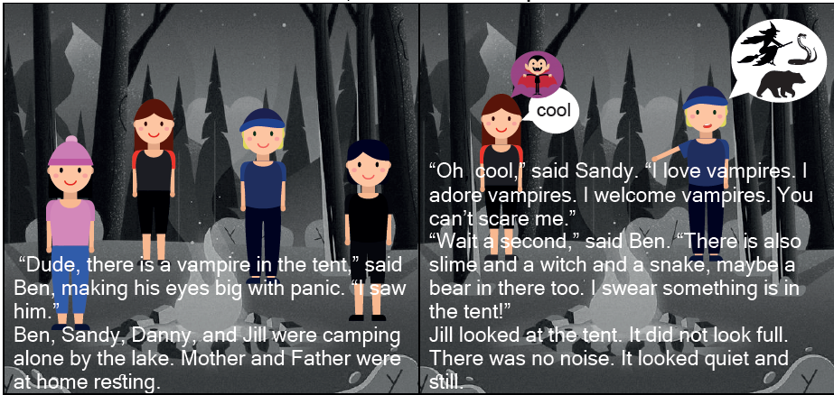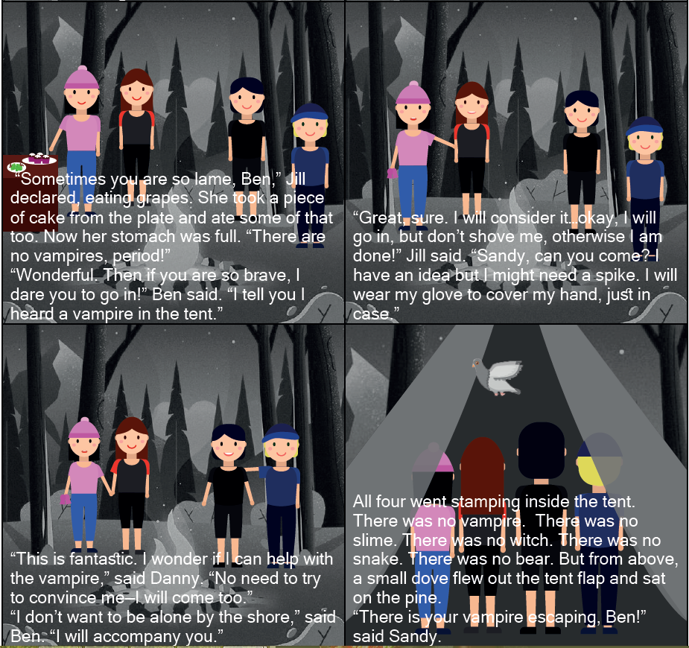

Word List
1 |  | love
2 |  | above
3 |  | come
4 |  | glove
5 | 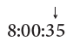 | second
6 |  | Mother
7 |  | some
8 |  | dove
9 |  | sometimes
10 |  | stomach
11 |  | welcome
12 |  | wonderful
Lotto o (short u)
Each player has a board containing different words from those on the other player's board. One board has words where O sounds like short u and one where O sounds different from short u. Cards are pulled from a bag, and the first player to completely fill his board wins. The learner can use a different board each time so s/he has an opportunity to read from both word groups.

Preparation: Print two copies of the following boards. Laminate. Cut one copy into 18 individual word cards and store them in a bag.
Play: Learner draws a card from the bag and reads the word. The player with that word on his board places the card on his board in the appropriate spot. The first player to fill his board - wins.
LOTTO – O sounds like short u |  |  |  | LOTTO – O sounds different from short u
accompany | otherwise | second |  | on | alone | home
consider | dove | something |  | out | adore | cool
love | welcome | wonderful |  | looked | noise | now

You can make more boards and cards using and mixing with these additional words:
O sounds like short u: glove, shove, above, cover, some, come, of
O sounds different from short u: too, look, no, so, go

