The Little Black Pine Plant
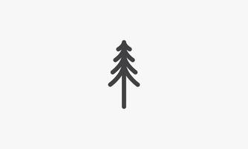  Lisa has a little black pine plant.  "Let's plant it!" said Lisa. | 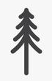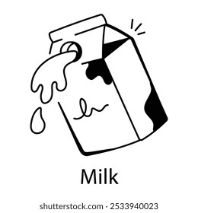  Lisa plants the little black pine in the land and adds milk beside its site.
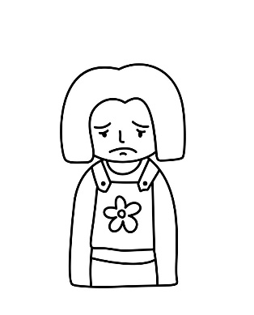  Lisa sat and sat.  The plant didn’t rise yet.  Lisa is sad. She talks and the plant listens. She held the plant. She helps it stand. | 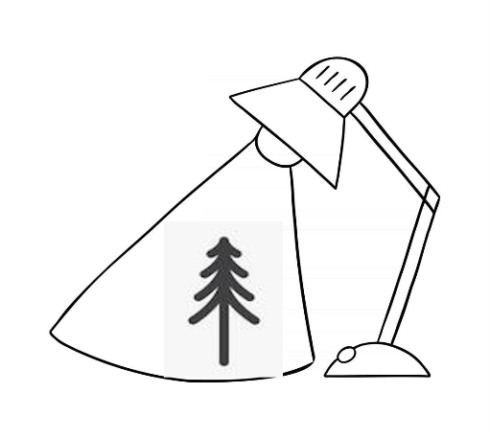  Lisa has a plan.  She hides the plant and shines a lamp at it.
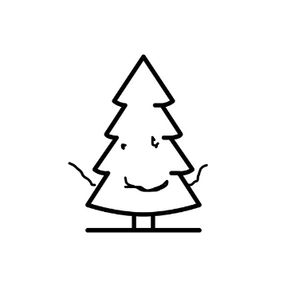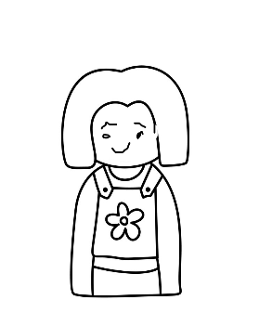  At last the plant rises and smiles!  It likes Lisa. | 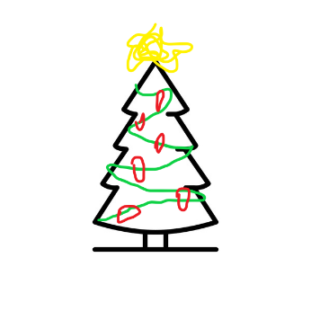  At the end, Lisa’s plant isn’t little.  It is a pine!  It is here. It is Lisa’s pride!

Word List
1 | 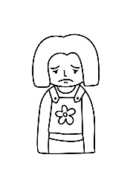 | Lisa
2 |  | milk
3 |  | likes
4 |  | pine
5 | 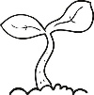 | plant
6 | 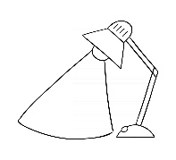 | lamp
7 |  | sad
8 |  | talks
9 |  | black
10 |  | stand
11 | 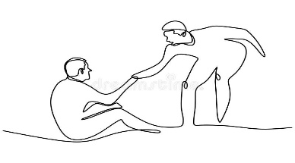 | helps
12 | 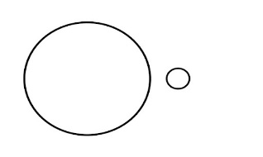 | little

Game: Concentration or Matching Game
Cut apart the squares. Match each word to its picture.

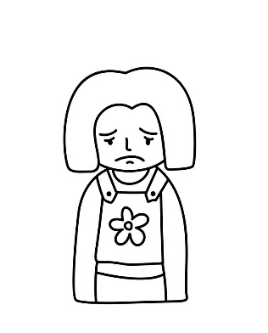 | Lisa
 | milk
 | likes
 | pine
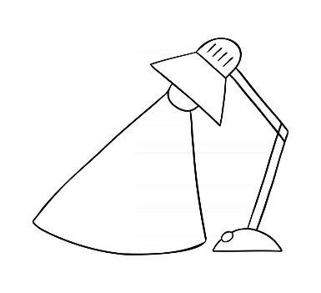 | lamp
 | black
 | sad
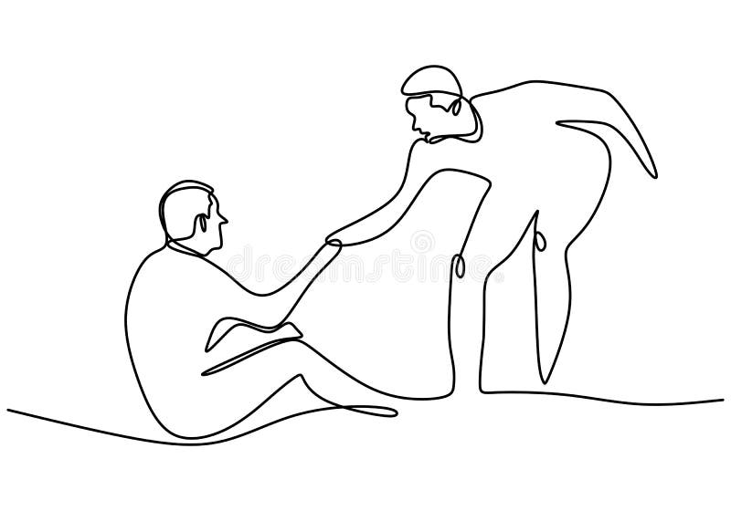 | helps
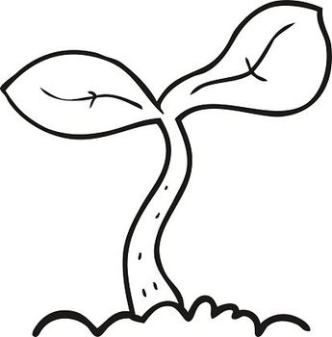 | plant
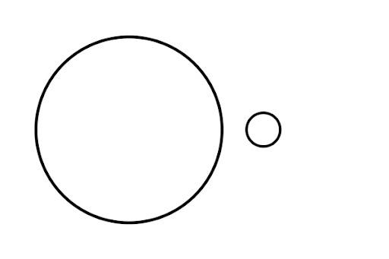 | little

Online Games:

https://wordwall.net/resource/90750967

